**Design of a Wearable and Portable Non-Invasive External Ventilation (NIEV)**

**Final Report**

Faculty of Applied Science and Engineering

APS490 Multidisciplinary Capstone

***Project Code: SickKids***

| Suhail Anuar | 1006362696 |
| --- | --- |
| Jimin Kwon | 1005088441 |
| Mona Murphy | 1004817852 |
| Yi Ling Soh | 1004900878 |
| Vanessa Jade Tan | 1005102933 |

Under the supervision of:

Professor Kamran Behdinan (MIE)

S. Ranjan Mishra (TA)

**March 26, 2023**

**Executive Summary**

In Fontan circulation, the pulmonary blood flow bypasses the heart, unlike the normal biventricular circulation. Over time, Fontan patients with this single-ventricle circulation experience elevated pulmonary vascular resistance (PVR) and subsequently a reduction in cardiac output (CO) and exercise intolerance. While there is no direct treatment for Fontan failure, studies have shown that assisting chest motion during respiration significantly promotes systemic venous return, thereby lowering PVR. As a result, the client, Dr. Honjo, has requested the design of a portable non-invasive ventilation device. Dr. Honjo is the surgical director of The Hospital for Sick Children (SickKids) and has a background researching Fontan failure and death relating to contemporary Fontan Circulation.

The design of a wearable NIEV will be primarily driven by its portability and effectiveness measured via

dimension and weight of the design, user mobility level, battery life, level of CVP and CO, operable inspiratory to expiratory ratio, and operating pressure range. The proposed portable biphasic cuirass design comprises the following parts: the jacket, the body, and straps, the cuirass shell and airtight seal, the pressure circuit including pumps, valves, and connections, the control systems, and the power module. A prototype design was created for a reduced scope of the proposed design which encompasses only the pressure circuit, controls, and power module excluding recharging features. To test the prototype a plastic container was attached to the design in place of the cuirass. Air flow in and out of the container was controlled by the design and measured using a pressure sensor to mimic the desired pressure changes in the cuirass.

The design has two modes. First, constant negative pressure ventilation mode which maintains a constant negative pressure inputted by the user. Second, biphasic pressure ventilation which alternates between positive and negative pressure at a set rate to aid in both inhalation and exhalation. Furthermore, a comprehensive risk and mitigation strategy was used to design the warning and failsafe system for the prototype. Building and assembling the prototype was an iterative process and various modifications were made to the original design to address issues. The final prototype was tested to identify if objectives that are relevant to the reduced scope were met. Ultimately, the design meets the functionality requirements and meets most but not all of the set objectives.

This report describes the design and prototyping process from start to finish. The next steps will be to integrate the current prototype with the jacket and cuirass, repeat the testing process until all objectives are met, then build a medical grade prototype.

Table of Contents

**1.0 Introduction 5**

1.1 Background 5

1.2 Problem Statement 9

1.3 Scope 10

1.4 Report Outline 11

**2.0 Design Requirements 11**

2.1 Functions 12

2.2 Objectives 12

2.3 Constraints 15

2.4 Service Environment 16

2.5 Stakeholders 19

**3.0 Existing Solutions 19**

3.1 Positive Pressure Ventilation (PPV) 19

3.2 Negative Pressure Ventilation (NPV) 20

3.3 Cuirass Ventilator 22

3.4 Other Solutions 25

**4.0 Alternative Designs 25**

4.1 Candidate 1: Artificial Rib Cage 26

4.2 Candidate 2: Electromagnetic Chest Jacket 29

4.3 Candidate 3: NPV + IAPV Jacket 30

4.4 Candidate 4: Modified Biphasic Cuirass 32

**5.0. Design Selection 33**

**6.0 Proposed Solution 34**

6.1 Detailed Design & Parts Selection 36

6.2 Proposed Design Analysis 46

6.3 Risks and Mitigation 47

6.4 Prototype Plan 52

**7.0 Prototyping 53**

7.1 Computer-Aided Design (CAD) Model 55

7.2 Pressure & Electronics Circuits, Control System 57

7.3 Building & Assembly 60

7.4 Prototyping Cost 66

7.5 Adherence to Existing Risk and Mitigation Plan 67

**8.0 Measure of Success 73**

8.1 Preliminary Testing for Functionality and Objectives 73

8.2 Future Verification Testing 76

8.3 Future Validation Testing 77

**9.0 Future Development 78**

9.1 Improvements on Safety Features, Extension on Risk & Mitigation Plan 79

9.2 System Simulation 80

9.3 Integration between Backpack and Cuirass 80

9.4 Medical Grade Prototype 81

**10.0 Conclusion 82**

**11.0 Appendices 83**

Appendix A: Ranking Objectives Matrix 83

Appendix B: CSAT/Likert Comfortability Scale 84

Appendix C: Design for Human Factors 84

Appendix D: List of Stakeholders and Their Interests 85

Appendix E: Benchmarking 86

Appendix F: Evidence of brainstorming 94

Appendix G: Detailed mechanisms of Alternative Designs. 96

Appendix H: Preliminary Hazard Analysis for the MD 106

Appendix I: Common Terms for Risk Matrix 107

Appendix J: System Usability Scale (SUS) 108

Appendix K: Acronyms and Equations 109

Appendix L: Simulation of Pressure Controlled Ventilation 110

**12.0 References 112**

**Abbreviations & Important Terms (Glossary)**

This glossary summarizes the abbreviations used in this document for reference.

| **AVP** | Abdominal Venous Pressure |
| --- | --- |
| **BPV** | Biphasic Pressure Ventilation |
| **C$** | Canadian Dollar |
| **CAD** | Computer-Aided Design |
| **CI** | Cardiac Index |
| **CMR** | Cardiovascular Magnetic Resonance |
| **CO** | Cardiac Output |
| **CVP** | Central Venous Pressure |
| **CFD** | Computational Fluid Dynamics |
| **ECE** | Electrical and Computer Engineering |
| **IAP** | Intra-Abdominal Pressure |
| **I:E Ratio** | Inspiratory:Expiratory Ratio |
| **ITP** | Intrathoracic Pressure |
| **LAP** | Left Arterial Pressure |
| **MD** | Medical Device |
| **ME** | Mechanical Engineering |
| **MPAP** | Mean Pulmonary Artery Pressure |
| **NIEV** | Non-Invasive External Ventilator |
| **NPV** | Negative Pressure Ventilation |
| **PBF** | Pulmonary Blood Flow |
| **PPV** | Positive Pressure Ventilation |
| **PVR** | Pulmonary Vascular Resistance |
| **SVR** | Systemic Vascular Resistance |

# 1.0 Introduction

## 1.1 Background

In the human body, two chambers in the heart facilitate blood flow throughout the body, denoted as the biventricular circulation. Pulmonary circulation is driven when the right ventricle pumps deoxygenated blood to the lungs, and systemic circulation is when the left ventricle pumps blood to the rest of the body (*Figure 1*). Fontan patients have hearts with single ventricles pumping the systemic circulation, whereas pulmonary by-passes the heart without another pumping, this is called Fontan circulation (*Figure 2*).

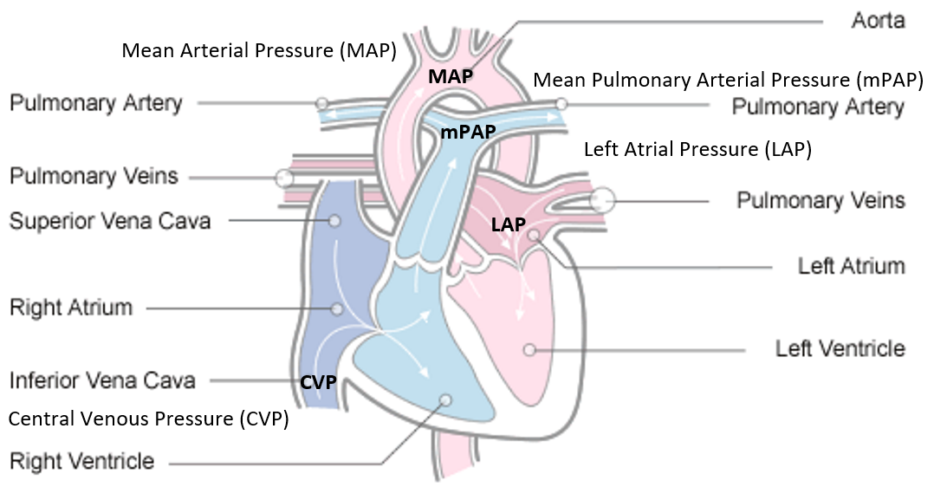

**Figure 1.** Labeled diagram of the heart that supports bi-ventricular circulation [1].

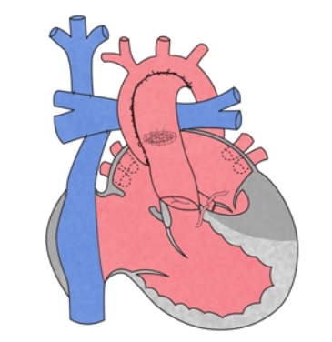

**Figure 2.** Diagram of post-Fontan-operative heart, two vena cava are disconnected from heart and directly connected to the pulmonary artery [2].

The by-pass is achieved using an extracardiac conduit through the Fontan procedure. This surgery is performed to patients at a young age (2~3 years old) born with a single working ventricle [3]. It allows patients to live semi-normally, with certain limitations in physical exertion, such as competitive sports. Over time, the single-ventricle patients experience a form of chronic heart failure denoted as the failing Fontan, characterized by elevated pulmonary vascular resistance (PVR) and subsequent reduction in cardiac output (CO) [4] [5]. The PVR is the total resistance against the blood flow through the pulmonary circulation: from the pulmonary arteries to the left atrium. Similarly, systemic vascular resistance (SVR) is defined as the total resistance against blood flow from the aorta to the vena cava.

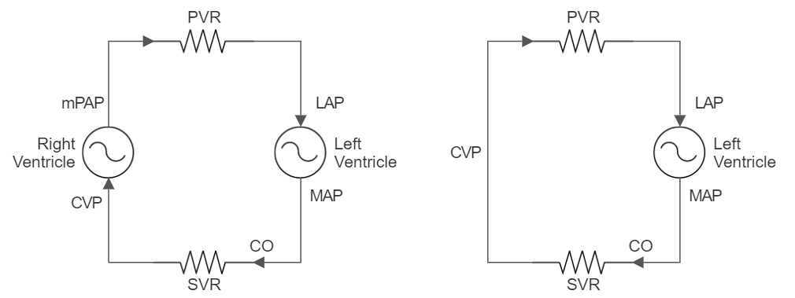

**Figure 3**. Electrical equivalent circuit model of biventricular (Left) and Fontan (Right) circulations. Refer back to Figure 1 for pressure abbreviations. CO is the blood flow pumped by the heart. Venous return, the blood flow returning from periphery back to heart is assumed to be equal to CO since closed loop circulation [6].

*Figure 3* demonstrates the series connection of cardiovascular components in terms of electric circuit analogy: pressure as voltage, blood flow rate as current and vascular resistance as resistors. Through this model, the PVR can be expressed as follows:

$R=\frac{ΔP}{Q} ⇒ PVR=\frac{CVP-LAP}{CO}$**(Eq.1)**

Central venous pressure (CVP) is the pressure in the thoracic vena cava, an important metric in measuring the performance of the right ventricle in normal circulation. CO is the amount of blood flow exiting the heart from the left ventricle into systemic circulation, equal to venous return under steady state. Hemodynamically, venous return is driven by the pulling force from the right ventricle and the pressure gradient between abdominal venous pressure (AVP) of the vena cava located within abdominal cavity, and the CVP of the vena cava located within the thoracic cavity [7]. Normally, the venous return is pulled by the low pressure in the right atrium (~0 mmHg).

In Fontan circulation, since thoracic vena cava does not enter the right atrium, venous return is solely dependent on the pressure gradient between AVP and CVP. The range of CVP for 100% functioning Fontan circulation is about 8~12mmHg [8]. The lacking pressure gradient that drives venous return into lungs depicts the inherent limitation of Fontan circulation. Applying the identical electrical circuit analogy, with some vena cava resistance, R, the CO equal to venous return can be expressed as follows:

$Q=\frac{ΔP}{R} ⇒CO=\frac{AVP-CVP}{R}$**(Eq.2)**

The two mathematical relationships of Fontan physiology, *Eq.1* & *Eq.2*, summarizes into *Eq.3* clearly stating the determinants of PVR, the critical factor to failing Fontan.

$PVR=\frac{CVP-LAP}{CO}; CO=\frac{AVP-CVP}{R}⇒PVR=\frac{CVP-LAP}{AVP-CVP}R$**(Eq.3)**

The progressively rising in PVR can result in several detrimental complications such as hepatic dysfunction, plastic bronchitis, and arrhythmia [5]. Statistically, Fontan patients exhibit a 20-years survival rate of 87.1%, and 48% of survivors suffer from Fontan complications [9]. Many studies support negative pressure ventilators as a method of enhancing the venous return and reducing PVR [10] [11]. This enhancement is achieved by supporting the respiratory pump effect, which involves changes in CVP and AVP augmenting the pressure gradient that drives the venous return.

During spontaneous breathing, normal intrathoracic pressure (ITP) is negative: -3.68mmHg at exhalation and -5.88mmHg at inhalation [12]. Below the diaphragm, normal intra-abdominal pressure (IAP) is positive, with a range of 0 ~ 5mmHg [13]. The pressure of each region compresses the veins within, naturally developing a pressure gradient that drives venous return from the abdominal vena cava towards the thoracic vena cava: ITP and IAP respectively correlates to CVP and AVP. This driving pressure gradient is augmented during inhalation by the respiratory pump effect depicted in *Figure 4*.

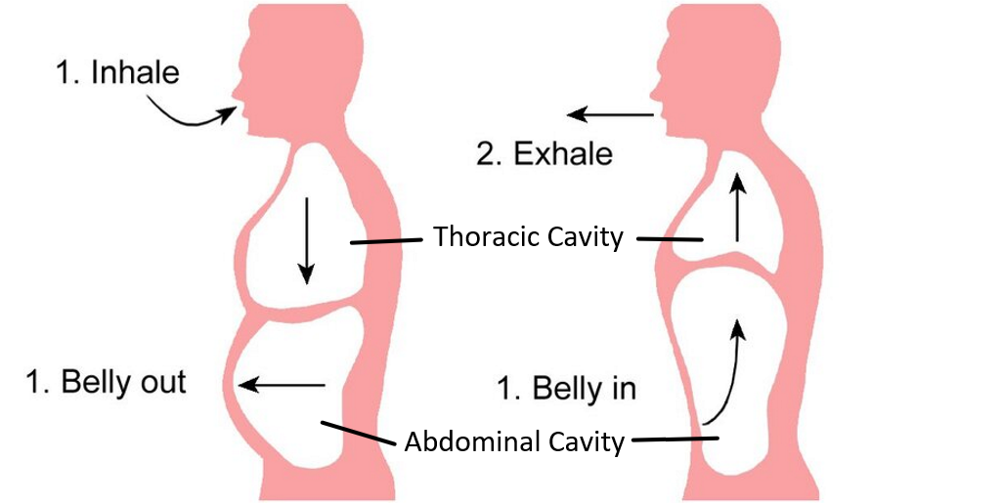

**Figure 4**. Respiratory pump: the expansion and contraction of lungs explained by the motion of diaphragm resulting in pressures in thoracic and abdominal cavities [14] [15].

Inhalation moves the diaphragm down, increasing thoracic volume and decreasing abdominal volume. Since pressure and volume have an inverse relationship, inhalation results in decreased ITP and increased IAP, thereby augmented pressure gradient driving blood from abdominal to thoracic cavity. In the context of *Eq.3*, inhalation decreases CVP and increases AVP which improves CO and lowers PVR.

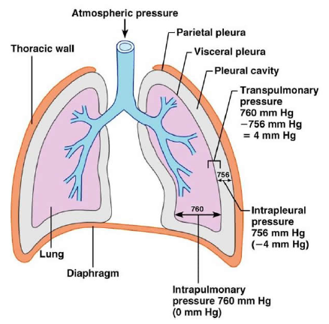

**Figure 5**. Respiratory structures and their pressures, inside brackets are the gauge pressures [16].

The structures of the respiratory system and their pressures are depicted in *Figure 5*. The thoracic space contains organs, namely the heart and lungs [17]. Lung tissues are naturally elastic, thus it will try to collapse without the surrounding negative intrapleural pressure (Ppl) pulling them in tension. Similarly, the elastic recoil pressure exerted by lung tissues are countered during lung expansion by the positive transpulmonary pressure (PL) [18]. The intrapulmonary pressure is the pressure exerted by atmospheric pressure within the alveolies (Palv). The three pressures can be mathematically related as follows:

$P_{L}=P_{alv}-P_{pl}$**(Eq.4)**

The subatmospheric Ppl surrounding lungs are also exerted on organs located between the two lungs: the heart, the superior vena cava and the thoracic aorta. This relates Ppl with the blood pressure. For example, when the vena cava is surrounded by more negative pressure from decreased Ppl, the blood pressure within, CVP, would decrease.

Relating Ppl to the chest wall motion during respiration, the pressure exerted by the muscles to expand and contract the thoracic cavity is denoted as trans-chest wall pressure (Pcw). It is the difference between the pressure inside and outside the thoracic wall. Where inside is Ppl and outside is the pressure on the thoracic body surface (the sum of atmospheric pressure Patm and external pressure Pexternal). In gauge pressure, Patm is considered 0, defining Ppl as *Eq.5*.

$P_{cw}=P_{pl}-\left(P_{atm}{+P}_{external}\right)$

$P_{pl}=P_{cw}+P_{external}$**(Eq.5)**

Negative pressure ventilation (NPV) supports chest wall motion by exerting negative pressure on the thoracic body surface during inhalation. The negative Pexternal induces more negative Ppl for an equal amount of work done by the muscles (Pcw). As mentioned above, decreased Ppl would reduce CVP which in the context of Fontan improve venous return (CO) and thereby reduce PVR.

This augmentation in venous pressure would be better achieved through biphasic ventilation. It can equally reduce CVP as the NPV during the negative pressure phase (inhalation) while also increasing AVP during its positive pressure phase (exhalation). Biphasic ventilation augments both ends of the pressure gradient driving the venous return, thus better improving the CO and reducing PVR. The results of study conducted by our client supports the aforementioned assumption, that BPV better augments venous return compared to NPV for Fontan population [10].

## 1.2 Problem Statement

Patients who have undergone the Fontan procedure have single-chamber circulation and only have passive pulmonary flow without another pumping chamber. This in turn results in a low stroke volume, as the heart pumps a reduced quantity of blood across the pulmonary vascular bed. In order to deliver blood to the pumping chamber, high venous pressure is required to overcome PVR [19]. The chronic inability of the single ventricle to increase stroke volume whenever there is an increase in demand results in symptoms of systemic venous congestion and exercise intolerance over time [5].

While there is no direct treatment for Fontan failure, studies have shown that improving respiration significantly promotes systemic venous return [10]. For Fontan patients, CO is dependent on passive pulmonary blood flow (PBF) and is sensitive to changes in intrathoracic pressure and PVR. In general, and as shown in *Eq. 1*, lower pressure or low PVR increases CO, while higher pressure or high PVR causes decreased CO [20]. There are many studies that investigate the effect of respiration on circulatory performance, as the heart and lungs work together to supply oxygen to the body and maintain healthy function. However, it is important to consider that some interventions that improve one system may be detrimental to another. Positive-pressure ventilation (PPV) is a method of invasive ventilation that facilitates the flow of oxygen to the lungs through intubation. The increase in intrathoracic pressure and PVR causes reduced PBF and CO, which is undesirable and even harmful for people with Fontan circulation [21]. On the other hand, negative-pressure ventilation (NPV), such as the iron lung [22], is a non-invasive process that reduces intrathoracic pressure in order to encourage the lungs and chest to expand and draw oxygen in. Based on a study on the effect of NPV on Fontan circulation, this increased PBF by 8% while CO improved slightly [10]. Another novel ventilation method is the biphasic negative ventilation (BPV) [23]. The shell is non-invasive and manipulates the inspiratory and expiratory phases of respiration by creating cycles of negative and positive pressure around the chest [24]. It was found that with biphasic ventilation, PBF increased by 25% and CO by 16% [10]. There are also other ways to manage the symptoms of Fontan failure and improve CO, such as resistance muscle training [25], nutrition management [26], and medication [27].

## 

The client has requested the design of a wearable and portable non-invasive external ventilation (NIEV) device called the “Fontan jacket.” Although commercially-available NIEV, such as NPV and BPV, have been shown to increase PBF and CO in people with Fontan circulation by facilitating thoracic expansion and decreasing PVR during respiration, these devices are inconvenient and are only designed for hospital use [28]. The scope of the design entails developing a prototype of the Fontan jacket, comprising the pressure circuit and the control system. If successful, the design will address a gap in the market for a NIEV that reduces CVP and improves CO through the manipulation of extrathoracic pressure, which can be worn and used for daily activities by users with mild to medium Fontan failure.

## 1.3 Scope

The purpose of the final design is to reduce PVR in patients with some degree of failure with their Fontan circulation. From *Eq.3*, PVR is defined as a function of CVP, AVP, LAP and R, of which the CVP and AVP are identified to be mechanically manipulable from the effects of non-invasive ventilators. This project involves designing a portable NIEV device which will be composed of three main components; a mechanism to manipulate pressure, a system that controls the mechanism and a jacket that encloses the two components to one wearable device.

The goal of this project is to create an initial design that performs under a limited set of circumstances that can be later expanded upon. Given the limited time frame and expertise of the team, we anticipate there will be aspects of the design that cannot be verified. In particular, verification that requires medical equipment and experts or testing the device with patients will not be feasible.

Considering the project limitations we have also limited the objectives for prototyping such that it operates under limited conditions. A full proposed design for the portable Fontan Jacket will be outlined, however the prototyping of the proposed design will only include a subsystem of the full design. Due to the reduced scope of the prototype a only a subset of the design requirements will be considered based on whether or not they apply to the subsystem.

## 1.4 Report Outline

This report described the entire design process from defining the design space to building a proof of concept prototype for a wearable and portable NIEV device called “Fontan jacket”. Firstly, the design requirements are outlined which were used to guide the design process. Using the design requirements existing and novel solutions were brainstormed. From these designs a proposed design that best meets the client need and design requirements was chosen. The selected design is then defined in detail with parts selection, prototyping plan, risk management strategies, and verification and validation of the design. The prototyping process including parts used, assembly process and any modifications is detailed. The measures of success based on the original objectives are used to ultimately determine whether or not the design is successful. Finally, future steps to expand on the preliminary prototype are outlined.

# 2.0 Design Requirements

The design of a novel portable NIEV device aims to improve Fontan circulation. It should perform the main functions of a NIEV device, while achieving portability and adhering to physiological, technological, and regulatory limitations. This section defines the design specifications that need to be met by the proposed design.

## 2.1 Functions

The portable NIEV or Fontan jacket should help people with mild to moderate Fontan failure by decreasing the overall CVP. This can be achieved by manipulating the extrathoracic pressure and thereby the intrathoracic pressure, mimicking the effect of diaphragm contraction and expansion when breathing. The main function of the device is to induce negative extrathoracic pressure, which will encourage expansion of the chest wall. This can assist patient respiration, and the induced pressure will facilitate pulmonary blood flow with reduced Fontan pressure (CVP) and improve circulation.

**Table 2.1:** Primary and secondary functions of the design

| **Primary Function** | Manipulate pressure around thoracic area |
| --- | --- |
| **Secondary Functions** | Take input based on:   1. Prompting user to input desired setting 2. Measuring and match natural breathing rate of user   Use input to adjust pressure change & rate based on exertion or demand |
| Push/pump air out of system to decrease thoracic pressure |
| Push/pump air into system to increase thoracic pressure |

In *Table 2.1*, the first secondary function can be broken down into two separate control modes. First is a Full-Control Mode where all the user’s breaths are forced and the frequency is set by the ventilator. Second is an Assist-Control Mode where the user’s spontaneous breaths triggers the ventilator to generate negative pressure to assist breathing [29]. During Assist-Control Mode, methods of sensing the user’s breath include measuring negative pressure using a pressure transducer catheter, measuring flow using a thermistor, or using a digital pressure sensor.

## 2.2 Objectives

The design of a wearable NIEV will be primarily driven by its portability and effectiveness. Although Hayek RTX is not currently used to support breathing for Fontan patients, it may be utilized as a benchmark for a biphasic NPV ventilator that will define the baseline and objective goals of the proposed design. The following detailed objectives are ranked in order of importance as determined by client request (See ***Appendix A***).

**Table 2.2:** Objective A: Portability of the Device

| **Objective A: Portability of the Device** | | |
| --- | --- | --- |
| **Sub-Objectives** | **Metric** | **Objective Goal** |
| Compact/Lightweight | Dimension and weight of the design | Dimension: 55.9 × 35.6 × 22.9 cm, standard size of an adult backpack  Weight: 5 kg, less than 10% of total body weight [30] |
| User Mobility Level | Ratio of exercise metabolic rate through Metabolic Equivalent of Task (MET) | Achieve support for light physical activity of 3 MET or lower, such as sitting, strolling at pace 1-2 mph and washing dishes [28] [31] |
| Battery Life | Number of hours usage on full charge | At least 8 hours of continuous use [32] |

**Table 2.3:** Objective B: Effectiveness

| **Objective B: Effectiveness** | | |
| --- | --- | --- |
| **Sub-Objectives** | **Metric** | **Objective Goal** |
| Level of CVP | CVP (Fontan pressure) measured through imaging [mmHg]  For ideal circulation:   * Normal 1~6mmHg [33] * Ideal Fontan 8 ~12mmHg [34] | Able to decrease Fontan Pressure by 2 mmHg [35] |
| Level of CO | Indexed measurements taken from cardiovascular magnetic resonance (CMR) imaging [L/min/m2] [36]  Normal: 5-6 L/min at rest, up to 35 L/min during exercise [37]  Healthy Fontan Cardiac Index: 2.6-4.2 L/min/m2 [38] | Able to increase CO index by 0.4L/min/m2 [10] |
| Inspiratory to Expiratory (I:E) Ratio | Unitless ratio of inspiratory time to expiratory time.  I:E ratio range for spontaneous breathing ranges 1:3 ~ 1:5 [39] | Able to support I:E ratio range of 1:6 ~ 6:1 [23] |
| Min/Max Operating Pressure Range | Extrathoracic pressure induced by the medical device [cmH2O]  Hayek: Maximum pressure range is -/+50cmH2O [23] | Able to control pressure parameter from -/+60cmH2O for expected operating range of -/+35cmH2O [10] |

### 

**Table 2.4:** Objective C: User Experience

| **Objective C: User Experience** | | |
| --- | --- | --- |
| **Sub-Objectives** | **Metric** | **Objective Goal** |
| Easy to operate | Number of steps taken to operate the device which includes assembly, setting up, and use of design. | Achieve complete operation within six or fewer steps [23] |
| Easy to use | Information: User is informed of current and desired state with feedback Y/N  Accessibility: User is able to wear and use the device independently Y/N | Keep the user informed of current and desired state with feedback  User is able to wear and use independently |
| Comfortability | 5-point Likert Psychometric Scale or Customer Satisfaction Score (CSAT) analysis of comfortability with users through surveys (See ***Appendix B***)  Minimize amount of vibrations felt by user [40] | At least 80% of positive user feedback [41] |
| Size Range | Number or range of sizes that is supported by the device  Hayek: Achieve support for cardiopulmonary function with biphasic and negative pressure in patients from < 1.8 to 180 kg [23] | One size for minimum viable product (average 20-y.o male):  Height: 5’8-5’11  Weight: 197.9lbs  Waist cir.: 40” [42]  Avg. chest cir.: 38”-40” [43] |

**Table 2.5:** Objective D: Durability

| **Objective D: Durability** | | |
| --- | --- | --- |
| **Sub-Objectives** | **Metric** | **Objective Goal** |
| Maintenance Requirement | The number of months the device can withstand before needing maintenance | Every six months or 2000 hours of use [44] |
| Life of Device | Expected length of device life in years or Expected Service Life (ESL) | Minimum of seven years ESL [45] [46] [47] [48] |

**Table 2.6:** Objective E: Cost of the Device

| **Objective E: Cost of the Device** | | |
| --- | --- | --- |
| **Sub-Objectives** | **Metric** | **Objective Goal** |
| Prototyping Cost | Cost for prototyping (C$) | Have a maximum prototyping budget of C$500 |
| Operation Cost | Cost for operating the device [C$/month]  Median healthcare cost for non-invasive ventilation: C$3925/month [49]  Eliminating non-device related  costs: C$68/month [49] | Have operation cost less than C$70/month |
| Manufacturing Cost | Total cost for manufacturing the device [C$]  Cost ranges of ventilator based on exchange rate of US$1 = C$1.3268: C$6,634~66,340 [50]  Cost ranges for portable ventilator: C$6,634~19,902 [51] | Have manufacturing cost lower than C$20,000 [52] |

## 2.3 Constraints

The design of a portable NIEV must comply with the legal requirements for a medical device. In addition to the standards named, the key requirements which may be relevant to the proposed design are also included and summarized in *Table 2.7*.

**Table 2.7:** Constraints of the Design

| **Constraints** | **Description** | **Requirements** |
| --- | --- | --- |
| Health Canada Medical Device Regulations (CMDR) [SOR/98-282] | The design must follow Class II Medical Device (MD) requirements according to CMDR with the declaration of device safety and effectiveness in order to be sold in the Canadian Market [53]. | **Safety:** Identified and minimized risks, or protection from risk implemented.  **Durability:** Parts and performance should not deteriorate under normal use to a degree that affects the health and safety of user during projected useful life.  **Tolerance:** Measuring functions should perform within appropriate tolerance limits |
| Good Clinical Practices (GCP) [ISO 14155] | The process of designing, conducting, recording, and reporting clinical investigations for the performance of MD which is carried out in human subjects must follow the guidelines of GCP [54] | **Vulnerability:** Clinical investigations shall not be conducted in vulnerable populations unless they cannot be carried out in non-vulnerable populations.  **Risk:** Risk analysis shall be performed for any potential adverse events including residual risk. |
| Quality and Performance of MD  [ISO 13485, ISO 60601] | To ensure product safety, efficacy and quality, the design must satisfy the product requirement and quality management system under ISO 13485 and ISO 60601, which also includes general safety requirements for all medical electrical systems and equipments [55] [56] | **Calibration:** Measuring equipment shall be calibrated and verified against measurement standards, and should have indication of calibration status.  **Quality:** Quality management shall be implemented, and criteria and methods needed to ensure effective operation and control. |
| Lung Ventilators for Medical Use  [ISO 10651] | The design must comply with all basic safety and essential performance requirements for life-supporting equipment ventilators [57] | **Materials:** All gas conducting parts shall be constructed from materials selected to take into account the chemical and physical properties of the substances.  **Surfaces:** Rough surfaces, sharp corners, and open ends of tubes that can cause injury shall be avoided or covered.  **Switches/Controls:** Non-continuous controls shall prevent remaining in intermediate position (e.g. on-off), and protect against accidental alterations. |

## 2.4 Service Environment

The service environment describes the environment that the design will operate in and includes elements that must be taken into consideration but cannot be manipulated. The proposed design will be used and operated daily by people with Fontan circulation. Thus, it is expected to be operated as they go about their regular activities and without the supervision of a medical professional.

**Physical Environment**

The physical environment comprises the operating conditions of the ventilator. The values are based in Toronto, ON, Canada.

**Table 2.8:** Physical environment

| **Factor** | **Description** | **Range** | **Average** |
| --- | --- | --- | --- |
| Atmospheric pressure | The pressure of the air outside the body | 98.53 to 103.62 kPa (1004.7 to 1056.6 cmH2O) | 101.63 kPa [58] (1036.3 cmH2O) |
| Relative humidity | The ratio of highest absolute humidity (the amount of water vapor in the air in g/m3) against the current absolute humidity based on air temperature. | 16% to 100% [59] | Morning - 81%  Afternoon - 61%  [60] |
| Temperature | The design will be worn outdoors and indoors during all seasons. | -17 to 30°C | Outdoors: -8 to 25°C [61]  Room temperature: 25°C [62] |
| Skin temperature | The design may be operating in contact with the user's body so body temperature is considered. | 33.5 to 36.9°C [63] | 33°C [64] |
| Clothing | The design must be portable, thus the clothes the user is wearing must be considered. | Minimum: worn over a light shirt  Maximum: worn over a sweater and under a winter jacket | Worn over one layer of clothing (ex. A cotton shirt) |

**Table 2.9:** Level of activity during use

| **Level of activity during use** | **Average heart rate** | **Average respiratory rate** |
| --- | --- | --- |
| Laying down | 40-50 bpm (sleeping) | 15-16 times per minute (sleeping) [65] |
| Resting (Standing or sitting) | 60-100 bpm | 12-20 breaths per minute [66] |
| Walking (daily activities) | 60-100 bpm | 20 breaths per minute [67] |
| Light exercise | Light exercise is considered less than 64% of the max heart rate i.e. less than 128 bpm [68] | 25-30 breaths per minute [69] |

*values are based on an average 20-year-old without Fontan circulation

**Demographics**

The design will be used by people with Fontan circulation with some degree of Fontan failure (low to moderate, but not severe) [28]. The user experience and human factors will be considered in the design process (See *Appendix C*). This consideration of human factors in the design process leads to safer design, better user experience, easier management, and reduced risk [70].

**Table 2.10:** Demographics of expected users of the device

| **Factor** | **Description** |
| --- | --- |
| Condition | Low to moderate Fontan failure |
| Age | The average age is 20, however, Fontan failure can begin ranging from age 10 - 40 [71] |
| Physical ability | Exercise intolerance, users may be able to tolerate very light exercise [71] |
| Size | Varying based on height, weight, and sex [72]   * Average male (age 20): 5’8-5’11, 197.9lbs, chest 38-40in, waist size 40in [42] [43] * Average female (age 20): 163.9cm, 68.7kg, size medium shirt measurements: chest 36-37”, waist 27-28” [73] |

## 

**Materials**

The materials used in the design will be impacted by the fact that NIEV devices work by manipulating pressure around the thoracic area. Thus, the material used will be informed by its ability to withstand negative pressure [74]. *Table 2.11* includes factors that should be considered when choosing materials for the design.

***Table 2.11:*** *Materials*

|  | **Factor** | **Description** |
| --- | --- | --- |
| Enclosure | Tensile strength (rigidity, toughness) | The maximum stress a material can withstand before breaking. |
| Elasticity | Ability of a material to return to its original shape and size. |
| Seal | Airtightness | The material’s ability to prevent the entrance or escape of air or gas. |
| Biocompatibility | The level of safety of the material for human skin. |

## 2.5 Stakeholders

The stakeholders of this design project are based on the people or organizations that are directly and indirectly associated with the project and are affected by the project development. The stakeholders' interests are categorized into three sections: economic, social, and legal. See***Appendix D*** for the full list of stakeholder interests.

# 3.0 Existing Solutions

There are several NIEV devices available in the market that are currently utilized to support respiration for various reasons. These existing solutions are analyzed to see how successful they are in their intended function, as well as how they can be applied for helping Fontan patients. Additionally, the analysis explores areas where they can be improved in order to meet the design requirements for the Fontan jacket.

## 3.1 Positive Pressure Ventilation (PPV)

Positive-pressure ventilation (PPV) is a method of ventilation that facilitates the flow of oxygen to the lungs through positive pressure, either invasively through intubation or non-invasively with a mask.

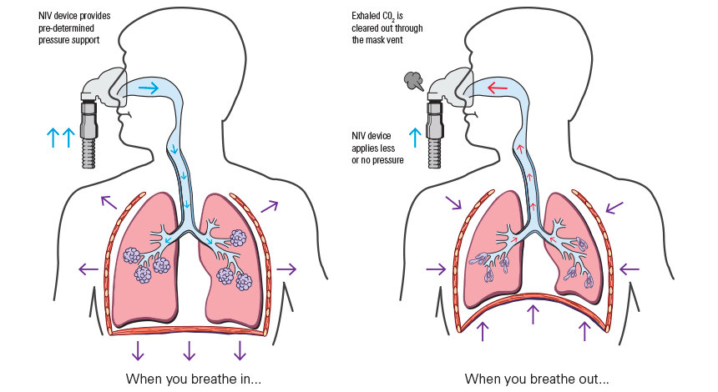

**Figure 3.1**. Breathing mechanism using non-invasive positive pressure ventilation [75].

As gas is delivered to the lungs, the intra-alveolar pressure increases until the set volume of gas is delivered (volume-regulated) or there is a change in flow or pressure (pressure-regulated). This signals the end of inspiration, and expiration happens passively to release built-up pressure. The pressure gradient between the patient and the ventilator can be described as

$P_{aw}-P_{muscle}=F⋅R+V/C+PEEP_{T}$

where Paw is the airway pressure, Pmuscle is the pressure generated by the patient, F is inspiratory flow, R is airway resistance, V is tidal volume, C is respiratory system compliance, and PEEPT is total positive end-expiratory pressure [76]. While it can be effective for assisting patients with breathing-related problems, the increase in intrathoracic pressure and PVR causes reduced PBF and CO. This is undesirable and even harmful for people with Fontan circulation [5]. *For this reason, the proposed design will not include any form of PPV where gas is directly forced into the central airways.*

## 3.2 Negative Pressure Ventilation (NPV)

Negative pressure ventilation (NPV) is a type of non-invasive ventilation in which the surface of the thorax is exposed to sub-atmospheric pressure, i.e. negative pressure. The reduced intrathoracic pressure causes the lungs and chest to expand, creating a pressure gradient that draws oxygen in. When the thoracic pressure increases to atmospheric pressure or greater, expiration occurs passively from the elastic recoil of the chest wall [77].

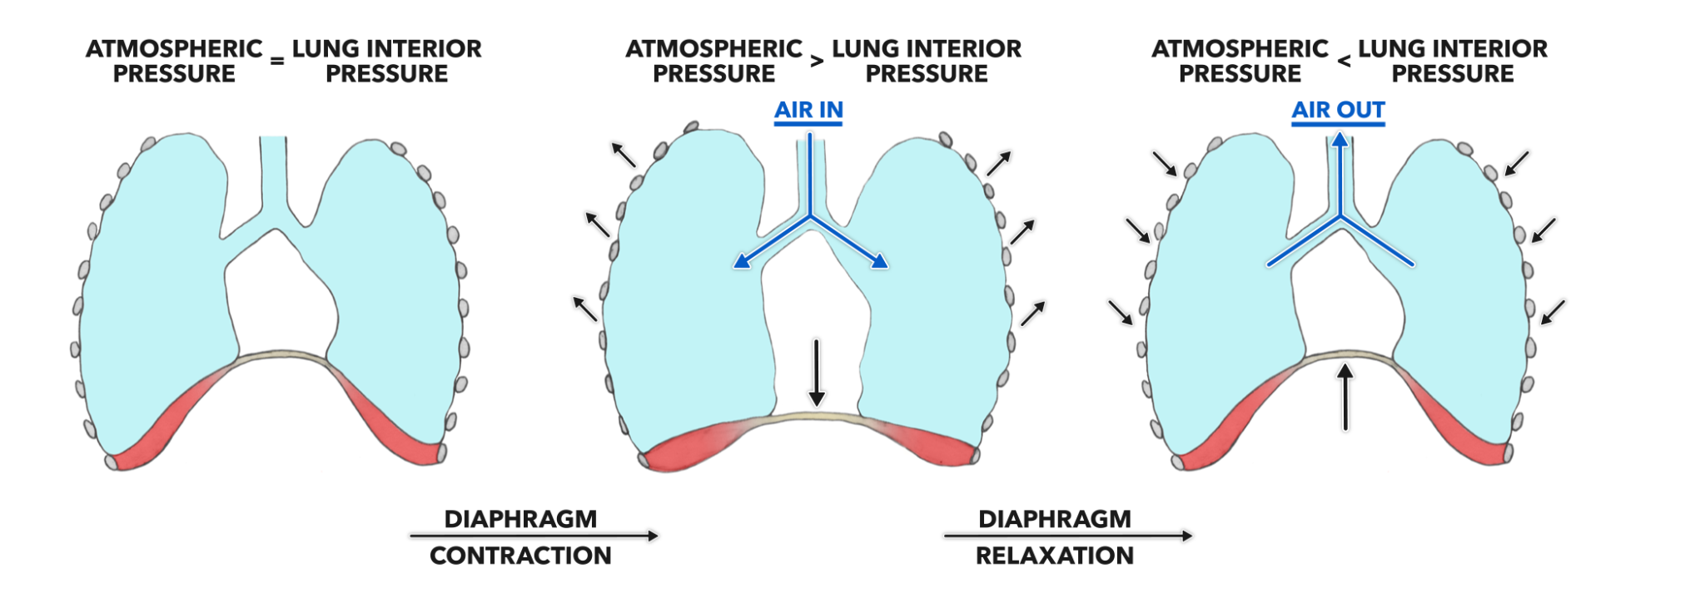

**Figure 3.2.** Breathing mechanism with negative pressure ventilation [78].

The iron lung or tank ventilator, one of the earliest and most common purely-NPV devices, is typically a large rigid horizontal cylinder or chamber enclosing the patient’s chest and abdomen. Most models of the iron lung were designed such that the patient’s entire body is enclosed in the tank, with only the head exposed.

***Table 3.1:*** *Iron Lung Objective Analysis*

| **Objective** | **Description** | **Meets Obj?** |
| --- | --- | --- |
| **A: Portability** | The iron lung is large and heavy. The Emerson tank was 290-337 kg, and even the more lightweight Porta-Lung was 45.5 kg. The user must lie down inside the tank with very little mobility. | *NO* |
| **B: Effectiveness** | Iron lung allows the setting of pressure level, respiratory rate, and I:E ratio. Based on a study on the effect of NPV on Fontan circulation, this increased PBF by 8% while CO improved slightly [10]. | *YES* |
| **C: User Experience** | Patient is unable to do anything or make significant movements while inside the iron lung. Vibrations can be felt underneath. Overall patient comfort was lacking [40]. | *NO* |
| **D: Durability** | The belts need to be replaced every few weeks, the cot every six months, and the motor every 12 years or so [84]. Cheaper parts wear quickly, but the device can be maintained by replacing them. | *YES* |
| **E: Cost of the Device** | The Porta-Lung cost £5K in 1991 [81], which is equivalent to £10.4K in 2022, or CA$16.3K. This is less than the goal of CA$20,000. | *YES* |

## 3.3 Cuirass Ventilator

A cuirass, sometimes called a chest shell, is a shell-like unit that creates a negative pressure around the chest area through use of fitted casing and sealants around the shell to avoid air leaks. A cuirass ventilator is an improvement or adaptation of the iron lung but is compacted into a smaller, more portable design. Currently, there are two common types of technology that are available in the market for this type of ventilation, Negative Pressure Cuirass Ventilation (NPCV) and Biphasic Cuirass Ventilation (BCV) [82].

NPCV devices work through a vacuum pump mechanism, which creates a negative pressure around the extrathoracic area and causes the patient’s chest wall to expand. The expansion of the chest wall causes a decrease in intrapulmonary pressure, which leads to ambient air flowing into the lungs. The expiratory phase of respiration is done by relying on the passive recoil of the patient’s chest through the removal of the lowered pressure in the chest shell, providing a breath out. BCV devices work in a similar method; however, the device works by applying a positive pressure around the thorax, to induce expiration [85].

**Hayek RTX**

Hayek RTX is a modified cuirass negative pressure ventilation, in which it uses BCV for its mode of cuirass ventilation which allows for user control over the I:E ratio.

***Table 3.2:*** *Hayek RTX Objective Analysis*

| **Objective** | **Description** | **Meets Obj?** |
| --- | --- | --- |
| **A: Portability** | The cuirass is bulky, with no battery or portable option and the ventilator system weighs 8.70 kg, exceeding the maximum weight goal by 3.7 kg [86]. | *NO* |
| **B: Effectiveness** | Hayek RTX allows user control over the I:E ratio, and proved to be effective at increasing the Level of CO in Fontan patients [10]. | *YES* |
| **C: User Experience** | Device is designed to be easy to use by users at home, covers a big range of sizes, and the soft foam seal provides greater comfortability relative to other forms of ventilation [23]. | *YES* |
| **D: Durability** | The device, including any accessories, consumables, and spare parts, is designed to operate well over 6 months. A typical biphasic ventilator lasts for almost 10 years before showing any sign of loss in performance [44] [95]. | *YES* |
| **E: Cost of the Device** | Hayek’s cost is C$20K, which fulfills the minimum objective goal [52]. | *YES* |

**Hayek MRTX**

Hayek MRTX is the latest version in Hayek’s RTX ventilator series, designed to be a more portable system to be used during emergency situations. The MRTX also operates using BCV, with the key difference being the overall dimensions and weight of the ventilator module itself.

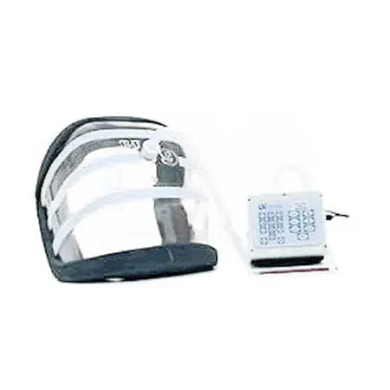

**Figure 3.3.** Hayek MRTX

While the Hayek MRTX manages to meet some of the objective goals for portability, such as having an overall weight of less than 5 kg, it falls short on battery life, only being able to offer up to 4 hours of continuous use as opposed to the goal of having 8 hours of battery life. Apart from that, the design of the ventilator itself, while being portable and compact as can be seen from *Figure 3.6*, fails to provide user mobility. There are no physical features of the product design that allow users to carry it and perform daily tasks conveniently. Similar to the previous design from Hayek, MRTX does not meet the objective of being a portable device based on the objective goals of the design.

**Breathe Global Venti**

While still in its early stage of production and development since its founding in 2020, Breathe Global has better portability compared to Hayek RTX’s design, allowing users to do daily tasks and activities with more mobility and comfort. *Table 3.3* analyzes how well the device meets each objective of the design requirements.

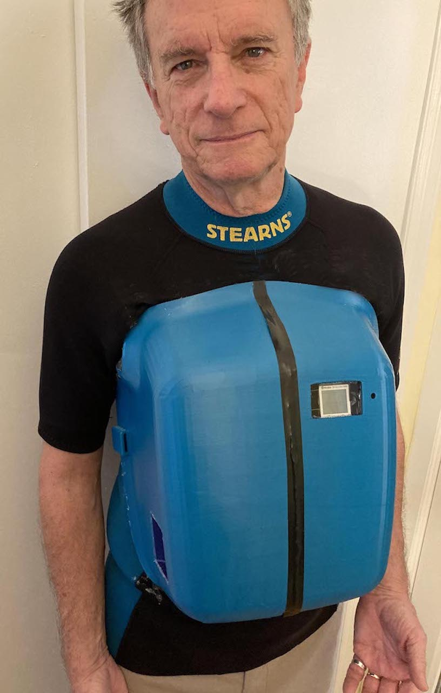

**Figure 3.4.** The device worn by Steve Bull, creator of Venti

***Table 3.3:*** *Breathe Global Venti Objective Analysis*

| **Objective** | **Description** | **Meets Obj?** |
| --- | --- | --- |
| **A: Portability** | Device is lightweight, compact, and allows a certain degree of portability for users. However, the cuirass is still bulky and can be improved, to extend the user’s range of motion. | *YES* |
| **B: Effectiveness** | NPV is proven to be less effective compared to BPV. This device is unable to meet the level of CO and CVP objective goals [10] [35]. | *NO* |
| **C: User Experience** | One of Venti's great features is that it is very easy to operate, requiring very little training for first-time users [93]. | *YES* |
| **D: Durability** | The design is composed of simple hard shell and pressure pumps without easily-wearing parts. | *YES* |
| **E: Cost of the Device** | The device does not use any consumables, and cost can be assumed to be equivalent or less than RTX due to similar components being the cuirass, pumps, and control system. | *YES* |

Like Hayek RTX, the Venti exceptionally meets the required secondary objective goals. However, it fails to achieve a vital component of the design’s main objective of effectiveness. The proposed design may incorporate the design idea for portability of the design from Venti, while also improving the effectiveness of the device to augment Fontan circulation.

## 3.4 Other Solutions

There are several other technologies and solutions that may be relevant for the purpose of the design as either a wearable or portable ventilation mechanism, which are unique to the ones mentioned in previous sections. These include the Intermittent Abdominal Pressure Ventilation (IAPV) and High-Frequency Chest Wall Oscillation (HFCWO). More details on the benchmark of these solutions can be found in *Appendix E*.

# 4.0 Alternative Designs

Creating a closed system requires sealing between the jacket and the patient, along the perimeter of the region that the design needs to manipulate pressure. This is predetermined from images of users wearing the existing non-invasive ventilators, front torso generally from the bottom of the neck to the bottom of the abdominal area. This region is further specified through body anatomy (*Figure 4.1*), by identifying parts of the body related to breathing: from below subclavius (top of pectorals) to below armpit and down until above asis. This captures most of the torso area where the muscles are involved in breathing while not impeding the motion of arms and legs.

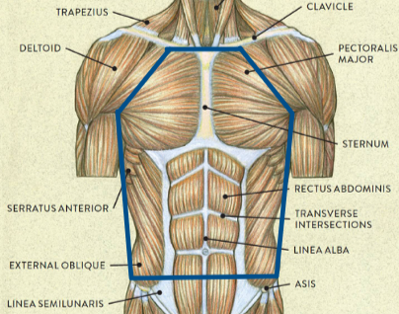

**Figure 4.1.** Outline of the critical chest and abdomen area [144]

The Fontan jacket design aims to reduce CVP and increase CO for people with Fontan circulation by supporting their respiratory function. While existing ventilation solutions exist, there is a gap in a solution that is effective, portable, comfortable and meets the other requirements of the design. The team explored various alternative designs that are outlined in the following sections, and a final proposed design will be chosen from objective analyses and other considerations, such as safety and risks.

## 4.1 Candidate 1: Artificial Rib Cage

Artificial Rib Cage by its name mimics the motion of the rib cage to induce the alternating biphasic pressure on the exterior of chest walls. The wearable structure will be in the form of a vest, where only the front side up to the subclavius will be covered by the artificial rib cage. The design incorporates a change in volume to manipulate extrathoracic pressure, which requires a closed system of the extrathoracic area where no mass transfer is allowed (no pressure leakage). The volume of the closed system is referred to as control volume. In order to seal this perimeter, the jacket has to preferably open on the perimeter, unlike typical jackets that open in the middle. Two possible candidates for jacket designs are shown in *Figure 4.2*. Velcro fixation is preferred over zippers or belts because 1) the elastic fabric of the vest must be pulled tight for sealing and 2) velcro takes less effort to operate.

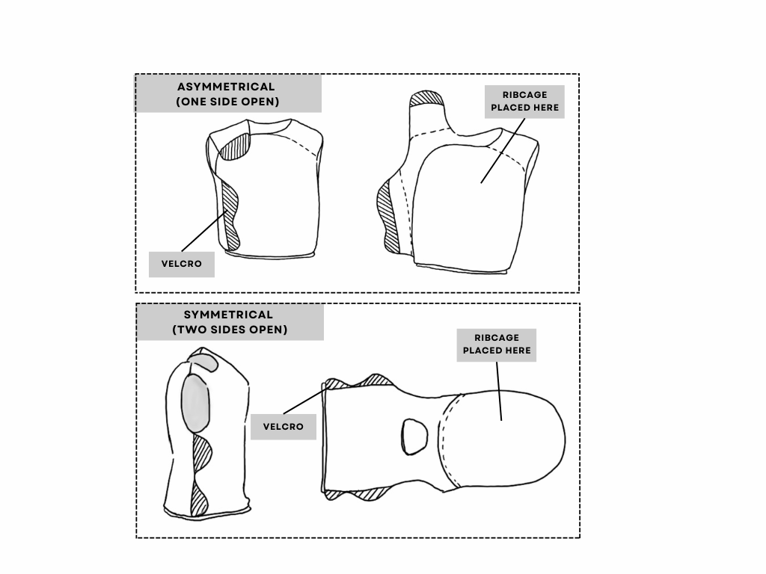

**Figure 4.2.** Jacket vest asymmetrical (top) and symmetrical (bottom) design

The ribs will be composed of lightweight hollow tubes with no sharp edges to prevent injury to patients during the operation. They will be connected to each other vertically by elastic material which will mimic the motion of intercostal muscles that allows thoracic expansion and contraction. At the center of the vest lies a central plate connecting all the ribs, mimicking the breastbone (sternum) in the human body. The whole will be enclosed within an elastic fabric, which will compose the vest for tightening the seal and adjusting for volume change from the motion of the enclosed volume.

The interior of the skeletal structure will be lined with a layer of non-breathable material, thus closed volume, that will inflate (unfold) under expansion and collapse (fold) under contraction of the rib cage. There is an inherent limitation of durability for this design. Any mechanism used for expansion would have to oppose the elastic recoil force of the whole system coming from every elastic connection between skeletal parts (ribs and sternum) and from the elastic fabric enclosure. This motion can be achieved by using servo motors to push away the Sternum with Ribs to expand the volume and pull them in to contract the volume as depicted in *Figure 4.3*. Further details of the candidate mechanisms of how to actualize the artificial rib cage motions are explained under *Appendix G.1*. In general this design’s breathing cycle is expected to induce fatigue in the mobile parts, and eventually result in early failure of parts.

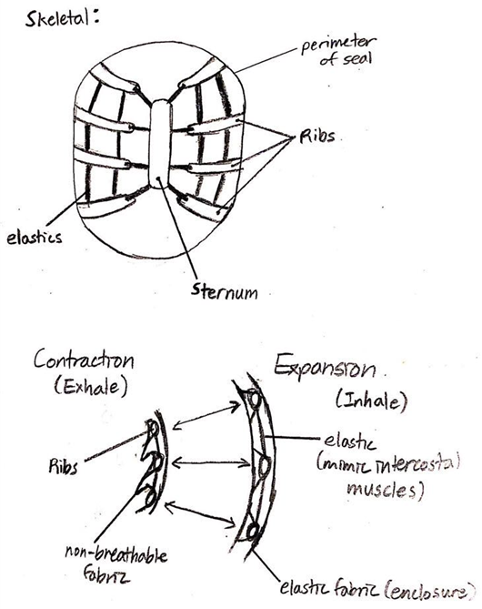

**Figure 4.3.** Artificial Rib Cage mechanism of motion

The artificial rib cage will be worn at a neutral skeletal position, where the pressure sensor positioned inside the system volume will be used to set the motor's negative and positive pressure of user input. The mathematical principle of this design is the ideal gas law:

$PV=nRT$**(Eq.6)**

The multiple of pressure and volume is constant, for a control volume where no mass can escape. Following is an example calculation of volume change required to induce pressure based on the values applied to BPV on Fontan patients in a study, where the change range of pressure is about -30cmH2O to 10cmH2O [10].

Assuming volume changes from a neutral position, where the pressure is at Patm = 1033.23cmH2O, the desired pressure range is from 97.1% to 100.1% of Patm. This converts to a volume range from neutral (V0) of 103.0% to 99.0%. This sample calculation depicts that it theoretically requires less than 5% of volume change to induce extrathoracic pressure that augments CO. Therefore it would not require pumps to induce the pressure, which removes the heavy and bulky component of ventilators.

***Table 4.1:*** *Artificial Rib Cage Objective Analysis*

| **Objective** | **Description** | **Meets Obj?** |
| --- | --- | --- |
| **A: Portability** | The slightly flexible volume instead of rigid shell volume allows the wearer to bend over. However, this degree of freedom is limited to the flexibility allowed by the rigid skeletal structure. The jacket will not be mounted with heavy and bulky components such as pumps and pipe connections. This removes parts that may hinder motion. | *YES* |
| **B: Effectiveness** | Change in volume of a trapped volume induces a change in the pressure based on ideal gas law. Thus, theoretically, it can induce negative chest wall pressure and further decrease Ppl from *Eq.5*. More negative Ppl is expected to reduce CVP and increase CO. Similarly, theoretically, it can induce positive pressure that would increase AVP and is expected to augment CO. | *YES* |
| **C: User Experience** | The servo motor is expected to induce much less vibration and noise than the pneumatic pumps. This will improve the comfort of the user experience. Operation and usage difficulties are expected to be similar to the existing ventilators. | *YES* |
| **D: Durability** | The motion mechanism needs to overcome the total elastic recoil force: the sum of the contraction forces from the jacket enclosure and the elastic connections between the skeletal parts. Every breath will make a cycle of tension and contraction and induce the parts to undergo fatigue stress, and therefore much faster failure of materials. | *NO* |
| **E: Cost of the Device** | It requires many custom-shaped parts which brings the manufacturing cost higher than building a volume with a shell. | *NO* |

This design theoretically can achieve portability, effectiveness, and user experience objective goals but it greatly lacks durability from the majority of the components allowing motion. Also, there are no existing mechanisms or products that support the effectiveness of this hypothetical concept. Limited to the project timeline, testing the effectiveness of a theoretical concept that severely lacks durability is not considered to be the best choice.

## 4.2 Candidate 2: Electromagnetic Chest Jacket

The electromagnetic chest jacket design is inspired by the conformal vest ventilator (CVV). CVV is a negative pressure ventilator that works by expanding the chest wall, to mimic natural breathing. The vest is made up of multiple tubes fitted tightly around the waist, controlled by a motor to expand and contract the tube. Unlike most NPV devices, which use air to generate negative pressure, the CVV uses motor and elasticity of the tube to create the negative pressure. Similarly, the Electromagnetic Chest Jacket aims to manipulate the transthoracic pressure, Pcw. Since Pcw = Ppl - Pbs, and Ppl is constant, we will manipulate the body surface pressure Pbs.

## 

**Figure 4.4a.** Conformal Vest Ventilator***Figure* 4*.*4b*.*** *Electromagnet Mechanism*

Like CVV, the Electromagnetic Chest Jacket does not use air pressure, but uses elastic, and subsequently only motor forces, to manipulate chest movement. In incorporates a flexible, but non-breathable metallic fabric such as high purity iron sheet. This material will be used to adhere to the body’s surface. Then using a rigid shell, and attaching electromagnets, the magnetic attraction force will assist with chest wall expansion for inspiration.

For exhalation, there is an option for NPV and BPV. NPV means that the electromagnet’s power is cut, to allow for passive exhalation. To induce positive pressure, one can reverse the current flow to flip the polarity of the magnet. The magnetic plate will repel the soft fabric, and thus applying pressure on the chest wall to assist with expiration. Further details regarding the development of this electromagnetic mechanisms, feasibility analysis and are under *Appendix G.2*.

***Table 4.2:*** *Electromagnet Jacket Objective Analysis*

| **Objective** | **Description** | **Meets Obj?** |
| --- | --- | --- |
| **A: Portability** | The electromagnetic jacket is light and compact. The electromagnet uses little power, thus using a small battery, thus it would be quite light. The electromagnets are also light and small in size. | *YES* |
| **B: Effectiveness** | Given the calculation from above, the design is able to achieve the targeted force effectively. This means that the level of CVP and CO target will be reached. It might not be too effective as the magnetic force is not evenly distributed, thus may not reach the CVP and CO target. | *YES* |
| **C: User Experience** | Patient is able to have a significant range of motion and high degree of movements because the Cuirass volume will decrease significantly - due to the magnetic nature of the design. | *YES* |
| **D: Durability** | The high purity iron sheet easily rusts and requires constant replacement, so it’s not durable. | *NO* |
| **E: Cost of the Device** | Electromagnets and batteries are cheap and easy to obtain. There are many available specifications to achieve the desired level easily. | *YES* |

## 

Although the electromagnetic jacket is able to produce the needed force to reach the target CO and CVP, it does not meet the minimum health constraint. We will not move forward with this device due to its inconclusive health impact on long-term low exposure electromagnetic fields. Furthermore, it is possible that it may not pass the EMC rating.

## 4.3 Candidate 3: NPV + IAPV Jacket

The NPV + IAPV Jacket combines NPCV (*Section 3.3*) and IAPV (*Section 3.4*) to achieve negative and positive pressure changes for respiration. The negative pressure-inducing cuirass combined with the positive pressure IAPV combines to make a BPV system. Taking inspiration from the most portable NPV systems like the Breathe Global Venti, the goal of this design is to refine the cuirass system such that the design is as minimal and portable as possible and then add an IAPV belt to generate BPV. The refinements of the cuirass ventilator can be broken down into the following steps:

1. **Reducing the size of the cuirass:**

The size of the cuirass should be as small as possible while still creating comparable negative pressure around the chest wall and allowing for normal chest wall expansion (2-5”) [98]. Ideally the size of the cuirass is the exact size of the chest wall fully expanded. If the user’s chest circumference is 40” (Section 2.4) and we assume the cuirass covers half the chest (20”). If 5” are added for normal chest wall expansion, the final cuirass dimension is approximately 25”.

1. **Attaching the pump to the jacket and removing the separate stand to hold it:**

By attaching the pump to the jacket, we can remove the stand and excessive tubes connecting it to the cuirass. The pump can be attached to either the front or back of the jacket.

1. **Reducing the tubing/pipes connecting the pump and the cuirass:**

Once the pump is attached to the jacket, the tubing connecting it to the cuirass can be minimized.

Least amount of tubing required is to have the pump connected directly to the cuirass. Otherwise having a short tube run along waist of jacket to connect pump in back to cuirass

1. **Reducing the size of the user interface and attaching it to the jacket:**

Replace the large box containing the pump, controls, and user interface with a smaller handheld device that can be attached to the jacket.

The detailed candidate designs with their respective analysis tables can be found under *Appendix G.3*. In general, the cuirass that supplies NPV covers the top thoracic area above the diaphragm and the belt that supplies IAPV covers the abdominal area below the diaphragm.

***Table 4.3:*** *NPV and IAPV Objective Analysis*

| **Objective** | **Description** | **Meets Obj?** |
| --- | --- | --- |
| **A: Portability** | Attaching the vacuum pump to the jacket increases the compactness and range of motion, however, it also increases the weight. The device will also require a battery powerful enough to power both systems which adds to the weight. | *NO* |
| **B: Effectiveness** | Because the design combines an NPV cuirass and IAPV, BPV is achieved. The NPV cuirass has been shown to be an effective method to reduce CVP [10]. The effectiveness will depend on the strength of the pump used for both the NPV and IAPV system and how airtight the cuirass is. | *YES* |
| **C: User Experience** | Using a reduced cuirass size from existing solution gives the user a larger range of motion, and using alternating NPV is more comfortable for the user. | *YES* |
| **D: Durability** | There are more parts when combining the NPV with IAPV which generally decreases durability, however it is still based largely on existing solutions so we know that they can be built to be durable enough to meet our objective. | *YES* |
| **E: Cost of the Device** | The design includes many parts that will add to the cost of the design including the NPV pump, the IAPV pump, building both the cuirass and the IAPV belt. | *NO* |

It has been shown that NPV is less effective than BPV in improving CO in Fontan patients [10], to correct this the NPV cuirass design has been augmented using a IAPV belt. However, this design adds unnecessary complexity and bulkiness to the jacket. As a result, the next design “Modified Biphasic Cuirass” was proposed.

## 4.4 Candidate 4: Modified Biphasic Cuirass

Current existing cuirass ventilators have proven to be effective in supporting the respiration of users and improving cardiac output for Fontan patients in the case of BPV [10]. In order to solely improve on the portability of the device, the “Modified Cuirass” takes the existing ventilator, removes unnecessary parts and additional features, and attaches the pumps, controls, and user interface onto the jacket directly.

Modified Biphasic Cuirass also aims to improve the design of the cuirass to be more ergonomic, more compact, and allow for added mobility for the user. To implement BPV, two pumps are attached to the front of the jacket, one to create negative pressure and one for positive pressure. *Figure 4.5* shows an early design sketch for the design concept.

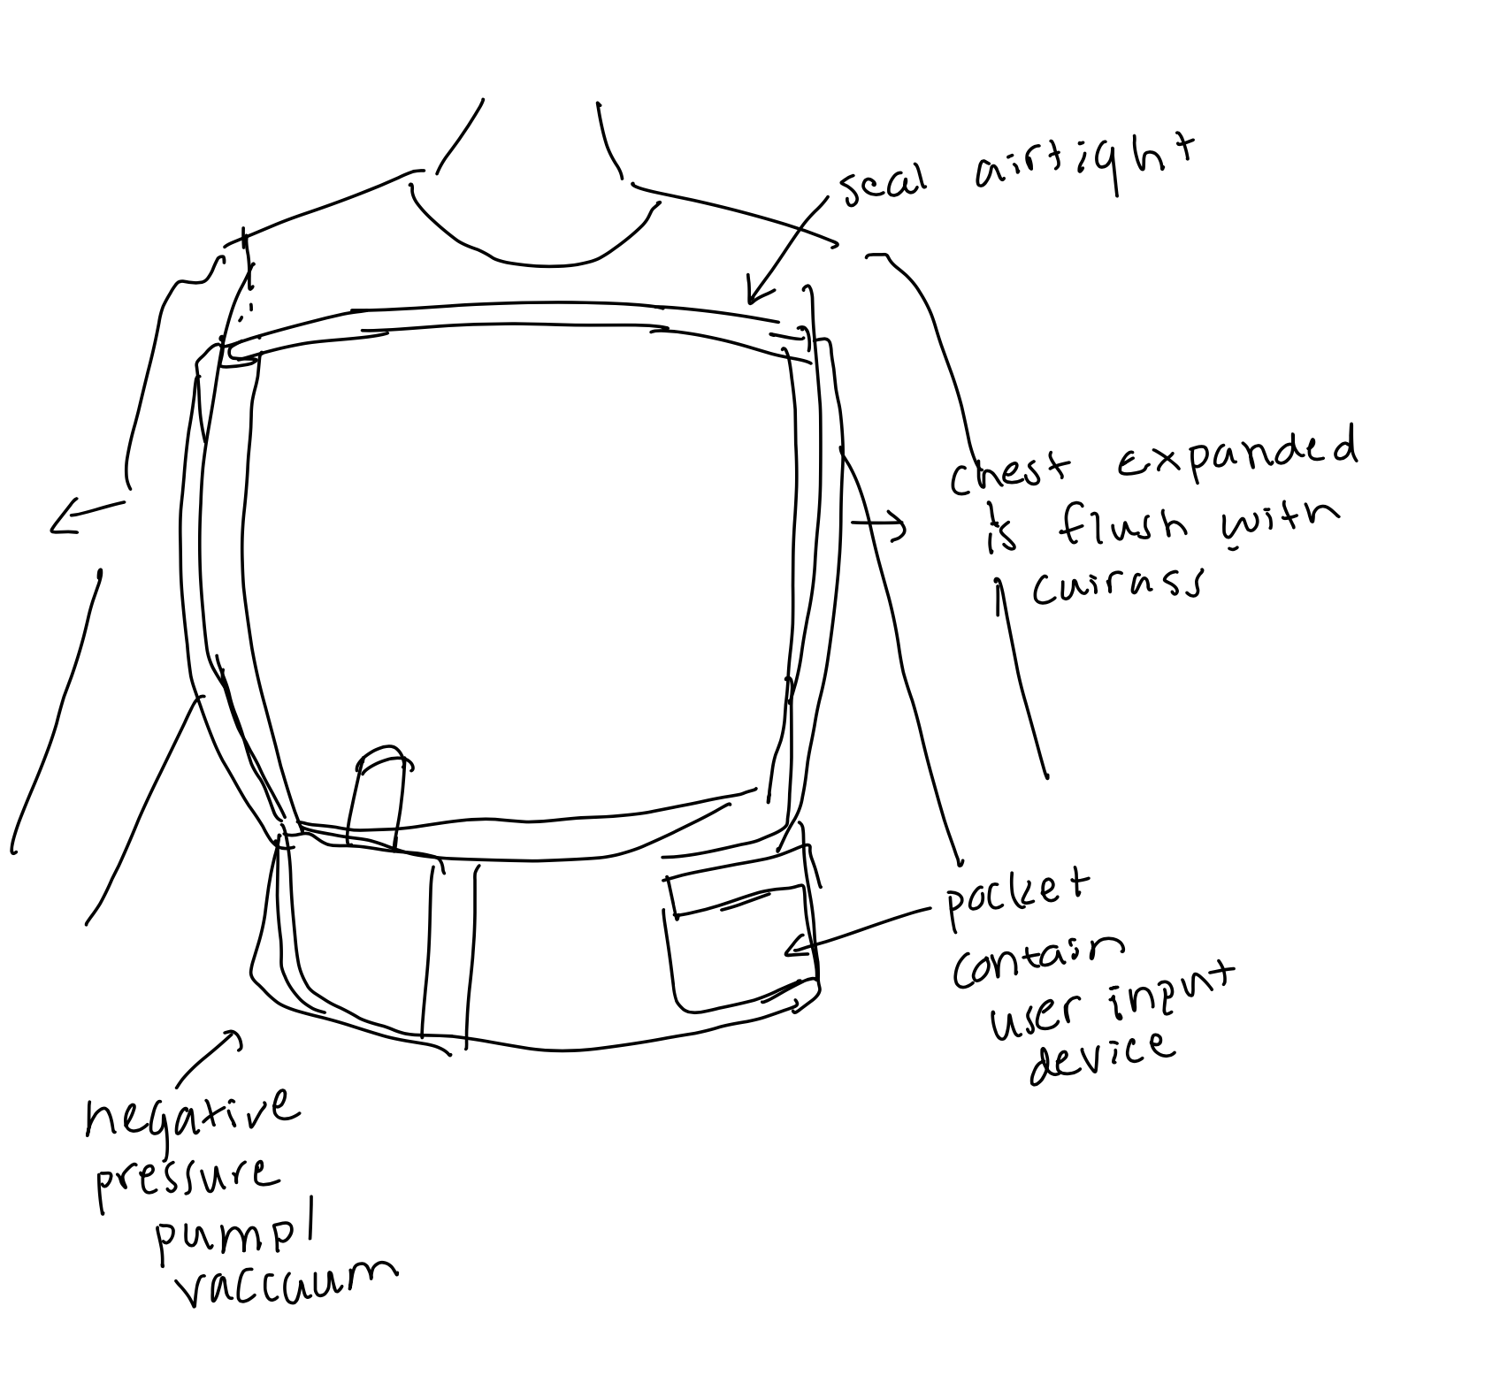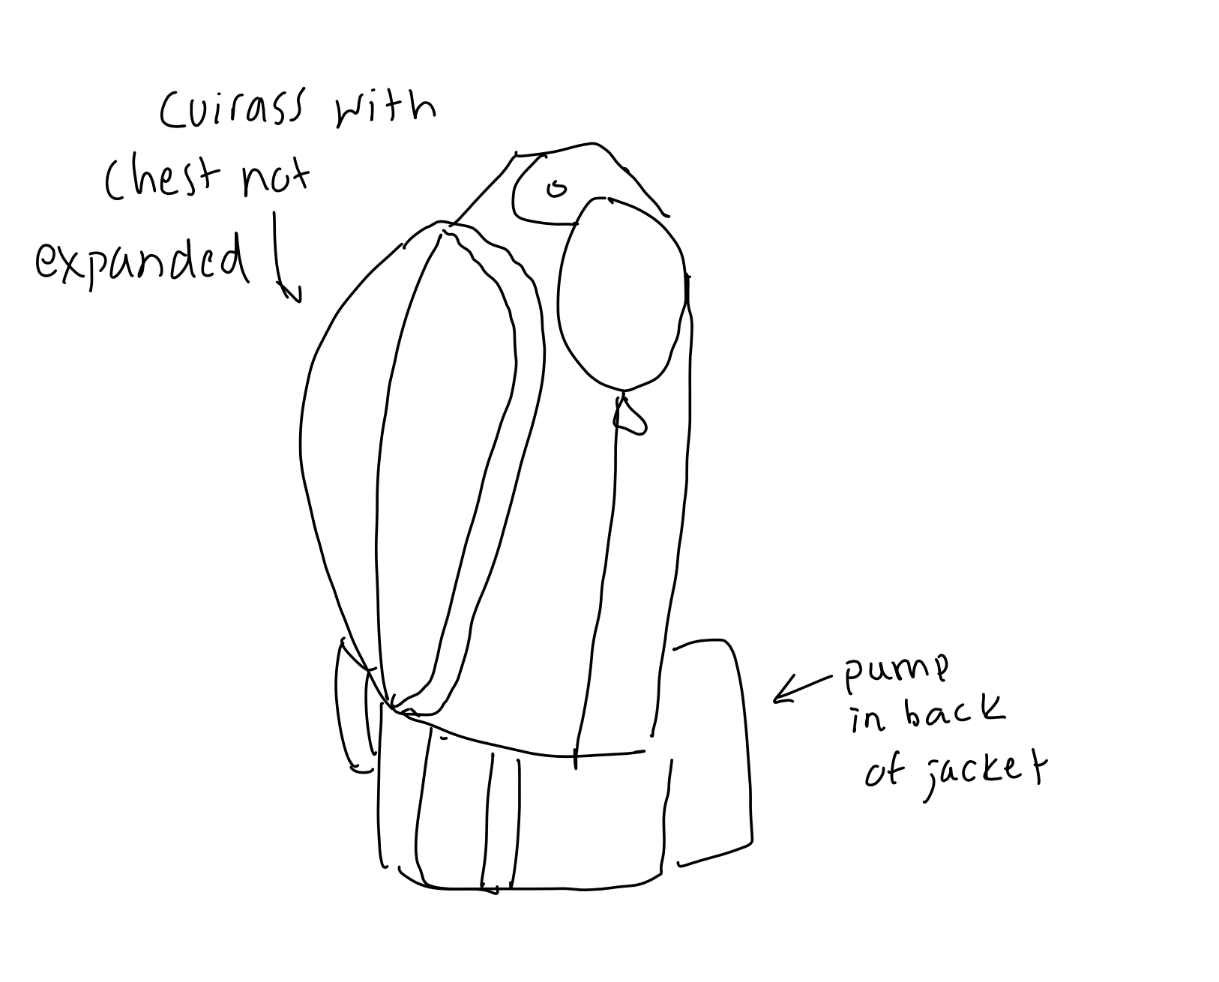

***Figure 4.5:*** *Early concept sketch for the Alternative Design*

***Table 4.4:*** *Modified BPV Cuirass Objective Analysis*

| **Objective** | **Description** | **Meets Obj?** |
| --- | --- | --- |
| **A: Portability** | Design will feature a compact more portable device with weight less than 5 kg by employing lightweight part selection and reducing additional features. | *YES* |
| **B: Effectiveness** | Design uses two pumps to implement a BPV system. Pumps will be chosen in order to meet the desired operating range of +/- 50cmH2O. | *YES* |
| **C: User Experience** | With only one system, the design is easier to wear and operate for the user. A reduced size of the cuirass increases the range of motion. | *YES* |
| **D: Durability** | The mechanical parts are contained, increasing durability. | *YES* |
| **E: Cost of the Device** | The parts required to build the pressure circuit increase the cost of the design. Two pumps to make BPV are needed. Also, a pressure sensor, and an appropriate battery. The cuirass itself which is made from plastic and foam should be low cost but the rest of the design will exceed our prototype budget of $500. | *NO* |

# 5.0. Design Selection

Using the objective analysis for each of the alternative designs, a weighted decision matrix (*Table 5.1*) was used to decide which design will be selected. Candidate 4, the Modified Biphasic Cuirass, was the design that had the highest score and best met the objectives so it was chosen as the proposed design. *Section 6* explains further exactly how the Modified Biphasic Cuirass meets our objectives for the design and a detailed analysis of the parts selected to achieve those objectives.

***Table 5.1:*** *Weighted decision matrix for proposed solutions. (Scores range from 1~5).*

| **Objective** | **A** | **B** | **C** | **D** | **E** | **Total Score** |
| --- | --- | --- | --- | --- | --- | --- |
| **Weight** | **30%** | **30%** | **20%** | **10%** | **10%** | **/5** |
| Ribcage jacket | 3 | 3 | 3 | 2 | 2 | **2.8** |
| Electromagnet Jacket | 2 | 3 | 3 | 1 | 3 | **2.5** |
| NPV+IAPV Cuirass | 2 | 4 | 3 | 3 | 1 | **2.8** |
| Modified Biphasic Cuirass | 3 | 5 | 4 | 3 | 1 | **3.6** |

# 6.0 Proposed Solution

The chosen proposed design is the ***Modified Biphasic Cuirass*** based on the preliminary evaluation of candidates. *Figure 6.1* and *Table 6.1* outline the main components of the Fontan jacket design, which are explained in detail in the following sections. The following sections also include material and parts selection, risk mitigation, and a prototype plan for verification. In *Section 6.1*, the reasoning behind each part selection is explained to ensure the design meets the objectives of portability, effectiveness, user experience, durability, and cost.

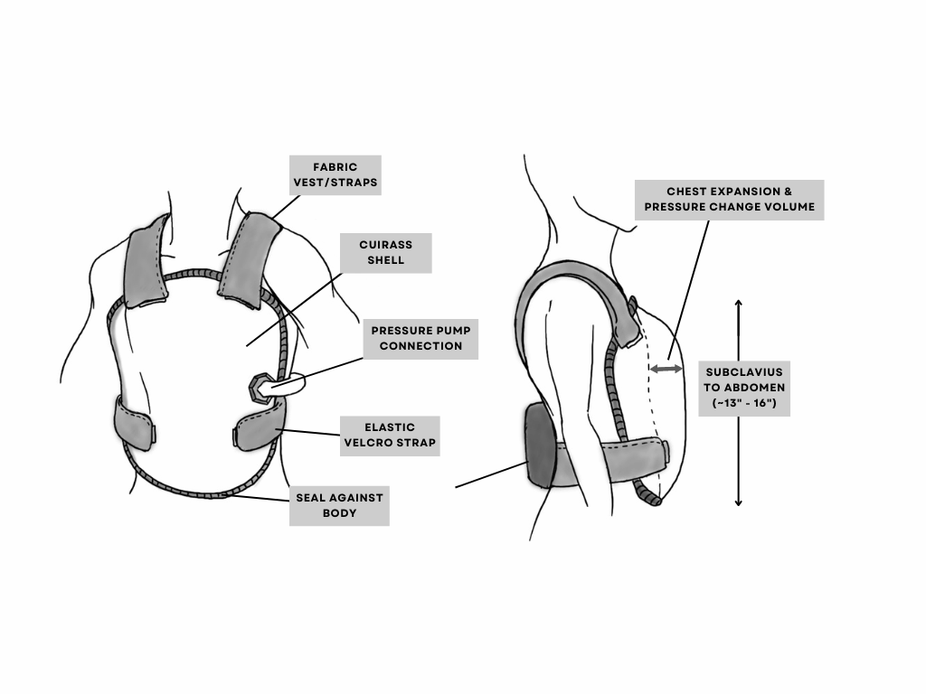

**Figure 6.1.** Modified Cuirass Design

***Table 6.1:*** *Components of Modified Cuirass*

| **Component** | **Subparts** | **Details** |
| --- | --- | --- |
| Jacket | Body & Straps | Jacket will be made of a flexible fabric in the form of a vest. The front of the vest will be composed of the main cuirass, while pressure pumps, battery, and other electronic components are mounted on the back. Vest will be secured on patient with elastic velcro straps around the waist |
| Cuirass | Shell | The rigid shell cannot change its volume when pressure is manipulated between cuirass and body, allowing for relative positive or negative pressure to be induced. In order to optimize portability and efficacy, the shell is designed to cover the critical pressure change area for respiratory function. |
| Seal | A seal around the perimeter of the shell prevents air from leaking due to pressure difference inside and outside the cuirass. It is important to consider that a perfect seal is unlikely, but minimizing leakage improves efficiency of the system and predictability of control for desired pressure gradient. |
| Pressure circuit | Negative pressure pump | Negative air pump removes air inside to decrease pressure within the cuirass, which supports the inspiration phase of breathing by supporting expansion of chest wall and lungs. |
| Positive pressure pump | Positive air pump delivers air inside the cuirass to increase pressure, which supports the expiration phase of breathing by contracting chest wall and lungs and pushing against abdomen. |
| Pipes/connections | To prevent reverse flow and damage to pumps, two pipe connections and valves for negative and positive flow connect the pump modules (mounted on the back) to the cuirass shell. |
| Control systems | Pressure sensor | A pressure sensor will measure pressure changes during the breathing cycle and provide feedback signal for the appropriate pump control to induce desired pressure change. It will continually adjust based on patient behavior to accommodate various positions and motions. |
| Controls circuit | Controls circuit enables pressure control through either Full-Control mode or Assist-Control mode. Based on desired inspiratory & expiratory pressure and rate, as well as feedback from the system, pumps will be controlled accordingly. |
| LCD Screen | LCD screen provides visual feedback to users on device settings and other information such as errors. |
| Power Module | Battery | The battery should be able to power the pumps and control system sufficiently for at least 8 hours of continuous use. Battery specifications will be defined based on requirements of the Fontan jacket for intended use. |

# 

## 6.1 Detailed Design & Parts Selection

**Cuirass shell: Polylactic Acid (PLA)**

The material of the cuirass shell must be strong and rigid (able to withstand desired pressure range), lightweight, and biocompatible. Considering these requirements, the most suitable material for the cuirass shell is plastic. Acrylic and polycarbonate (PC) are both strong, stiff, transparent plastics that could be suitable for the cuirass [100]. Polylactic Acid (PLA) is a common material used in 3D printing. In *Table 6.2*, the three materials’ mechanical properties are compared. Both PC and PLA meet the design requirements however, the shell will be prototyped using 3D printing so PLA is the chosen material for the cuirass shell due to its accessibility.

***Table 6.2:*** *Properties of Acrylic vs Polycarbonate (PC) vs Polylactic Acid (PLA)*

| **Criteria** | **Acrylic [101]** | **PC [102]** | **PLA [103]** |
| --- | --- | --- | --- |
| Rigidity (Flexural modulus) | 2.96 - 3.30 GPa | 0.228 - 10.0 GPa | 0.167 - 13.8 GPa |
| Tensile strength (yield) | 64.8 - 83.4 MPa | 40.0 - 154 MPa | 8.00 - 103 MPa |
| Max stress | 62.0 - 83.0 MPa | 30 - 105 MPa | 0.160 - 3000 MPa |
| Weight | 1.19 g/cm3 | 1.01 - 1.51 g/cm3 | 1.00 - 2.47 g/cm3 |
| Biocompatible | Yes | Yes | Yes |
| Cost | - | About 25% more expensive than acrylic [104] | Approximately $25/kg to 3D print [105] |

**Cuirass Seal: Neoprene Foam**

The material selected for the seal will determine how airtight the system is and how much leakage will occur. As a result, it is important that the seal is elastic, flexible, and able to create an airtight seal. Common sealants are rubber, silicone, and foam. The criteria used for material selection are based on its elasticity, biocompatibility, and weight which uses compression set, hardness, and material density respectively for measurement and comparison as can be seen in *Table 6.3* [106] [107] [108].

​​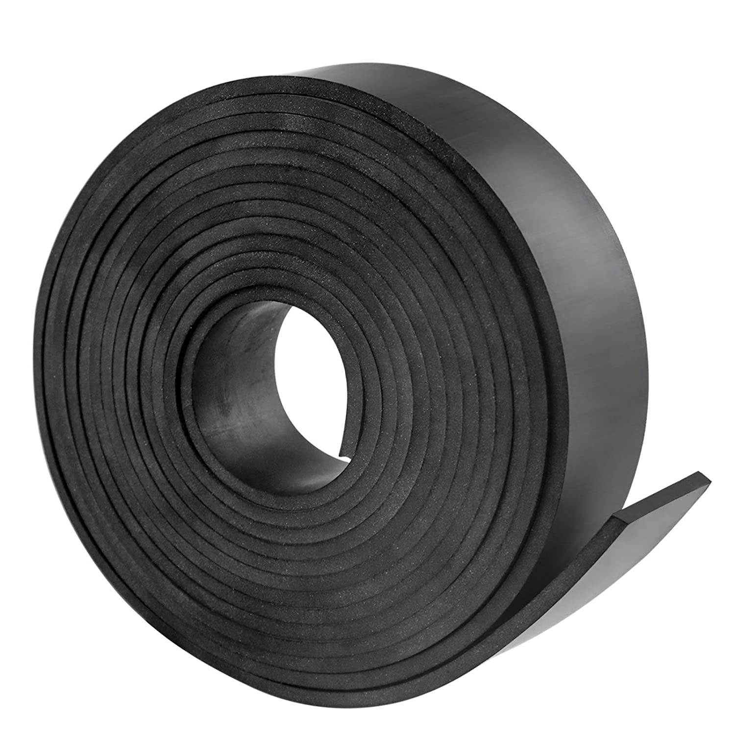 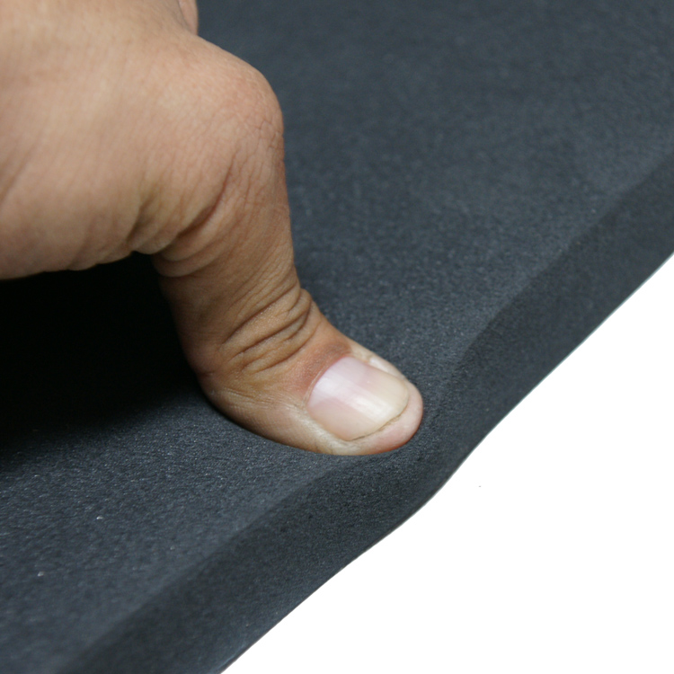 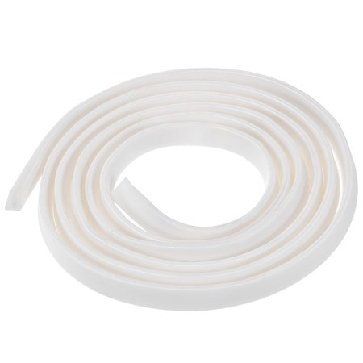

**Figure 6.2**. Neoprene Rubber (left), Neoprene Foam (middle), Silicon Extrusion Seal (right)

***Table 6.3:*** *Properties of sealing materials*

| **Measurement Criteria** | **Neoprene Rubber** | **Neoprene Foam** | **Silicone** |
| --- | --- | --- | --- |
| Compression Set at 50% for 23°C | 33% deformation | 35% deformation | 12.3% deformation |
| Elastomer Hardness | Shore A, 60  (Medium Hard) | Shore 00, 45  (Extra Soft) | Shore A, 60  (Medium Hard) |
| Material Density | 1500 kg/m3 | 155 kg/m3 | 1200 kg/m3 |

Based on the above properties of the sealing materials, the proposed design will select ***Neoprene Foam*** as a sealant material due to its extra soft material which avoids skin abrasion on the user and its natural form-fitting which increases its ability to form an airtight seal along the perimeter of the cuirass.

**Jacket Design**

As shown in *Figure 6.1*, the design of the jacket can be broken down into two parts, the shoulder straps and the elastic and velcro straps around the waist to secure the cuirass and create the seal. The shoulder straps are secured to the top of the rigid shell of the cuirass and connect to the component that contains the parts for the pressure circuit and control system. The shoulder straps will have adjustable sizing similar to a backpack to better fit the user. The straps used must be strong enough to support the weight of the system, 5 kg, and comfortable for the user. An example of straps that may be used can be seen in Figure x. Because the straps are supporting the weight of the entire design, they must not be elastic so the cuirass can be held securely in place and not move around.

Elastic and velcro straps are used to attach the cuirass to the body similar to the straps shown in Figure x. Straps go over and attach to the outer side of the cuirass to secure it in place. An elastic material is used so that the straps can be tightened which will help create an airtight seal between the cuirass and the body.

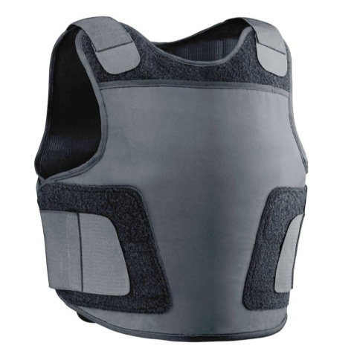

**Figure 6.3.** Jacket vest sample with elastic velcro waist strap [109]

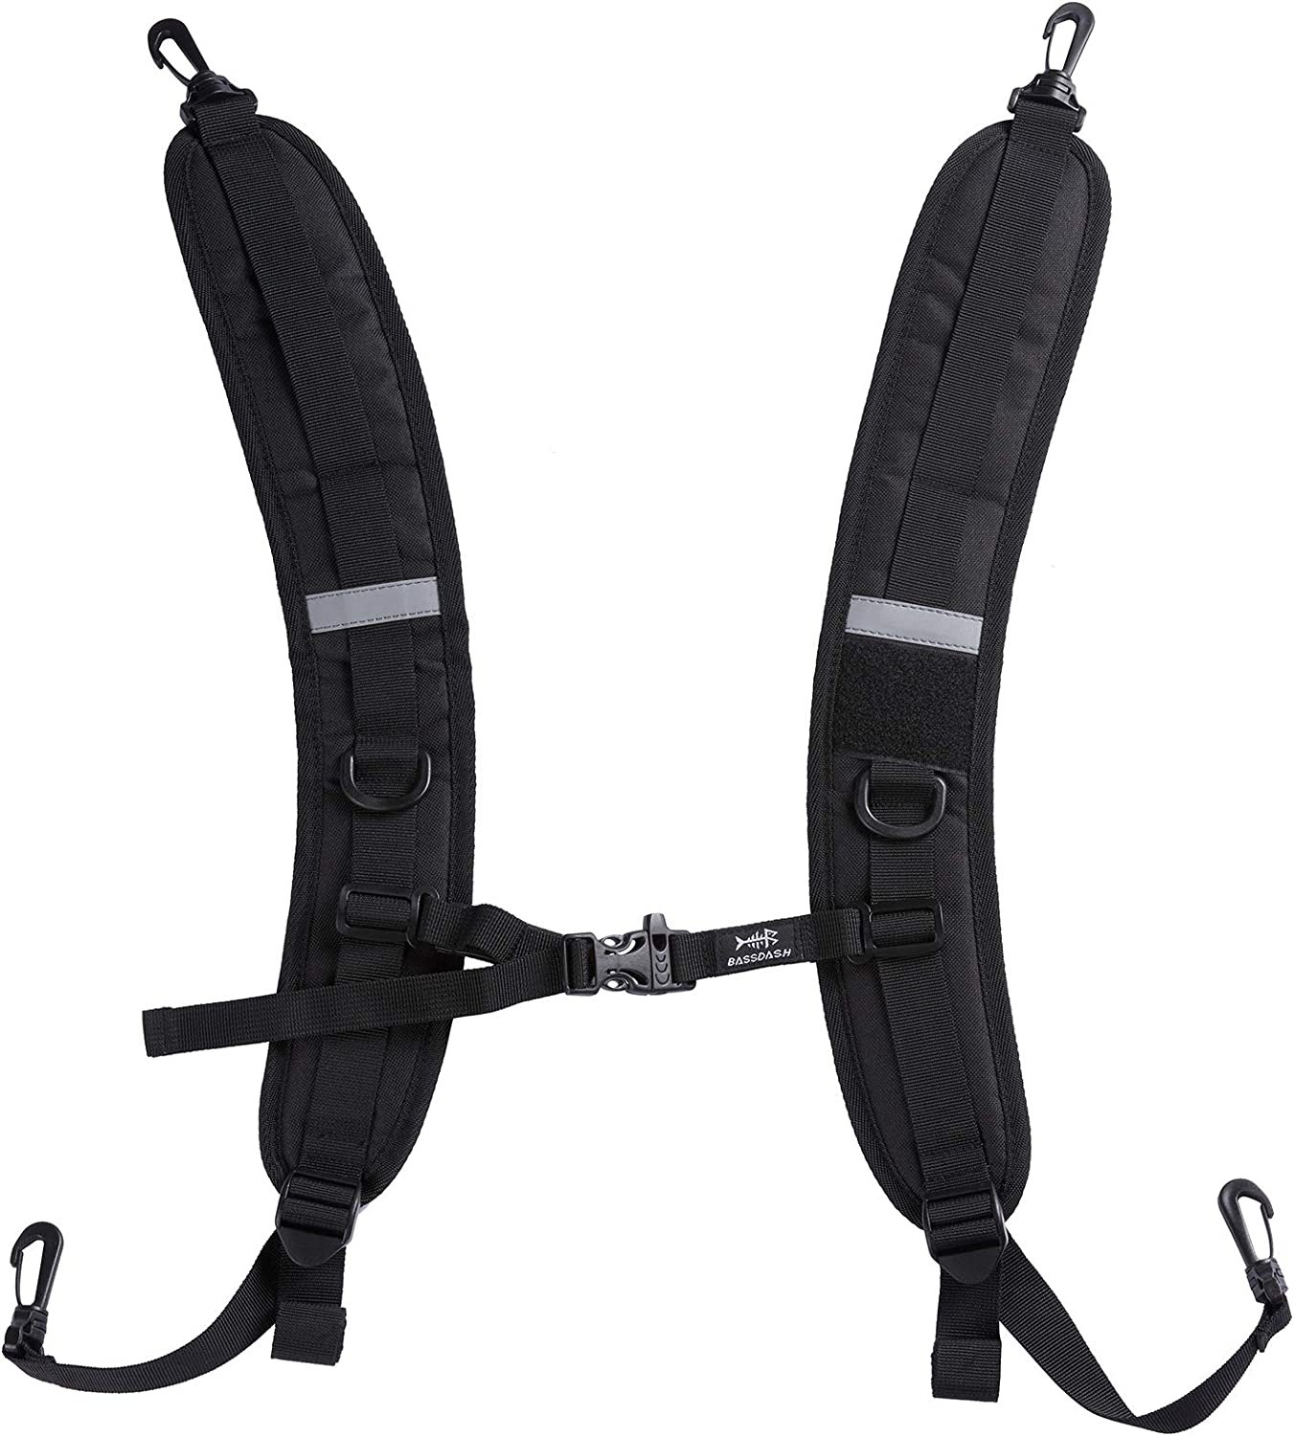 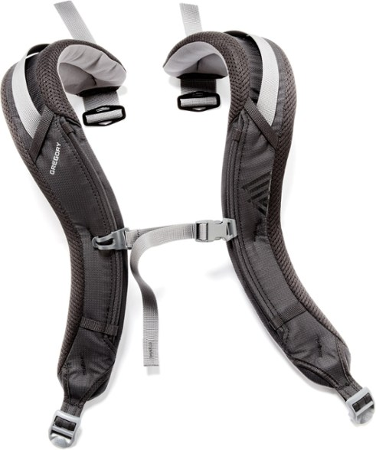

**Figure 6.4.** Shoulder strap samples, padded and adjustable for ergonomics [110] [111]

**Pressure Circuit Design**

From the maximum cuirass size in *Figure 6.5*, the approximate volume based on half-cylinder, V = πr2h/2, is approximately 0.015m3 (15L). As defined in *Table 2.9*, the typical respiratory cycle is 3 seconds: 1 second for inspiration and 2 seconds for expiration [112]. The amount of pressure change the pump needs to produce is -/+60cmH2O. Using the ideal gas law (*Eq.6*) and assuming nRT as constant, this equates to approximately -/+ 6% changes in volume. Based on the total estimated volume of the cuirass, the flow rate required is 0.45L/s, or 27L/min. This defines the maximum threshold that the pump selected must be able to transport 30 L/min of air out of and into the system.

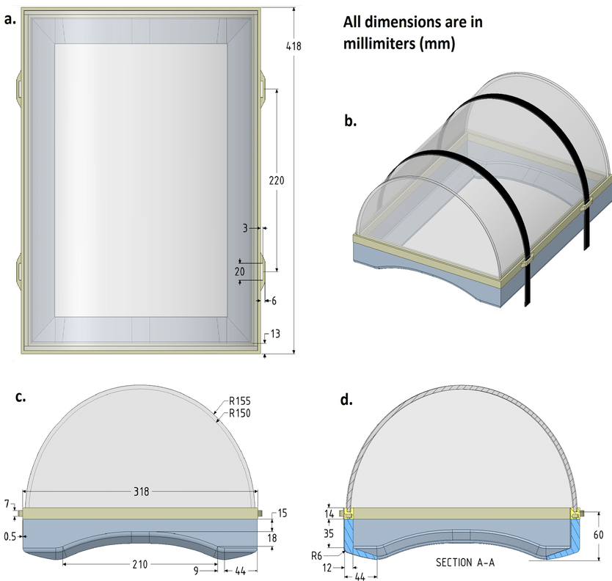

**Figure 6.5.** Maximum cuirass size [113]

Pumps operate in one direction, suction through the inlet and flow discharge through the outlet. Thus the pump(s) should be able to do two ways of air transport to achieve the intended function of the jacket:

1. From inside to outside of control volume, to induce negative pressure on chest supporting inhale.
2. From outside to inside of control volume, to induce positive pressure on chest supporting exhale.

*Figure 6.6* depicts two possible pressure circuits that can conduct the two paths of air transport, respectively shown in blue and red arrows.

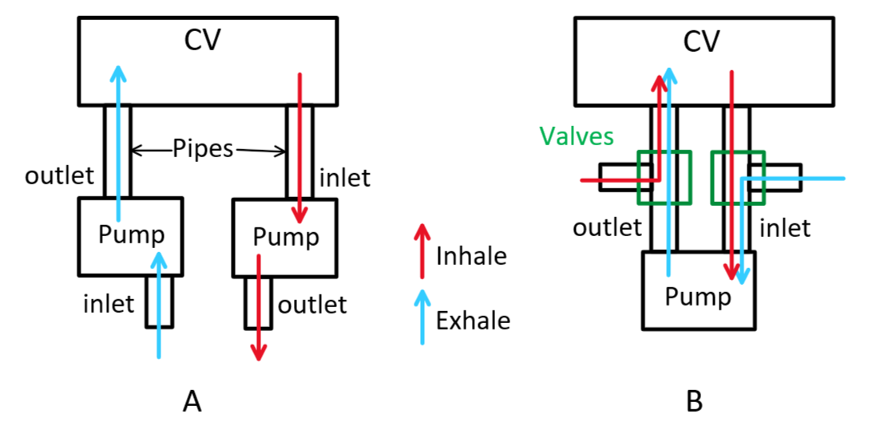

**Figure 6.6.** Two-pump system (A) and one-pump system (B) for two-way air transport

*System A* requires two pumps, and *System B* requires one pump with two valves. The 3-way 2-position valves needed to complete B are expensive ($60 or more) [114]. Although pumps are larger than two of these valves, one pump will have a shorter life cycle than two pumps. Thus, A is preferred over B.

The direct connections of pumps to pressure changing volume can result in issues like reverse flow that can damage the pumps. To avoid these problems, 2-way valves are introduced, as shown in *Figure 6.7*. Two pipe connections to CV are also reduced to one to reduce the extra volume within pipes that can disrupt flows. In addition, an exhaust port and a drain valve are connected in case of emergency as a measure of safety.

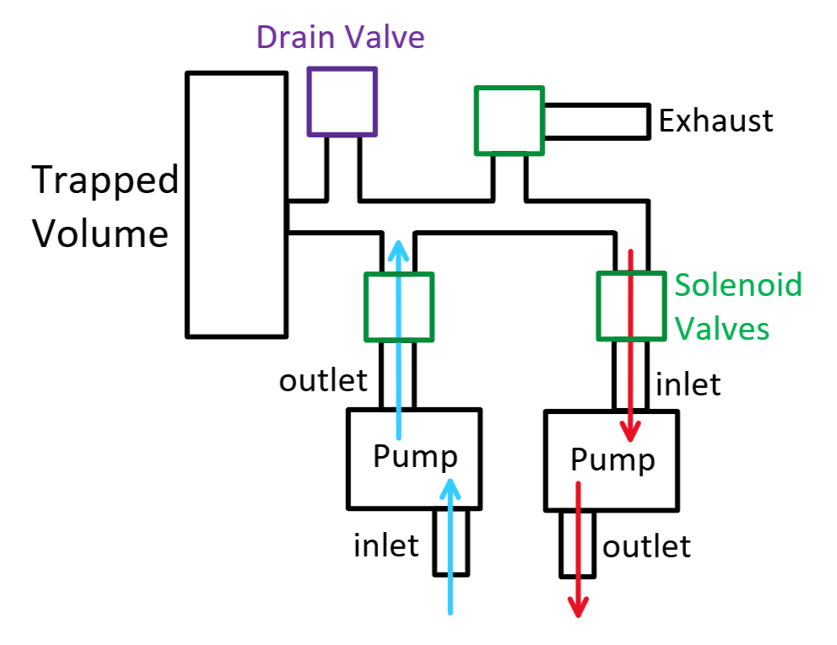

**Figure 6.7.** Two-pump system with safety valves

There are two safety measure valves, each controlled electronically by the control system and manually by hand. The electronically-controlled valve will be the same 2-way solenoid valve used for protecting pumps from reverse flow. Manual valves should be totally mechanical for safe operation during electronics malfunction. The smaller and cheaper valve alternatives, compatible with pipe connectors and with reviews supporting no leakage, are selected.

Based on the objective goal of backpack size, the largest dimension of the pump should not exceed 22.9cm, and the maximum total weight should be less than 5kg. Allocating half of the weight allowance to the pressure and control circuit (2.5kg), the weight of a single pump should not exceed 600g to account for pipes, valves, and electronics including the battery. Limited to the portable size and weight and prototyping budget, the available types are centrifugal or diaphragm pumps (*Figure 6.8*). Transporting air can cause detrimental issues with centrifugal pumps that cannot operate in dry conditions [115], narrowing the selection to diaphragm air pumps.

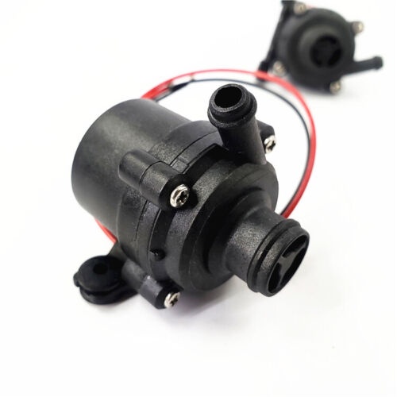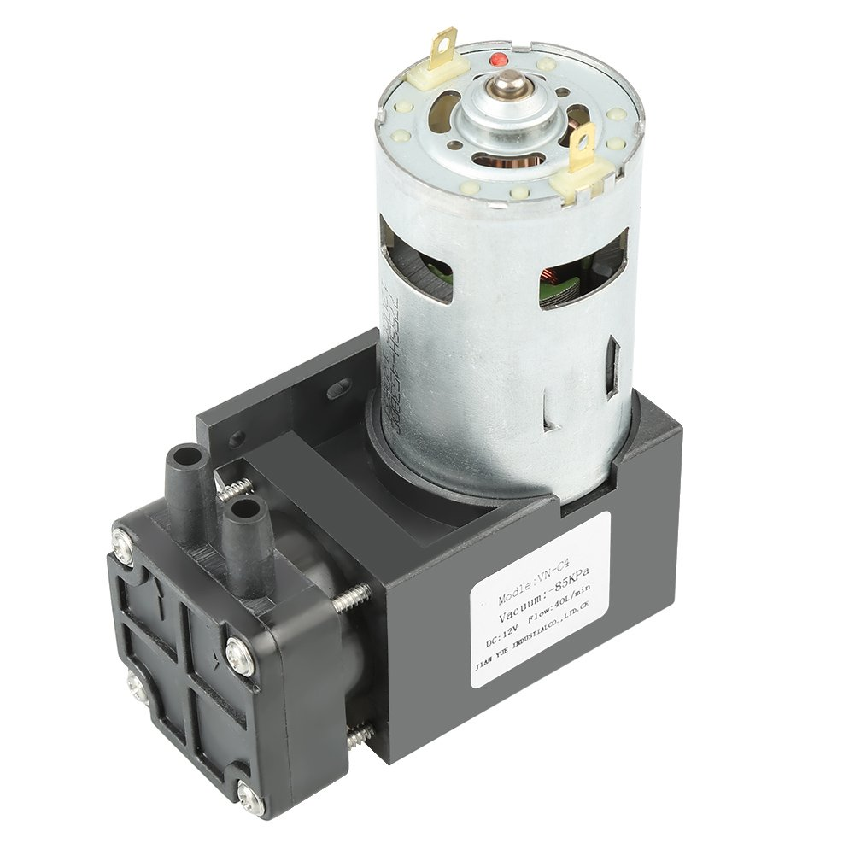

**Figure 6.8.** Centrifugal (left) and diaphragm (right) pumps [116] [117].

The pipe’s outer diameter (OD) is constrained by the inlet/outlet diameter of the pump ¼”. Its material must be safe for the human body, eliminating polyvinyl chloride (PVC). The safe alternatives are polyurethane (PU) [118] and silicone and they both fulfill the temperature range defined in *Table 2.8*. Connectors for pipes to pumps and valves are constrained to pipe OD ¼”, limiting the choice of size to ¼” or ⅛” national pipe thread (NPT). The smaller and cheaper alternatives, PU pipe and ¼” NPT connectors are selected. Based on the pressure circuit diagram, 5 port splitter or 3 T-connectors are required. A metallic block splitter with 5 ports is selected because metallic parts are more durable than plastic, and a single metal splitter is more economical than multiple metal T-connectors.

Considering minimal dimension, cost, and rated voltage, the selected parts for composing a pressure circuit are organized in the table below.

***Table 6.4:*** *Pressure Circuit Bill of Materials.*

| **Component** | **Dimensions** | **Specifications** | **Quantity** | **Cost** |
| --- | --- | --- | --- | --- |
| Diaphragm Pump | 11x9x4.4cm, 490g | DC12V, 42W, 40L/min  Inlet/Outlet diameter ¼” | 2 | $58.79 per pump [117]  Total $117.58 |
| Solenoid Valve | 8x8x3cm, 140g | DC12V, 6.5W,  ¼” NPT female | 3 | $20.73 per valve [119]  Total $62.19 |
| Mechanical Valve | 12.2x6.4x2cm, 50g | Brass, ¼” NPT male | 1 | $19.39 [120] |
| Pipe | ¼” OD  1m length | Polyurethane (PU), Working conditions:  -20 ~ 65 ℃, 8400cmH2O | 1 | $22.99 [121] |
| Male Connector | ¼” OD, ¼” NPT | Stainless Steel, 10/pack | 10 | $16.99 per pack [122] |
| Block Splitter | 9.5x4.3x2.21cm  109g | Aluminum, Nickel plated  ¼” NPT female 5 ports | 1 | $15.06 [123] |
|  |  |  | Total | $153.95 |

There are multiple existing projects where two diaphragm pumps are used to transport air into and out of a control volume, where the flow rate is controlled by PWM signals controlling motor speeds [124] [125]. These also use valves for each pump and for the exhaust port, supporting the justification of valve addition. Generally, the existing operating pressure circuits demonstrate the pressure circuit design feasibility.

**Control System Design**

Two control modes are identified in the design:

1. Full-Control Mode: user’s breaths are forced and the frequency is set by the ventilator
2. Assist-Control Mode: user’s spontaneous breathing triggers ventilator to generate pressure change

During Assist-Control Mode, methods of sensing the user’s breath include measuring negative pressure using a pressure transducer catheter, measuring flow using a thermistor, or using a digital pressure sensor. The sensor must be able to detect the range of at least -/+60cmH2O. A pressure sensor that meets the specification is AMS 5915 [126], shown in *Figure 6.9*, more specifically the AMS 5915-0100-D-B. This is a bidirectional differential pressure sensor that supports a pressure range between -100 to 100 mbar, which is approximately -/+101.97cmH2O. This safely encompasses the -/+60cmH20 range. The error for low pressure ranges (defined as ≤ 100 mbar) is 1.5% of the maximum range from -/+1.5cmH2O. The pressure sensor is small, 15.24mm x 15.24mm, and can be easily fitted inside the cuirass with minimal impact on the cuirass design. The weight of the pressure sensor is 3g, which is 0.06% of the 5 kg from objectives.

The battery of the device must be able to power the pressure sensor, both pumps and valves, and the Arduino controller. The diaphragm pump uses 12V and 3.5A, the Arduino Mega has an operating voltage of 5V and recommended input voltage range of 7-12V, and the solenoid valve uses 12V and 540 mA. The Eco-Vault 12V rechargeable lithium-phosphate battery [127] can provide a 12V power supply of 8.08A to the pumps and valves. For the controller, a Qsmily 6V rechargeable battery pack can be used [128].

For the proposed design, the display should be able to prompt users for input when setting up the device and display the inputted settings back to them. It will display 3 main values: the pressure range, the breathing rate, and the I:E ratio. An LCD screen that meets these requirements and is compatible with Arduino is the DSD Tech 20x4 LCD screen [129]. This screen can display 4 rows of 20 characters each.

The design must receive user input somehow to set the pressure range, breathing rate, and I:E ratio. To do this, a 3x4 keypad will be used [130]. Other options that were considered to receive input were dial (knob) or up-down keys. The keypad and display will be on a handheld remote that is attached with a wire to the jacket and controller (See *Figure 6.10*). When not in use, a pocket attached by velcro to the bicep/arm of the jacket can store the remote. The remote will also have a case enclosure to ensure buttons are not accidentally pressed. One button on the remote will be dedicated to an emergency stop button, which will open the exhaust and then shut the system off.

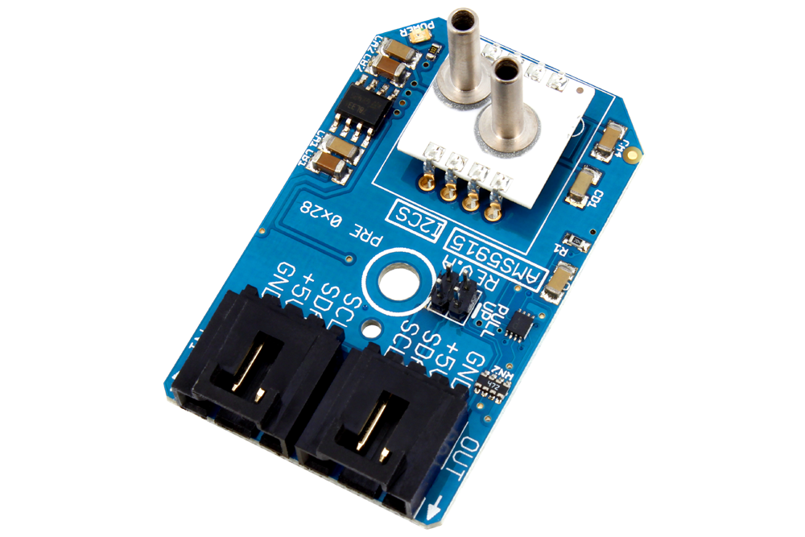 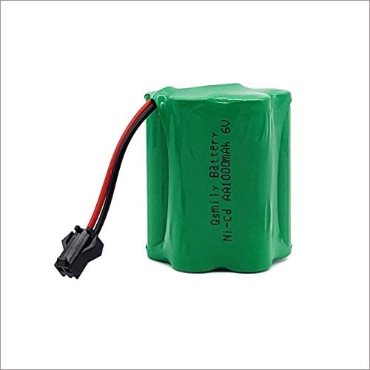 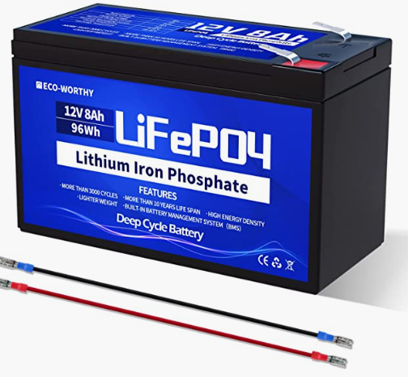

**Figure 6.9.** *Pressure* s*ensor (left), 6V battery (middle), 12 V battery (right)*

***Table 6.5:*** *Control System Bill of Materials.*

| **Component** | | **Selected part** | **Dimensions** | **Specifications** | **Cost** |
| --- | --- | --- | --- | --- | --- |
| Pressure sensor | | AMS 5915-0100-D-B  [126] | 15.24 mm x 15.24 mm, 3g | Detects range -/+101.97 cmH2O;  Error for low-pressure ranges (≤ 100 mbar) is 1.5% of the maximum range from -/+1.5cmH2O | $75.95 |
| Controller | | Arduino Uno [132] | 68.6 x 54.3 mm, 31.75g | Operating Voltage: 5V  Input Voltage (recommended): 7-12V  Input Voltage (limit): 6-20V  Digital I/O Pins: 14 (of which 6 provide PWM output)  SRAM: 2 KB (ATmega328P)  EEPROM: 1 KB (ATmega328P)  Clock Speed: 16 MHz | $47.98 |
| Pressure circuit battery | | Eco-Vault 12V rechargeable lithium-phosphate battery | ‎19.5 x 14.2 x 10.2 cm; 900 g | Power 2 12V, 42W (3.5A) pumps and 2 12V, 6.5W (540mA) valves  Rechargeable | $69.99 |
| Controller battery | | 6V rechargeable battery [128] | 100 x 58 x 14.5 mm, 191g | 6V, 1000 mAh | $24.99 |
| Display | | DSD Tech 20x4 LCD display [129] | 10.69 x 6.71 x 3 cm; 100g | Display 4 lines, 20 characters | $15.99 |
| Input | | 3x4 keypad [130] | 18.8 x 10.16 x 0.03 cm; 10 g | 12 buttons arranged in 3x4 grid, uses 7 microcontroller pins | $12.95 |
| Motor driver for pumps | | L298n  [152] | 4.3 x 4.3 x 2.7 cm; 30g | Logic Voltage: 5V  Driving Voltage: 5 ~ 35V DC  Logic current: 0 ~ 36 mA  Drive Current: 2A (max)  Maximum power consumption: 25W | $2.50 |

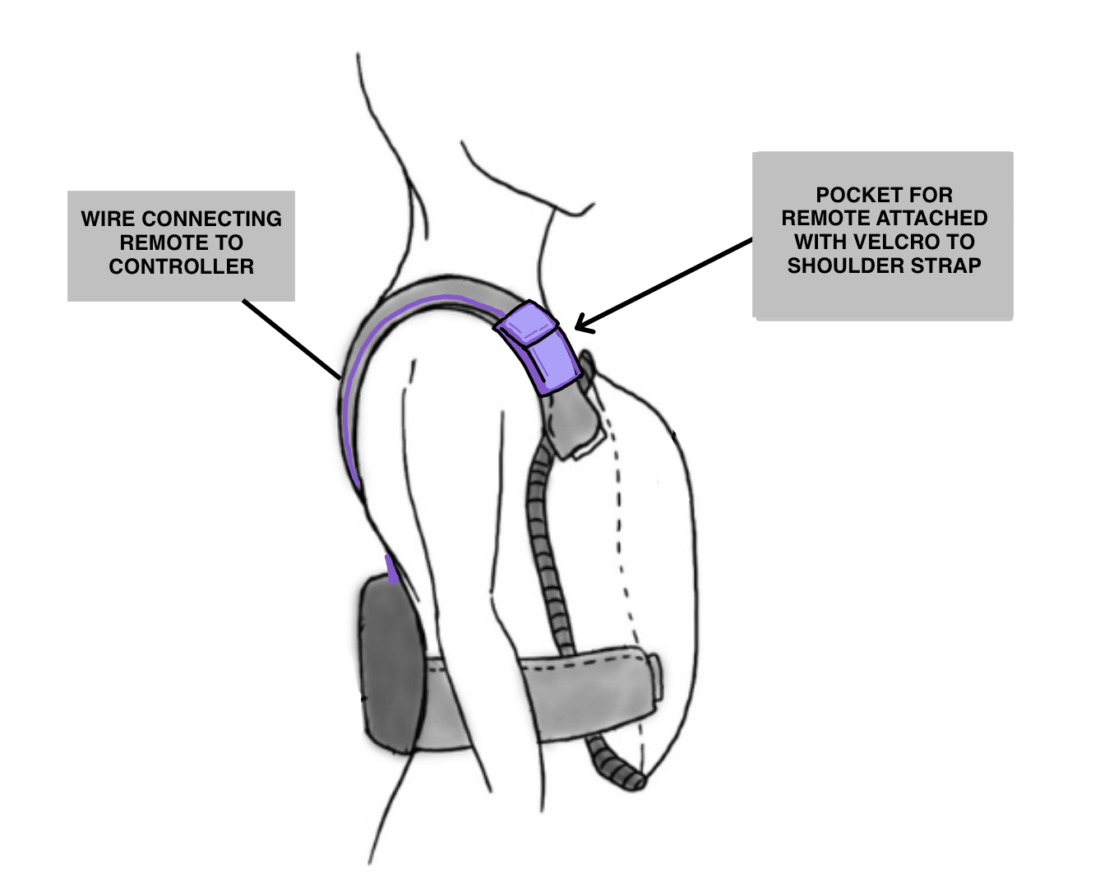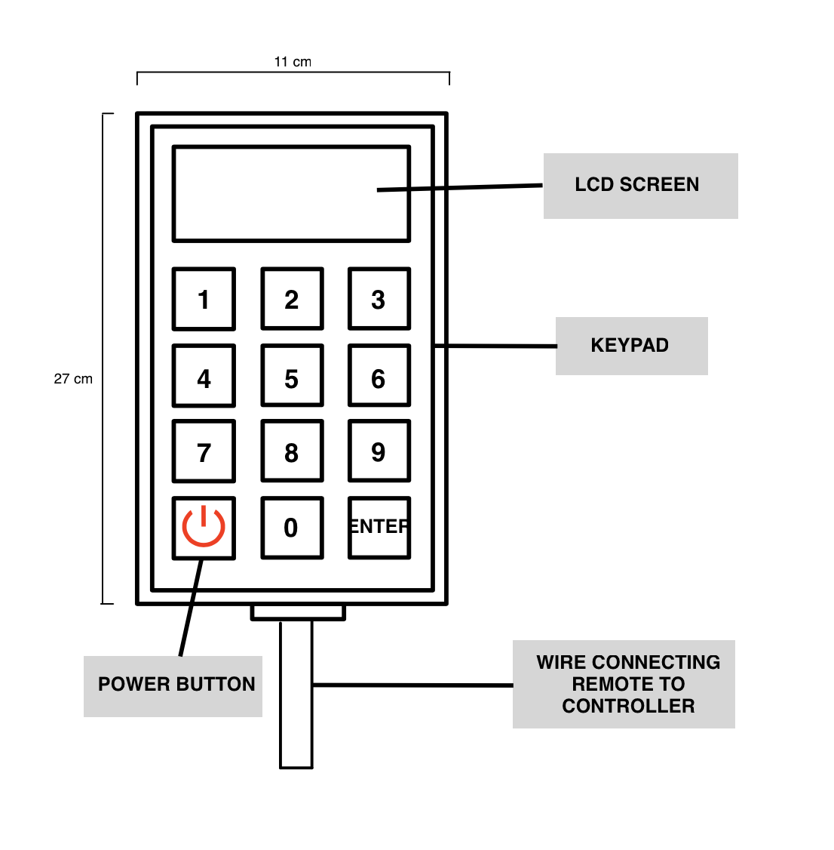

**Figure 6.10.** Remote placement and design



**Figure 6.11.** Sample display on LCD screen for control setting

In *Figure 6.12*, a high-level block diagram for the control system is shown. The inputted I:E ratio, pressure settings, and breathing rate will be used to generate a reference signal which will be sent to the controller. The controller then converts that signal into control signals which are sent to the actuators (the pumps and valves). The plant in this system is the patient levels we are trying to control. The pressure sensor inside the system sends feedback to the controller to complete the closed-loop controlled design.



**Figure 6.12:** Block diagram of control system

## 6.2 Proposed Design Analysis

Overall, the proposed design successfully meets all the design requirements outlined in *Section 2*. The previous section described how each part is able to meet the design requirements to meet our objectives. *Table 6.6* gives a detailed cost and weight analysis of the proposed design. A benefit of this design is that since it is based on existing devices, there is supporting literature that can verify its functionality and can be used as reference when building a prototype for the proposed design. It uses one closed system which reduces the complexity of the design and the effectiveness of using BPV with Fontan has been tested. The weaknesses are that by attaching the pressure circuit, controls and battery to the jacket, this increases the weight of the design. It is also unable to provide a perfect airtight seal so some leakage is expected which will impact the pressure it is able to generate in the cuirass. Additionally, it is still a complex system with many parts that must be compatible with each other. Although this was taken into consideration in *Section 6.1,* further testing may be required once the parts have been ordered.

***Table 6.6:*** *Cost and Weight Analysis of the Proposed Fontan Jacket*

| **Part** | **Material** | **Weight** | **Cost** |
| --- | --- | --- | --- |
| Jacket | Elastic fabric vest | 200 g | $20.00 |
| Elastic and velcro straps | Foam, max capacity 20kg | 153 g | $27.95 |
| Cuirass shell | PLA (3D printing) | 1.5 kg | $37.5 |
| Cuirass seal | Neoprene foam | 150 g | $28.13 [131] |
| Diaphragm pump | DC12V 42W -85KPa Vacuum Pump, Flow 40L/min Mini Oilless Vacuum Pump | 490g | $58.79 per pump [117]  Total $117.58 |
| Solenoid Valve | 12V DC 1/4" 2 Way Normally Closed Pneumatic Aluminum Electric Solenoid Air Valve | 140g | $20.73 per valve [119]  Total $62.19 |
| Mechanical Valve | Ball Type Drain Valve, 1/4-Inch NPT Male Thread | 50g | $19.39 |
| Pipes and Connectors | Polyurethane (PU),  Stainless steel | 376.48g  120g | $22.99  $16.99 |
| Pressure sensor | AMS 5915-0100-D-B | 3g | $75.95 [133] |
| Controller | Arduino Uno | 25g | $27.60 [132] |
| Screen & Keypad | DSD Tech 20x4 LCD display | 100g  10 g | $15.99 [129]  $12.95 |
| Batteries | Eco-Vault 12V rechargeable lithium-phosphate battery  6V rechargeable battery | 900 g  191g | $69.99  $24.99 |
| Motor driver | L298N | 30g | $2.50 [152] |
|  | Total: | ~4.3 kg | $582.69 |

## 6.3 Risks and Mitigation

Improving upon our Risk and Management plan from the Project Requirements, the current strategy will focus on our proposed design and the relevant risk mitigation steps to be taken based on the requirements that were set by ISO 14971 (Application of Risk Management to MD) for terminology and principles related to risk management of MD [134]. For this current iteration of the risk management plan, we have decided to also focus the scope of the study on the risks during the prototyping stage of the MD.

# 

**Hazard and Operability Study (HAZOP)**

Based on the previous Preliminary Hazard Analysis for the MD (See ***Appendix H***), the next step of completing the risk management plan is to conduct a HAZOP study. HAZOP is utilized to produce a full description of the MD and how it is intended to be used. HAZOP can also help to systematically review every part of the MD’s intended use and discover any deviations from the normal operating conditions that can cause hazardous or operability problems [135].

In this study, HAZOP identifies the type of hazards that will be significant while the device is operating in its environment, to help the team focus on improving the design and mitigating associated risks.

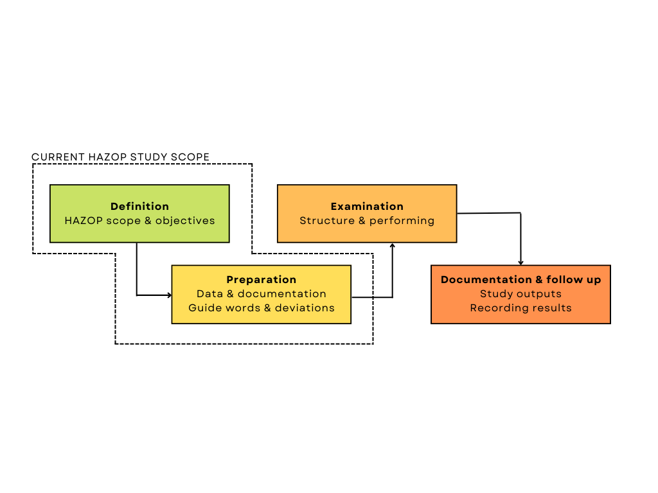

**Figure 6.13:** HAZOP study scope for current design stage

**Table 6.7:** Scope and Objectives of study

| **Scope of HAZOP** | ***Phase of HAZOP Analysis:*** Concept Stage  ***MD Life Cycle Stage:*** Product Use and Prototyping stage  ***System Boundary:***All device components considered based on Figure X during use case, excluding any hazards relating to maintenance of device |
| --- | --- |
| **Objectives of HAZOP** | ***Purpose of Study:*** To identify major risks based on current design choices and allow for consideration in a future iteration of HAZOP study  ***Performance Requirements:*** Abide the standards for quality and performance for MD based on ISO 60601 and ISO 13485 [55] [56].  ***Groups at Risk:*** Patients, Caretaker |

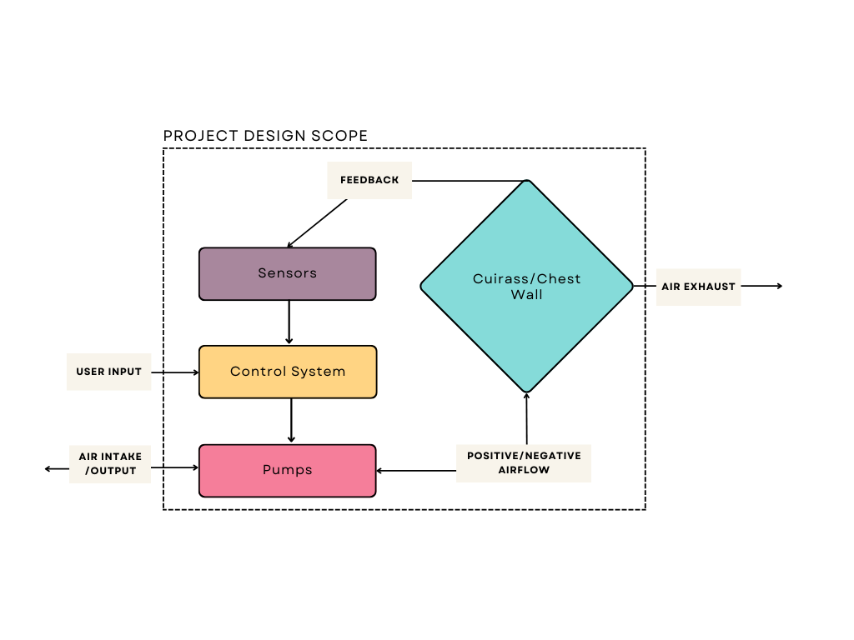

***Figure 6.14:*** *Project Design Scope under HAZOP considerations*

The HAZOP method uses exhaustive enumeration, where every identified hazard, operational disturbance, or deviation was examined carefully for each component of the design for us to identify any potential causes of failure [136]. *Table 6.9* establishes the guide words we use in this study, to provide a structure to our analysis. *Table 6.8* shows the example of basic guide words and their generic meaning.

For example, combining “Pumps” during the operational state of the “Inspiratory phase” combined with the “MORE” guide word will describe a situation where the pumps applied more pressure than intended during the breathing-in phase of the user. The analysis is conducted such that each element in each column under *Table 6.9* is combined to exhaustively enumerate and create a different outcome or scenario that may occur during the device use.

**Table 6.8:** Establishing guide words and deviations

| **Guide Words** | **Meaning** |
| --- | --- |
| NO/NOT | Complete negation of the design intent |
| MORE | Quantitative increase |
| LESS | Quantitative decrease |
| AS WELL AS | Qualitative modification/increase |
| PART OF | Qualitative modification/decrease |
| REVERSE | Logical opposite of the design intent |
| OTHER THAN | Complete substitution |
| EARLY | Relative to the clock time |
| LATE | Relative to the clock time |
| BEFORE | Relating to order or sequence |
| AFTER | Relating to order or sequence |

**Table 6.9:** Establishing guide words and deviations

| **Design Components** | **Operational State** | **Guide Words** |
| --- | --- | --- |
| Jacket  Elastic and velcro straps  Cuirass shell  Sealing  Pumps  Pressure sensors  Controller  Battery  LCD display | Wearing the device  Switching on  Switching off  Device calibration  Inspiratory phase  Expiratory phase  Device storage | NO/NOT  MORE  LESS  AS WELL AS  PART OF  REVERSE  OTHER THAN  EARLY  LATE  BEFORE  AFTER |

**Table 6.10:** HAZOP sheet for detailed hazard identification

| **Risk No.** | **Operational State & Components** | **Guide Word** | **Deviation Explanation** | **Possible Causes** | **Consequence** |
| --- | --- | --- | --- | --- | --- |
| R1 | Pumps + Inspiratory phase | MORE | Negative pressure supplied to the cuirass exceeds the set limit | Failure of the control system to properly set pressure limits | Device will cause user to have difficulty in breathing |
| R2 | Pressure sensors + Expiratory phase | LATE | Sensors detected late pressure rise in the cuirass | Disturbance in the signal/sensor causing delay and error | Mismatch in actual I:E ratio that the device should achieve |
| R3 | LCD Display + Device calibration | REVERSE | Display showing an incorrect information while calibrating the device | Error in system coding causing information to be displayed incorrectly | User is misinformed on the exact parameter used |
| R4 | Controller + Device calibration | REVERSE | User input on controller outputs totally different pressure | Wrongly installed system layout for a proper input-output matching | Similar to R3, user is misinformed on the parameter used |
| R5 | Battery + Device storage | NOT | Defective battery causing explosion hazard | Exposure to high temperature and overcharging | Device will be a dangerous potential explosive hazard |
| R6 | Battery + Wearing the device | EARLY | Device battery deplete faster than required | Loss of battery power after multiple cycles | Device randomly shutting down even with normal use |
| R7 | Cuirass Shell + Inspiratory phase | NOT | Cuirass breaks during the breathing phase | Due to use of material with low tensile strength | May induce trauma to user due to sudden pressure increase |

Through exhaustive enumeration using *Table 6.9*, some of the potential hazard scenarios are listed under *Table 6.10* for our analysis. *Figure 6.15* shows a three-region Risk Matrix for the presented hazard scenarios, where inductive reasoning was used to qualitatively determine the effects of each hazard on our design. ***Appendix I*** outlines the common terms for severity and probability levels.

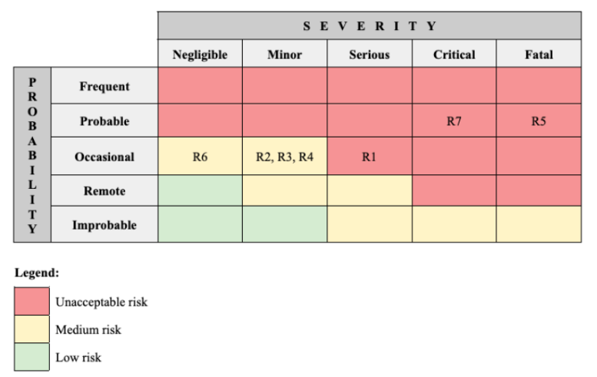

**Figure 6.15.** Risk matrix for the severity and probability of identified risks

**Table 6.11:** Risk control measure for consideration on design iteration

| **Hazardous Scenario** | **Risk Control Measure** |
| --- | --- |
| **R1:** Negative pressure supplied to  the cuirass exceeds the set limit | Include a circuit breaker system for the controls to immediately disconnect the power module to the pumps once the pressure sensors detects an operating pressure nearing the pressure limits |
| **R5:** Defective battery causing  explosion hazard | Install a battery overcharge protection circuit with automatic cut off system to avoid swollen battery due to overcharging and preserve the ability for the battery to recharge over time |
| **R7:** Cuirass breaks during the  breathing phase | Use cuirass material with high tensile strength to avoid sudden fracture due to pressure changes, and employ paddings around the cuirass to minimize chance of fracture caused by sudden impact from falling etc., |

Based on the risk matrix, unacceptable risks were further analyzed for mitigation efforts that can be taken to redesign the device and eliminate any unacceptable risks that pose a dangerous hazard to the users. *Table 6.11* above details the possible risk control measures that can be taken by the design team for three of the unacceptable risk scenarios. In further design stages, once more detailed design documentation for the system parts is determined for the device prototype, the current HAZOP study can be continued to determine more risk control measures that can be taken by the design team, before going forward to the examination stage for structuring and performing the analysis.

## 6.4 Prototype Plan

The first step of the prototype plan is to make models for the major components of the design including the cuirass shell and control system. The CAD model of the cuirass will be used to do a simulated stress analysis of the design and confirm that it will be able to withstand the desired pressure range.

**Market-Available Parts**

Common parts that are available on the market, such as the choice of diaphragm pump, valves, control electronics, and jacket strap material can be purchased directly for prototype purposes. These do not need to be designed from scratch.

**3D Printing: Cuirass**

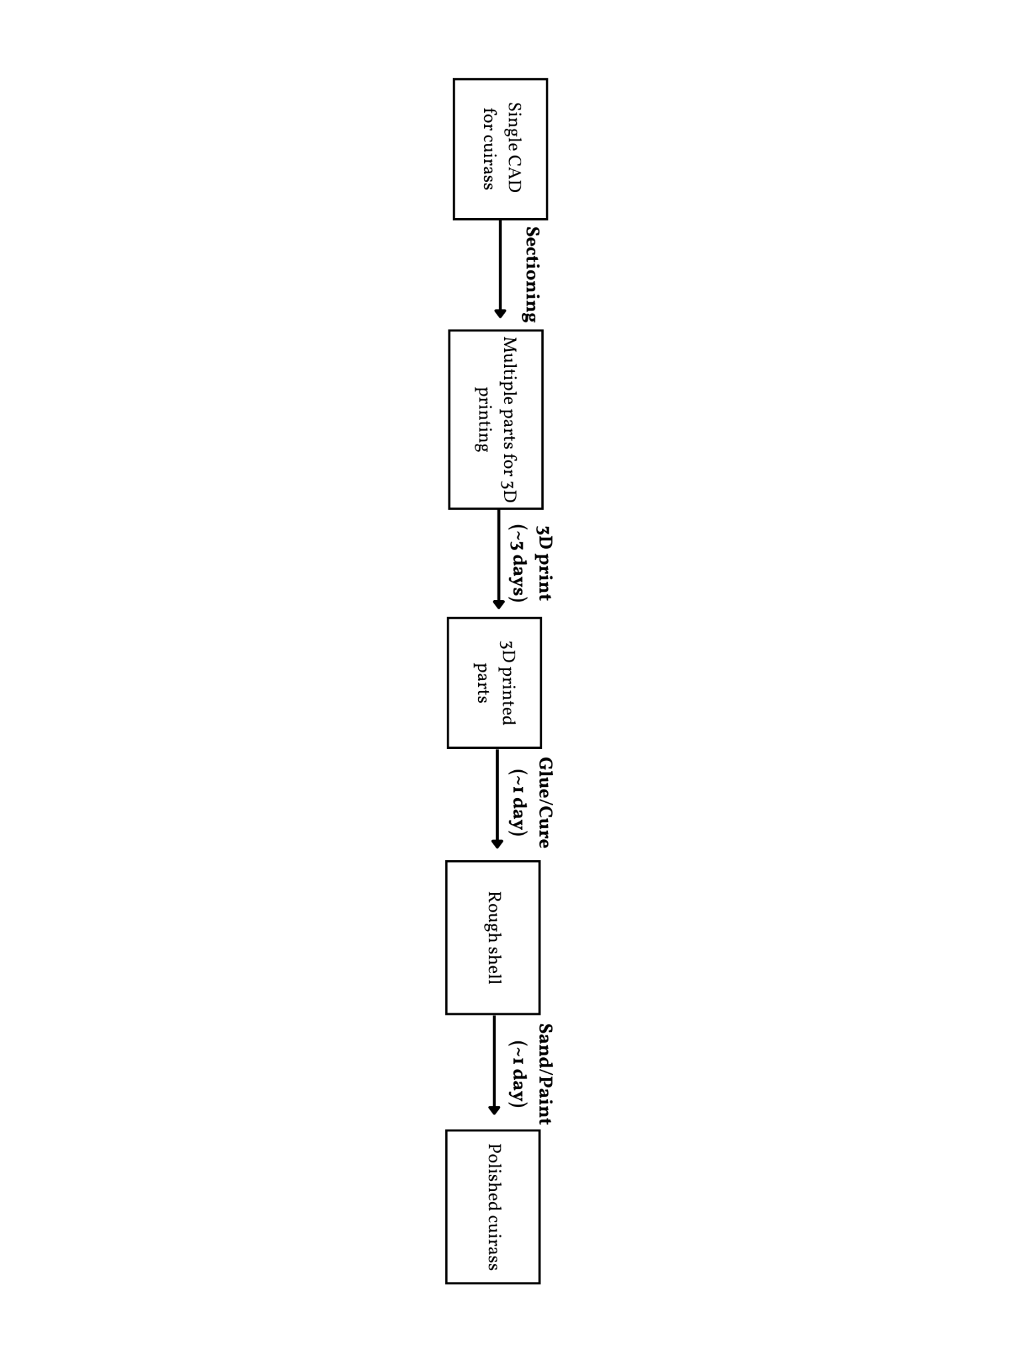

**Figure 6.16.** Cuirass prototyping flowchart

Since the cuirass is large and does not fit within most 3D printing build volume constraints, the design must be sectioned off into multiple parts, constraining each section to be smaller than the 3D printer bed size and exporting the parts to STL file. Currently, the available 3D printers at Myhal Center use the Prusa MKS3 series, with a build volume of 250 x 210 x 210 mm [137]. It would take approximately 3 days to complete all the 3D printing parts. The cuirass must be airtight and rigid, so it is recommended to use a plumber’s cement or epoxy to join PLAs [138]. More specifically, epoxy can be used as both glue and filler, to fill in possible misprints or cracks. Using epoxy will guarantee rigidity in the applied area. Epoxy requires the epoxy resin and hardener to be mixed in a correct ratio to achieve the desired bonding strengths, which means it is possible to botch the bonding process. The curing process can take up to several hours, depending on the amount applied. When cured, the epoxy can be sanded and painted to achieve a smooth finish. The entire epoxy process from start to end (completion of curing), is estimated to take 1 day. After assembling the cuirass, and leaving the epoxy to cure completely, the team would sand the entire cuirass jacket to ensure smoothness which is estimated to take 1 day. It is noted that the prototyped cuirass would be significantly heavier than the final design, to account for the weight of 3D prints and its infill density and the amount of epoxy used. The team will use caulk to connect the cuirass shell to the sealing foam.

# 7.0 Prototyping

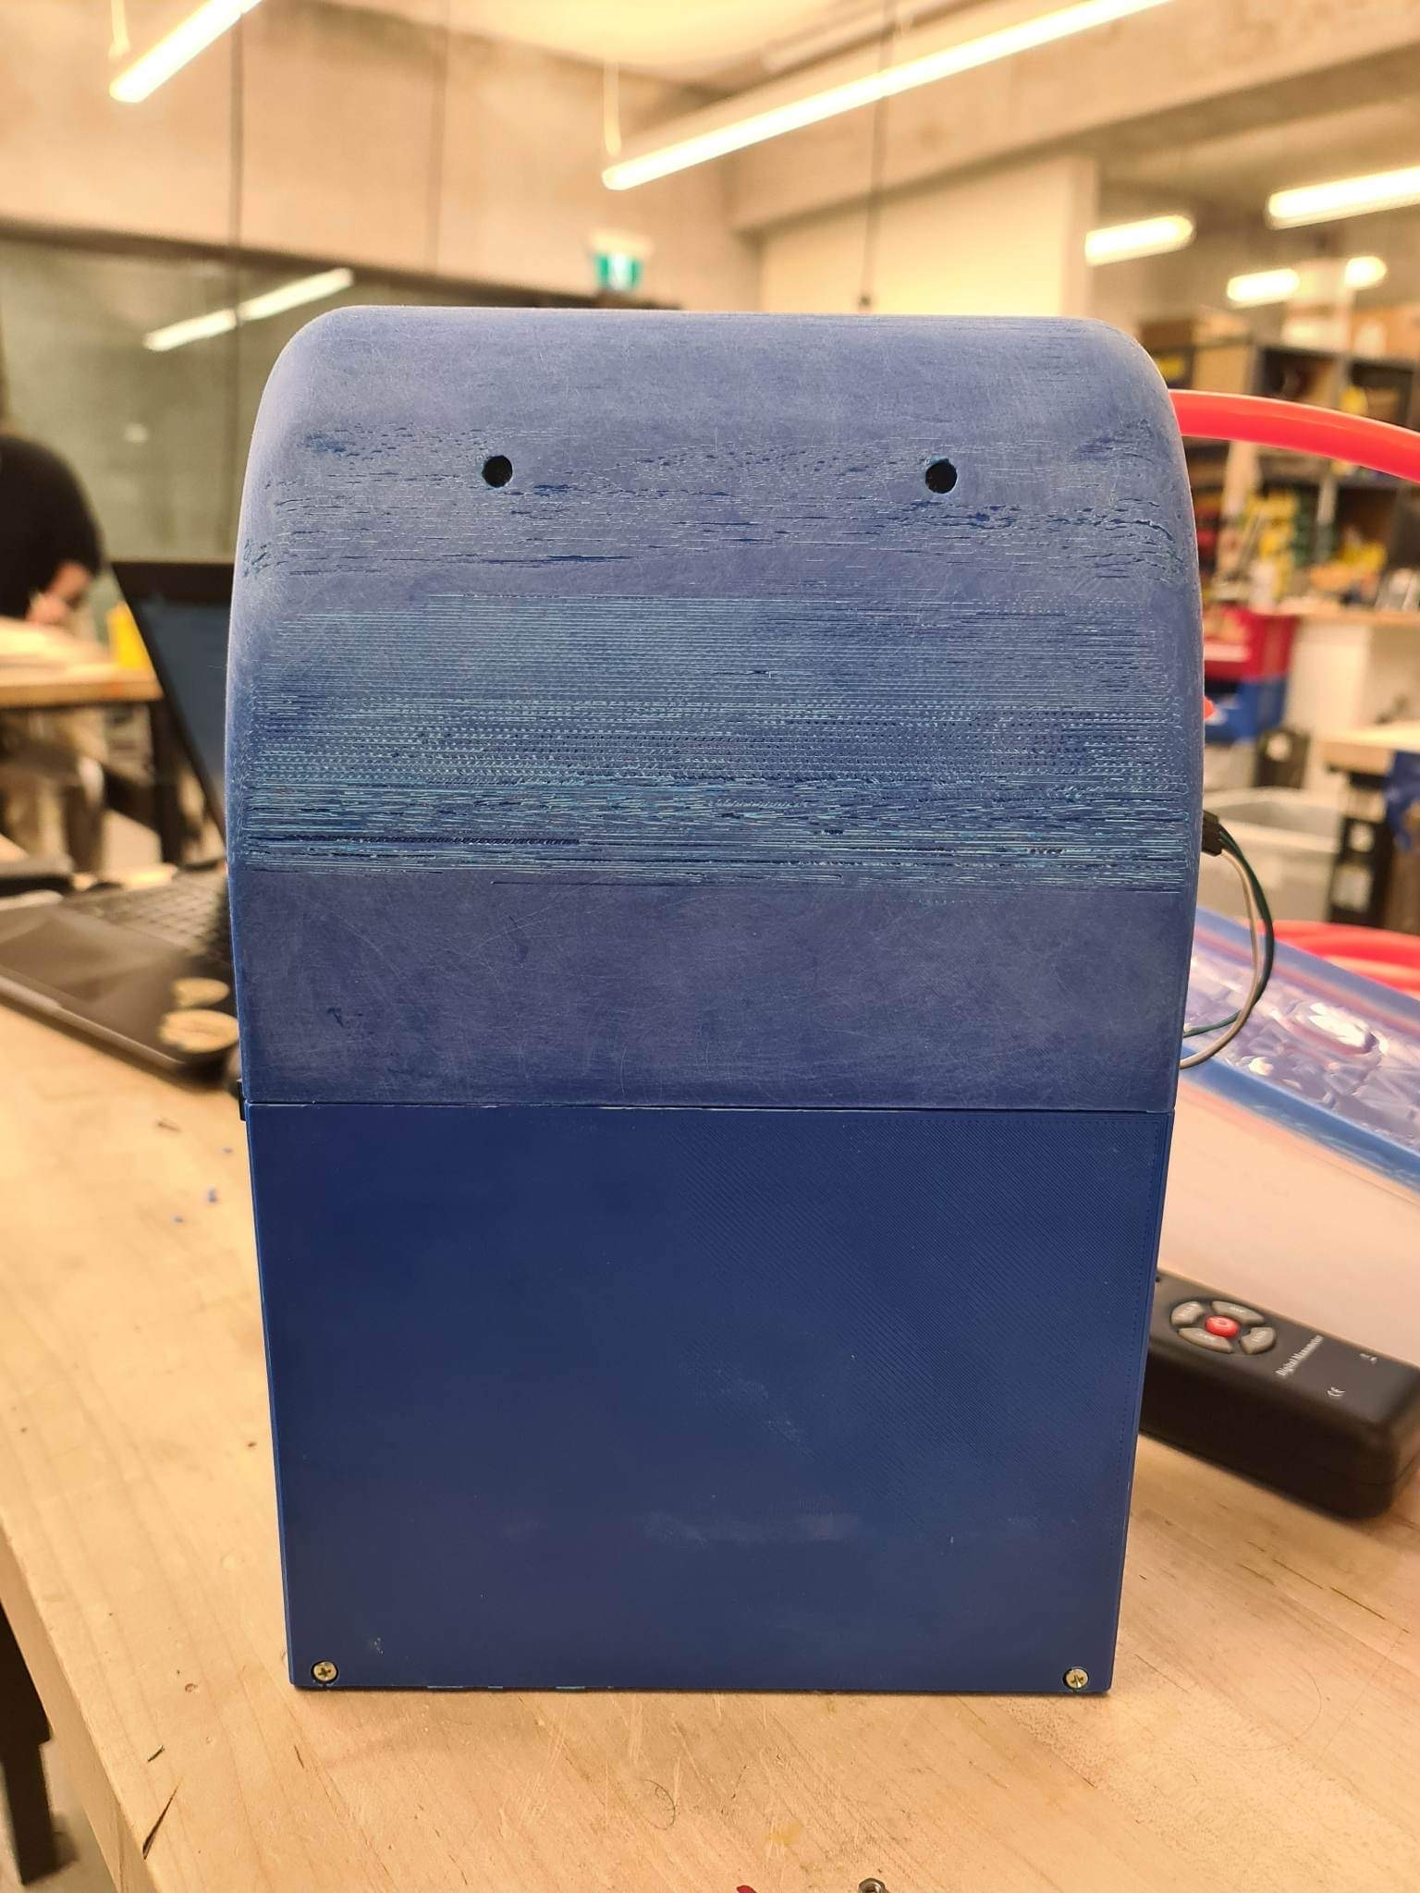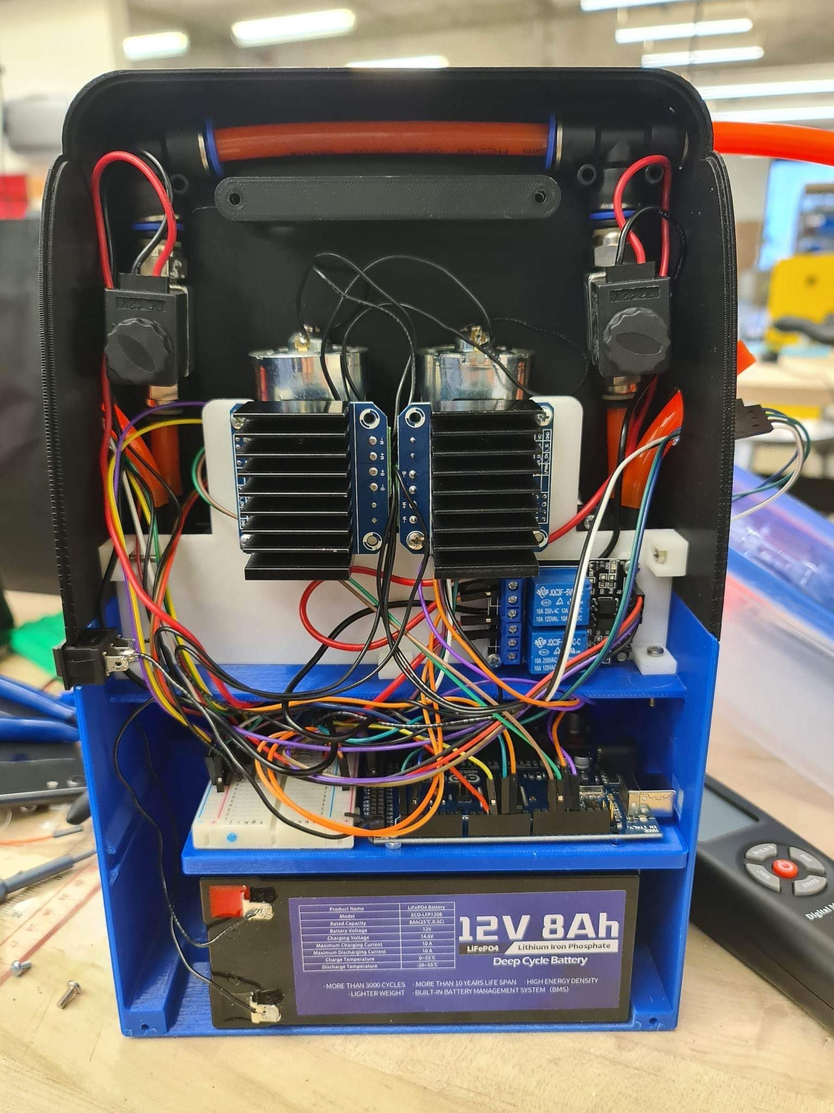

**Figure 7.1.** Final device prototype of the backpack

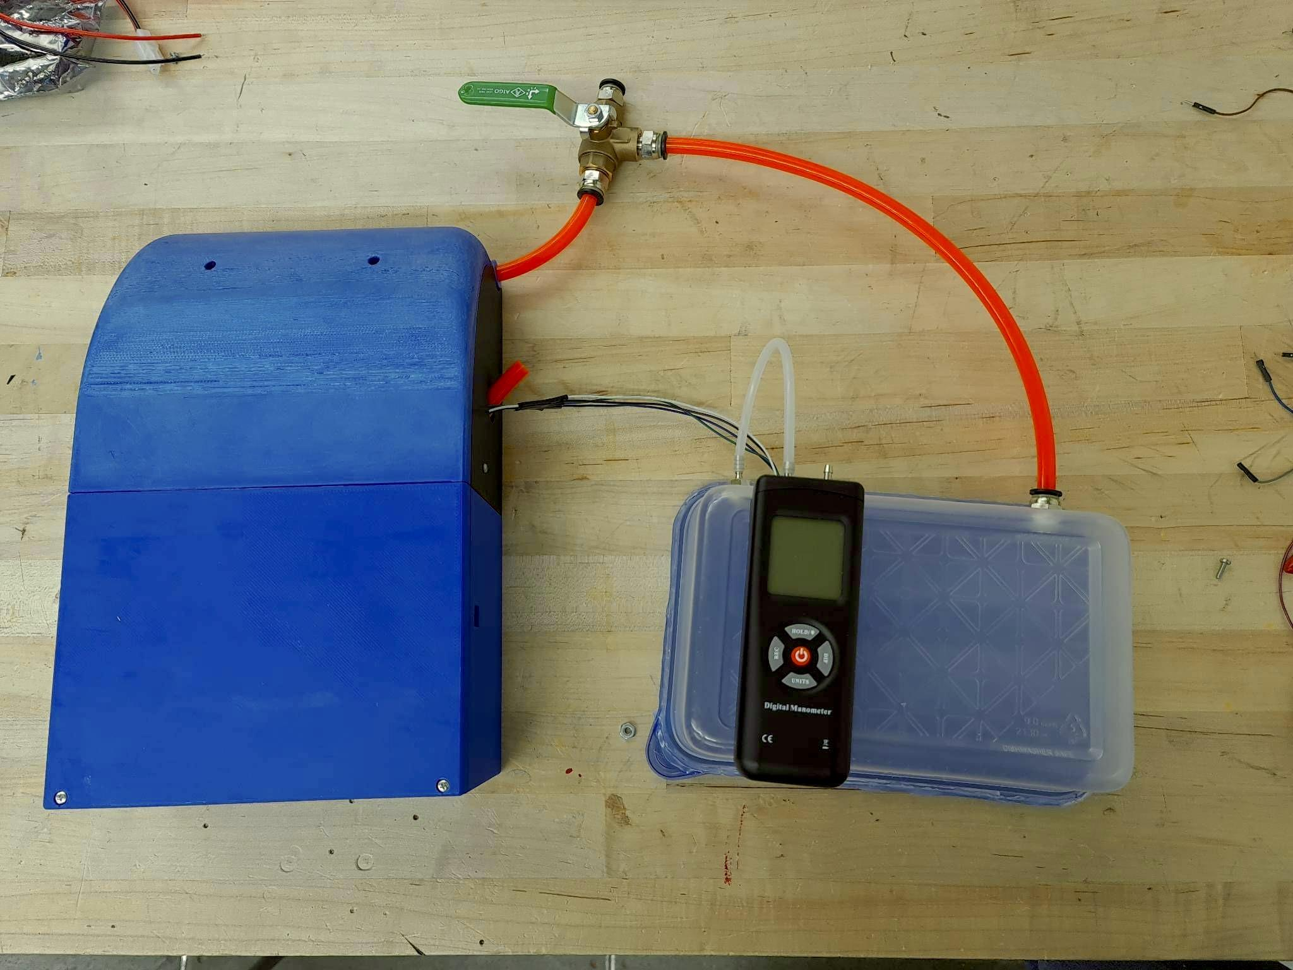

**Figure 7.2.** Entire system design, including the placeholder cuirass and digital manometer for validation

Before starting the prototyping stage, the scope of the project was redefined under consideration of its feasibility, existing expertise, time and resource constraints. After negotiating with the client to identify critical features, the redefined scope will only focus on the pressure circuit and controls system. Due to constraints with time and resources, simulating the fluid dynamics and pressure flow within the system through computational fluid dynamics (CFD) analysis will not be performed. Additional features, such as battery charging, GUI, and a user-control remote, will not be integrated in the prototype.

The prototype will only include full-control mode without assist-control, but the hardware infrastructure is present to implement this mode in the future. Additionally, most of the standards requirements cannot be met during this phase but are taken into consideration under *Section 9.4*. The components chosen to be used for the prototype, such as pumps, are selected for the purpose of achieving a Minimum Viable Product (MVP) .

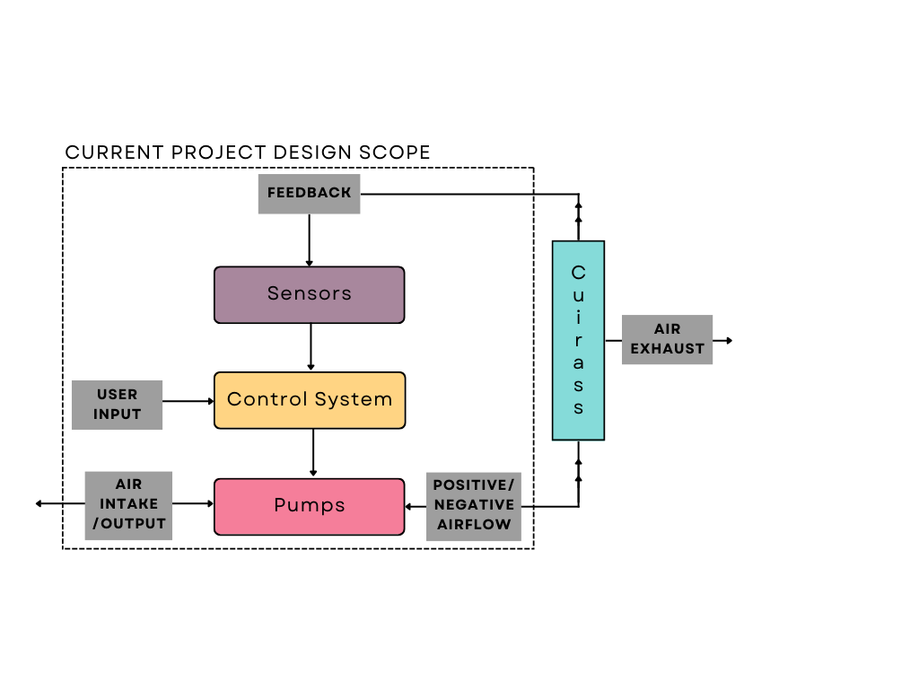

**Figure 7.3.** Revised project scope for the proposed design

## 

## 7.1 Computer-Aided Design (CAD) Model

The development of a CAD model was done using SolidWorks for the design of an enclosure for the control systems. This section will detail the preliminary approach and subsequent modifications made throughout the process to create the final prototype. The design specifications and objectives have been thoroughly examined to establish a solid foundation for the design of the CAD model. Throughout the process, the model’s feasibility and compatibility with the design specifications were continuously evaluated. Any necessary adjustments were made to ensure accuracy and functionality.

### 7.1.1 Preliminary Design

The first iteration for the “backpack” mainly focused on designing the smallest possible footprint to ensure that the device is more ergonomic, while ensuring enough maneuverability for debugging. This was achieved with a design with dimensions of 20x28x11cm, which is similar to a small backpack as can be seen from the figure below. The pressure circuit components and batteries, which occupy a significant space, were arranged in a way that balanced functionality, accessibility, and weight distribution.

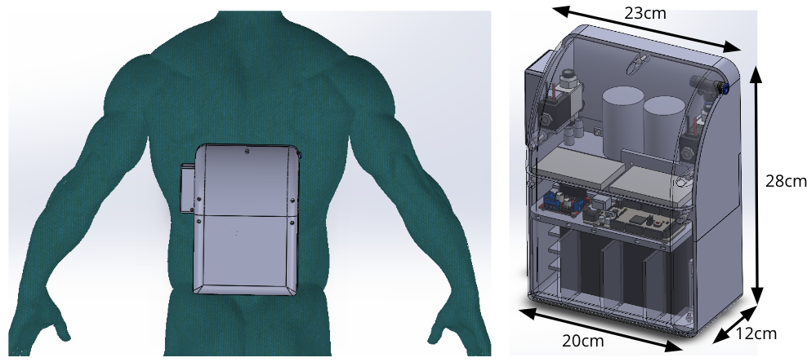

**Figure 7.4.** Dimension for the first iteration of the design

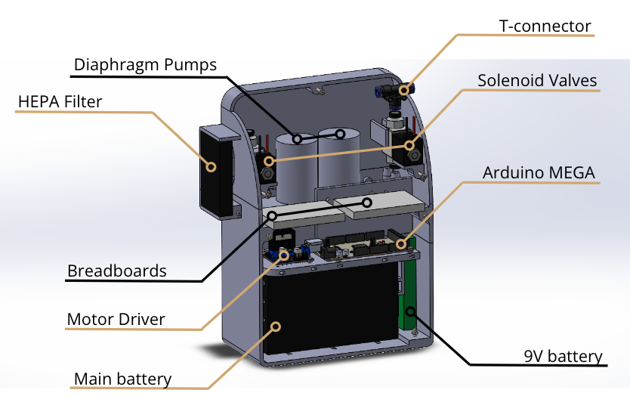

**Figure 7.5.** Preliminary CAD model backpack design

### 7.1.2 Modifications & Final Design

Some of the issues identified with the first design iteration were as follows:

1. The inability of the design to secure the pumps in place, especially due to high vibration when the pumps are operating.
2. Difficulty to access the electronics within the pressure circuit and controls system enclosure.
3. Minor differences in dimensions between the arrived components (pumps, breadboards, valves, etc.) and the preliminary model’s dimensions.

Redesigning the model to address these issues, the modified CAD model includes the following changes to improve the functionality and efficiency of the backpack.

1. Screwed assembly of the 3D printed walls presses onto the pumps clamps them in place, alongside with silicone anti-vibration pads that further dampens the vibration from the pumps during operation.
2. The electronics compartment is designed as a pull-out drawer to provide access for maintenance, debugging or testing. The Arduino MEGA communication port is accessible without disassembly through the dedicated port on the casing.
3. Overhaul of the entire dimensions were made to accommodate the actual dimensions of the components, leading to a final backpack dimensions of 20x32x11cm, which is only slightly larger than the initial dimensions.

The updated CAD model that addresses all the issues was 3D printed to produce the prototype casing. Details on printing technique, assembly, and materials used are discussed in *Section 7.3*.

## 7.2 Pressure & Electronics Circuits, Control System

The following section describes the preliminary and final design for the pressure and electronics circuits and control system.

### 7.2.1 Preliminary Design

Based on the proposed solution described in *Section 6*, the design is broken down into three major components: the pressure circuit, electronics, and controls. *Figure 7.6* and *7.7* show the initial design of pressure circuit and electronics. The pressure circuit is composed of two diaphragm pumps, three solenoid valves and a manual valve, details are under *Section 6.1*.



***Figure 7.6:*** *Initial pressure circuit diagram*

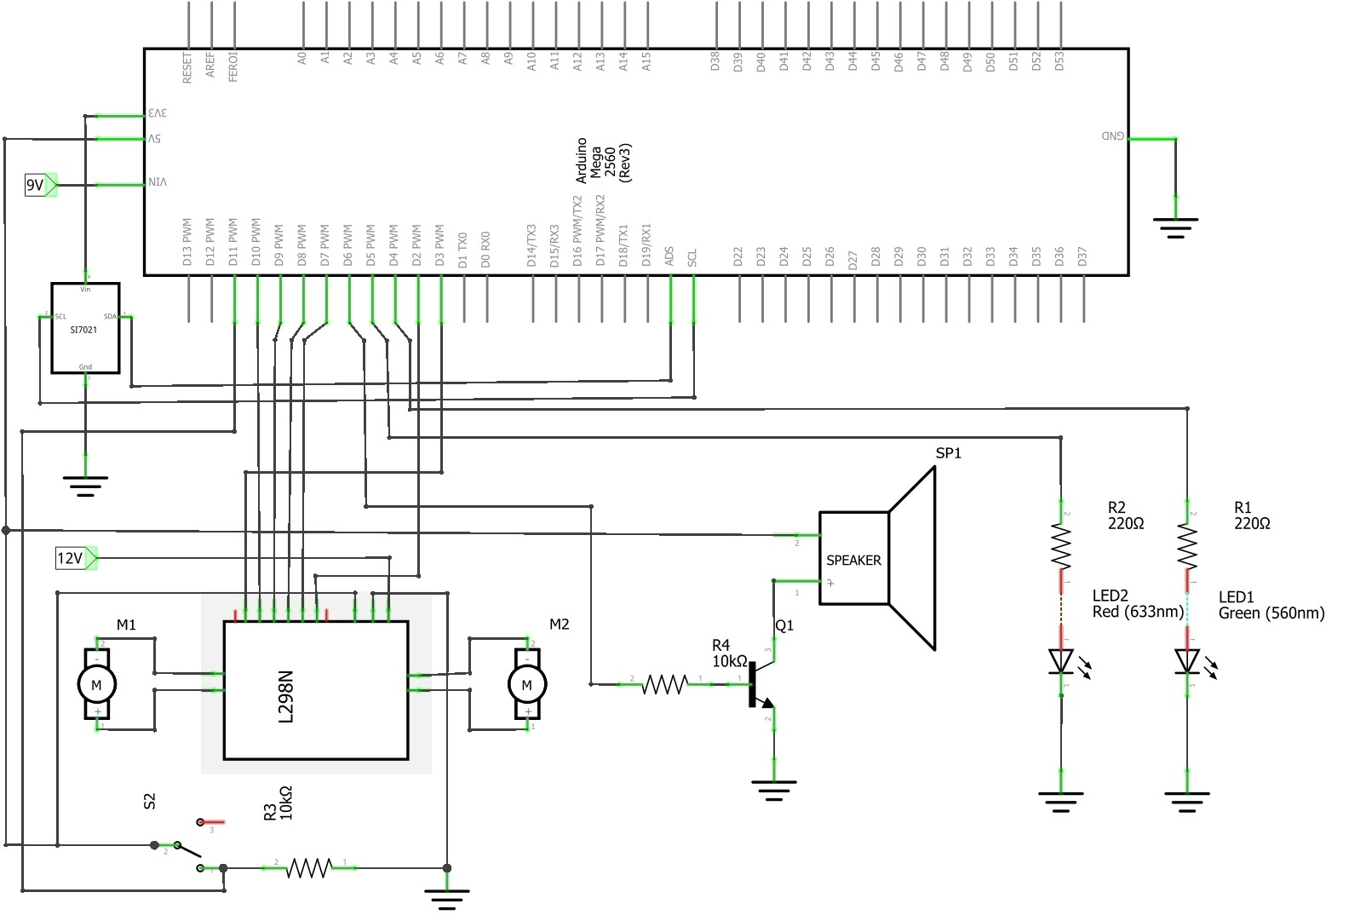

***Figure 7.7:*** *Initial electronics design*

The initial control system was programmed on Arduino IDE. The system was split into separate functions to set up control signals, receive the pressure reading from the sensor, parse user input, set NPV mode or BPV mode, and manage the safety alarm system. More details on the programming of the control system are under *Section 7.3.3*.

### 7.2.2 Modifications & Final Design

After assembling the pressure circuit and electronics initial testing some issues were identified.

1. Power delivered to the pumps was less than the desired 12V.
2. By default, valves are closed unless current and a voltage up to 12V is provided. However, the Arduino can only provide up to 5V, while controlling when they are opened or closed.
3. There was no visual cue for low and medium priority warnings.
4. The pumps draw up to 3.5A of current, but the L298N motor driver used is only rated to 2A. Thus, the pumps require more current than the driver provides, resulting in poor performance and possible damage.

To address these issues, the following adjustments were made:

1. A buck boost converter was added to increase and regulate voltage delivered to the pumps to ensure consistent voltage despite battery charge.
2. A relay module was added to supply 12V to valves with 5V control signals from Arduino.
3. A yellow LED was added in addition to the red and green LEDs for low and medium priority warnings. This light can be either off, on, or flashing to indicate different warning levels.
4. Motor driver for the pump was replaced to support 3.5A or more.

Addition of electronic components to support the intended function of the design required further modifications to the 3D printed casing where the parts are mounted.

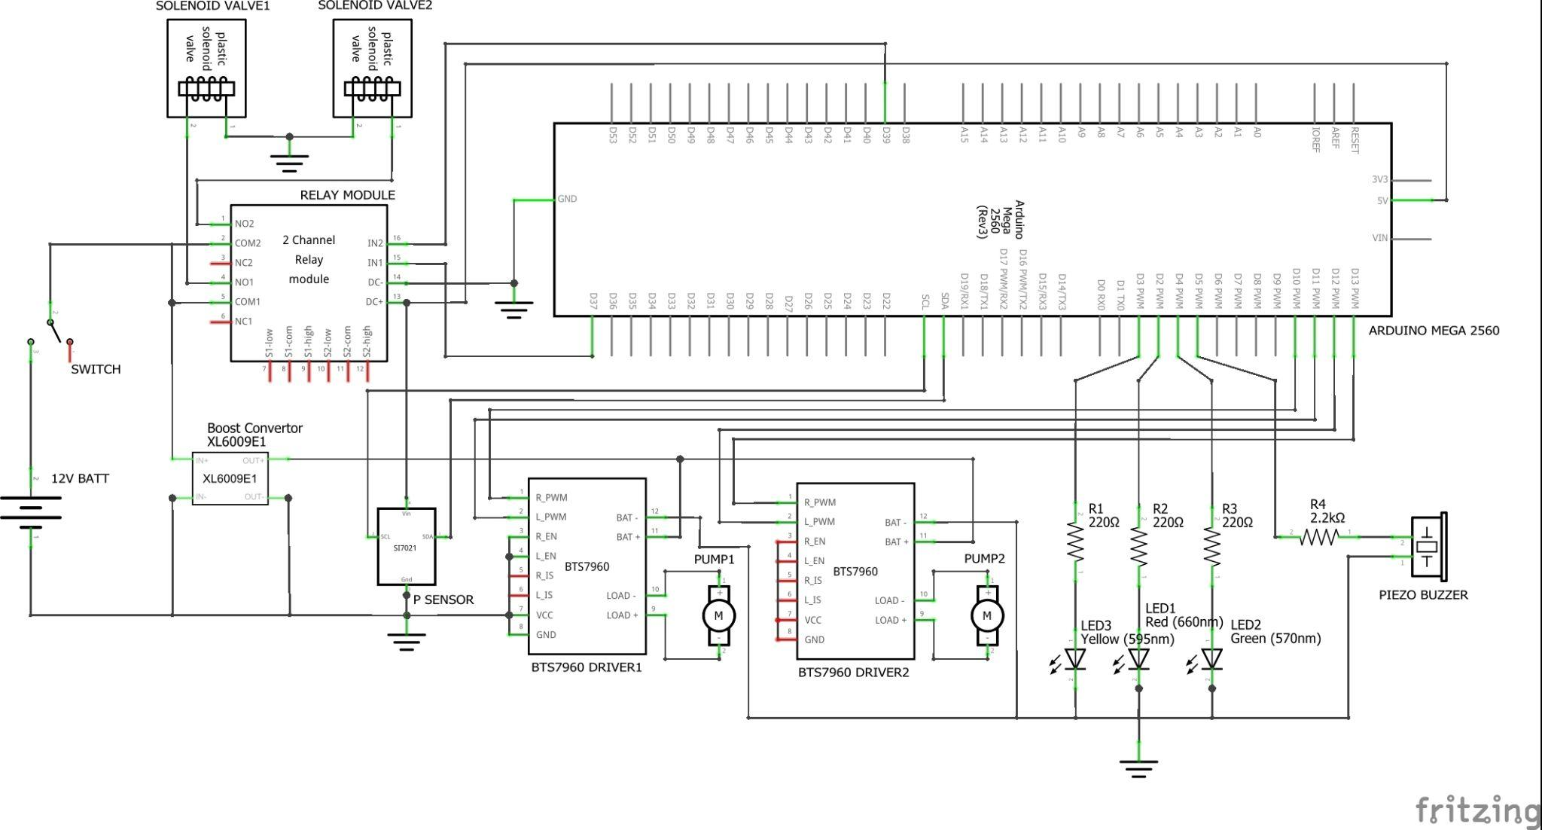

***Figure 7.8:*** *Modified electronics design*

## 7.3 Building & Assembly

The prototype requires integration and assembly of the backpack enclosure, the pressure circuit, and electronics. This section details the assembly method for each part, as well as the challenges and considerations throughout the design process.

### 7.3.1 Assembly I: Backpack Enclosure

The backpack enclosure is 3D printed with PLA filament, using Original Prusa Mk3/s with 0.4mm nozzle diameter, 0.2mm height resolution and 15% cubic infill. Due to printing size restrictions, the final assembly was broken down into four sections: the top cover and top compartment, and bottom cover and bottom compartment, as can be seen in *Figure 7.9* and *Figure 7.10* below.

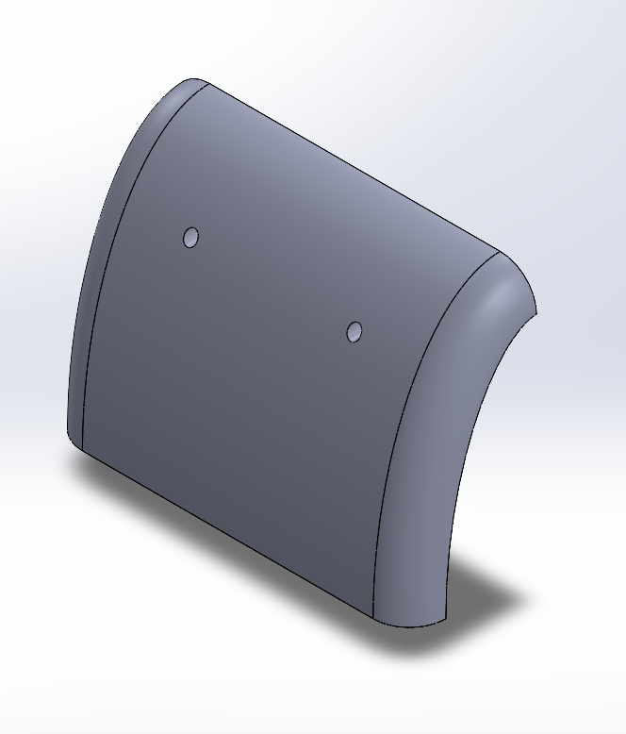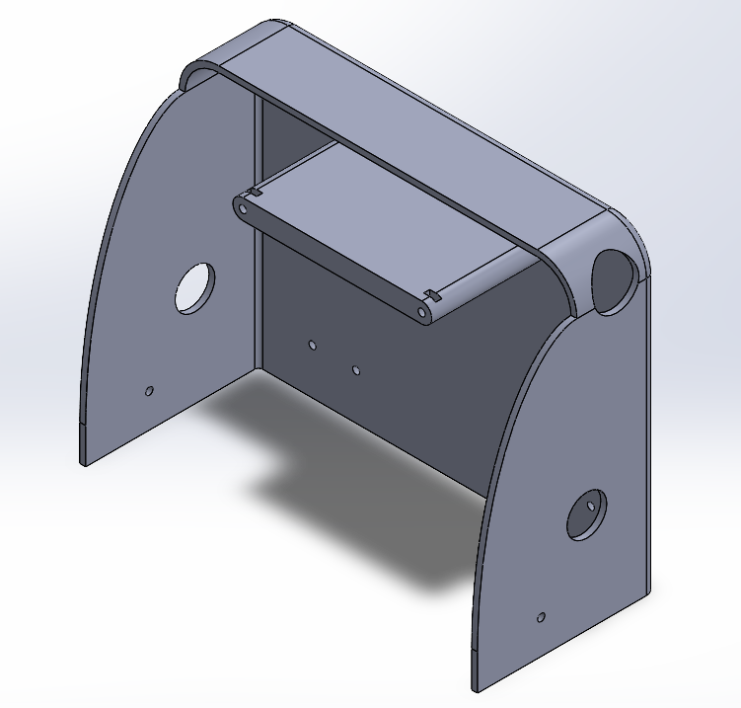

**Figure 7.9.** (From left to right) Top cover, Top compartment

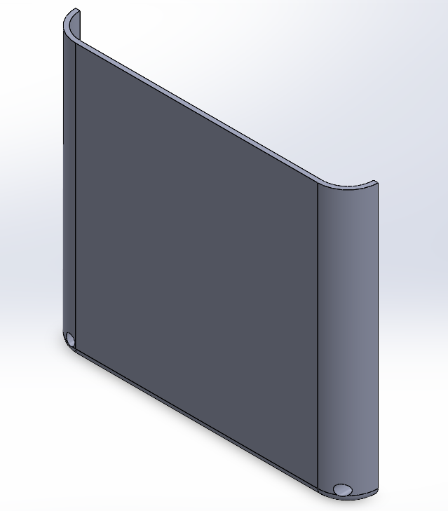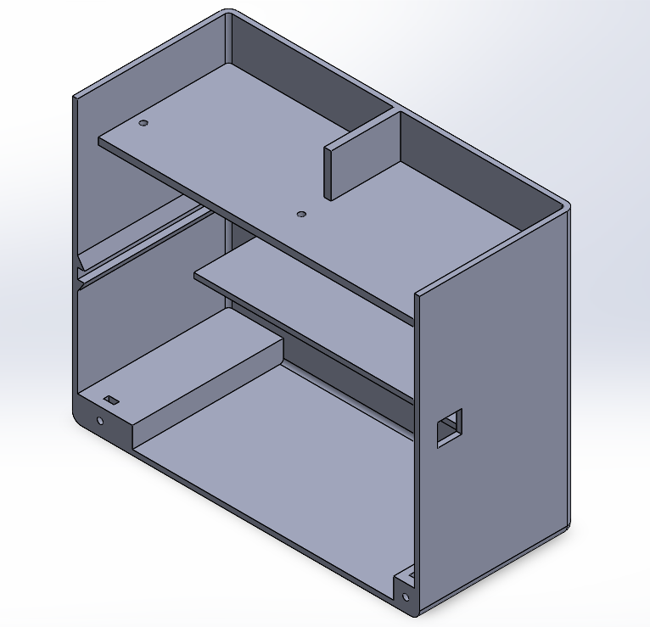

**Figure 7.10.** (From left to right) Bottom cover, Bottom compartment

Before assembly, the individual parts are sanded down to ensure that any rough or uneven surfaces are smoothed out after printing, in order to ensure that the parts fit together properly and securely, without any gaps or inconsistencies that could compromise the integrity of the enclosure structure. Prior to assembling the enclosure, the electronic parts were primarily fixed onto the two additional 3D printed plates as depicted in *Figure 7.11* and *Figure 7.12*. Bolts and nuts were used to affix electronics onto the case and to join these parts into a full enclosure as depicted in *Figure 7.1.*

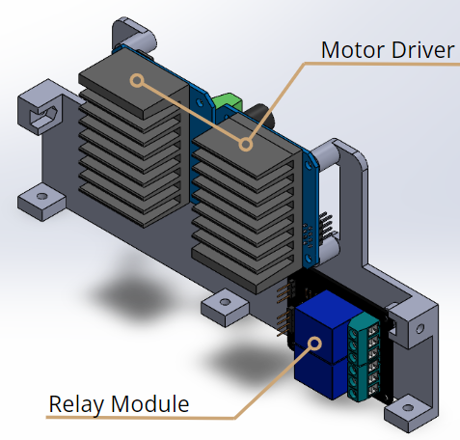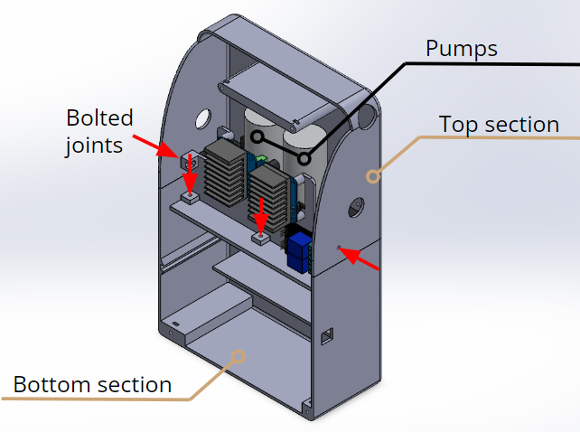

**Figure 7.11.** Wall with Electronic parts installed (Left), Wall connecting two sections (Right).

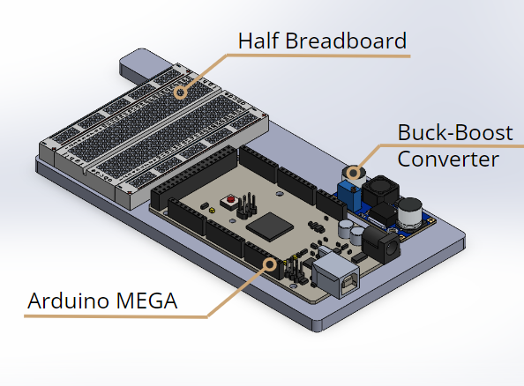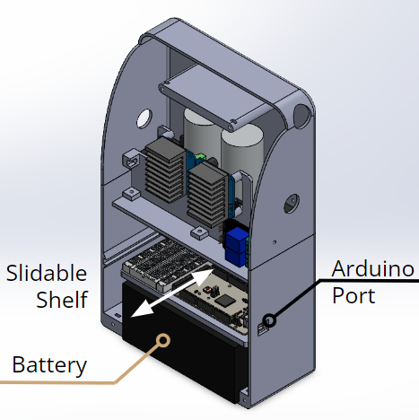

**Figure 7.12.** Shelf with Electronic parts installed (Left), Shelf installed in enclosure (Right).

The compartment attachment configurations are as follows:

1. Two pumps, wrapped in layers of silicone for vibration damping, are installed to the top section with bolted joints. The pipes and valves are installed at this stage with the pumps (*Section 7.3.2*).
2. Battery is fitted into the bottom section
3. Electronics are installed to Wall and Shelf using bolts, nuts, and tape (for breadboard).
4. Top section is joined with the bottom section by the wall that has electronics (5 bolts).
5. Top cover and bottom cover joined with top and bottom section respectively (5 bolts).

The final enclosure design, however, presents some issues that require attention and further consideration in future design iterations in order to present a more robust device. Currently, the team presented interim solutions to address these issues, presented in the table below.

***Table 7.1:*** *Enclosure design issues outline*

| **No.** | **Design issues** | **Interim/Current solution** | **Future suggestion** |
| --- | --- | --- | --- |
| 1 | No supportive fixture at the middle section between top and bottom covers. | Reinforce with tape as adhesives. | Redesign the model to include screws between the covers. |
| 2 | Exposed wiring for LEDs and pressure sensor connected to the cuirass. | Protection using black insulation tapes. | Redesign the model to include proper ports, or use Bluetooth instead of wired connection. |
| 3 | No proper means of ventilation for cooling within the enclosure. | *Not addressed* | Include vents or small fans and thermal fins within the enclosure. |

## 

### 7.3.2 Assembly II: Pressure Circuit

The pressure circuit assembly uses four 5-cm, two 11.5-cm, and one 30.5-cm long tubes. The tubes are joined using multiple push-lock male connectors, two solenoid valves and one mechanically actuated valve located outside the enclosure, near the cuirass. Refer to *Figure 7.13* and *7.14* for pressure circuit assembly. The two pumps were installed in the case with silicone anti-vibration pads along the perimeters of the pumps’ enclosure. The 30.5-cm long tube was then connected to the simulated cuirass volume.

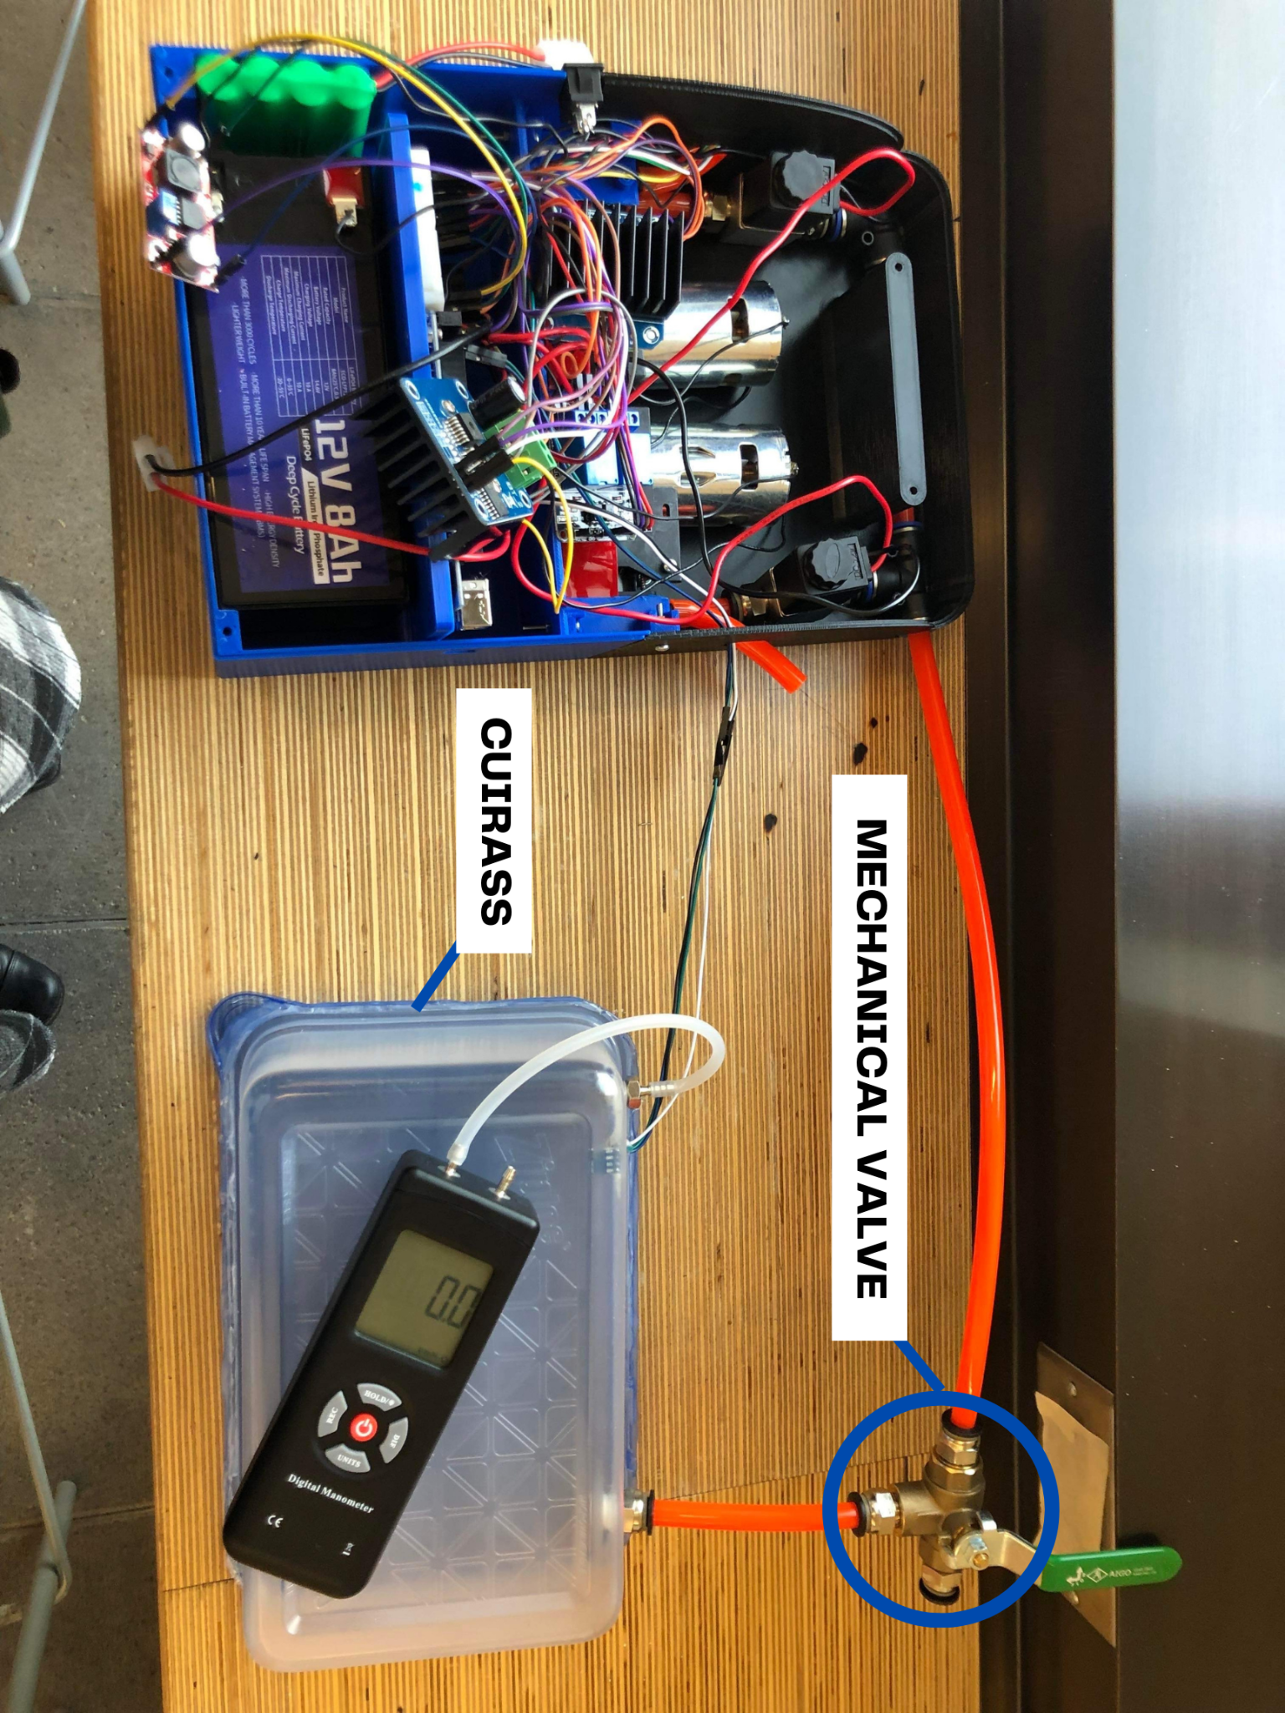

**Figure 7.13.** Connection of the tube from backpack to the cuirass

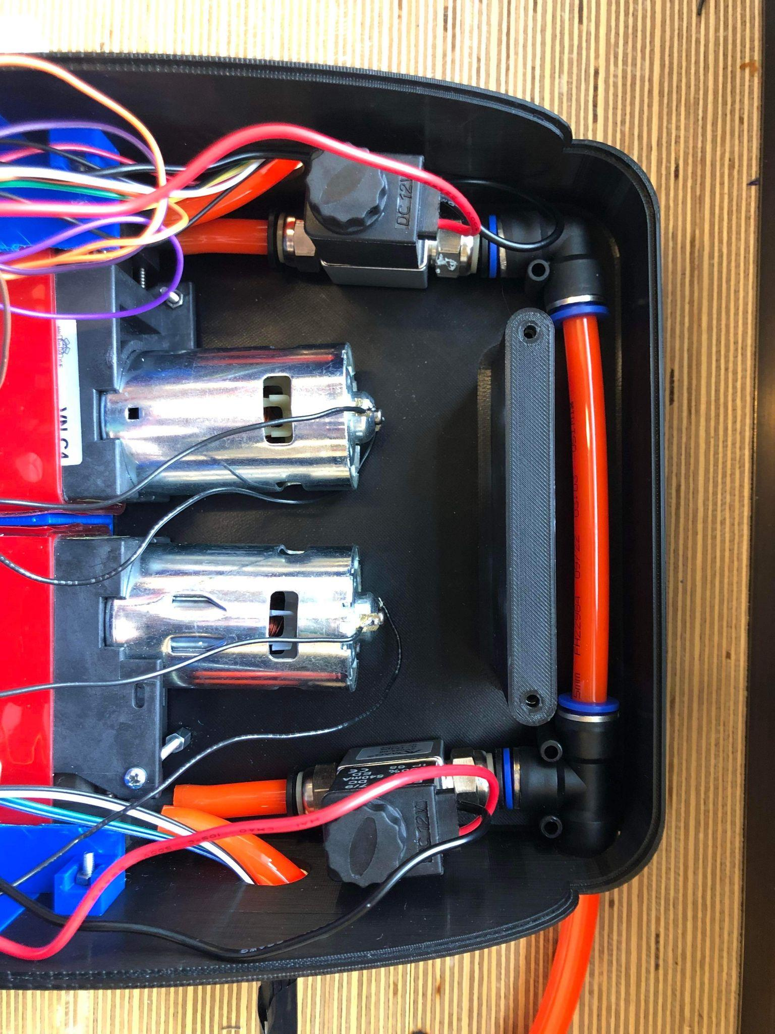

**Figure 7.14.** Close up view of the final pressure circuit assembly

***Table 7.2:*** *Enclosure design issues outline*

| **No.** | **Design issues** | **Interim/Current solution** | **Future suggestion** |
| --- | --- | --- | --- |
| 1 | Absence of cuirass due to revised scope (out of scope). | Polypropylene (PP) case of volume 2.13L used as placeholder for testing purposes. | Design a cuirass that is wearable, durable, and able to provide a good seal during operation. |
| 2 | Mechanical valve is not easily accessible for emergency use by the user due to its placement. | Mechanical valve is positioned nearer to the cuirass. | Place the mechanical valve on the cuirass itself, or where it is easily reachable for the user. |
| 3 | No filters included for the final design. | *Not addressed* | Use a HEPA filter, installed near the intake air vent to filter small air particles. |

Design issues 2 and 3 were not considered critical to the device's operation during the prototype stage, but neglecting these components can lead to pump malfunctions and pose a safety risk to the user during emergency situations. Therefore, for the development of a more sophisticated prototype, these issues need to be addressed to ensure proper functionality and eliminate potential safety hazards.

### 7.3.3 Assembly III: Electronics

The electronic components are wired based on the schematic in *Figure 7.8.* Components including the batteries, pressure sensor, and buck boost required soldering. The majority of the components are connected through the breadboard with distinct colored jumper wires. Since there are many wired connections, shortening the length of the wire and grouping the wire by color helped with organization and debugging. The electronic components are controlled with an Arduino MEGA, programmed using the Arduino IDE. Through rigorous testing and few failed attempts with the parts selection, the current components are ensured to achieve functionalities to compose an MVP.

Using an Arduino MEGA and the Arduino IDE, *Figure 7.15* summarizes the structure of the code that was utilized in the control system of the device. *Figure 7.16* and *Figure 7.17* displays the ideation and logic behind NPV and BPV modes, respectively.

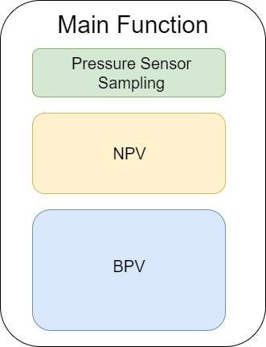 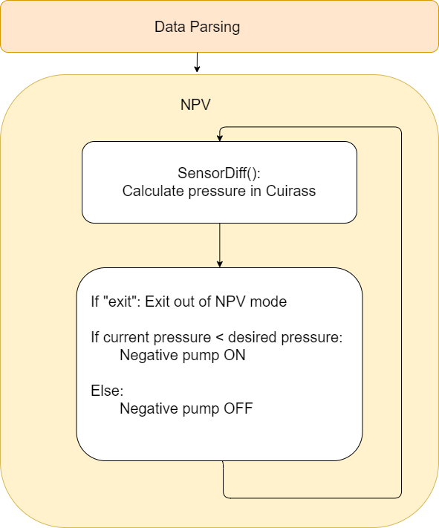

**Figure 7.15.** Skeletal structure of the arduino code **Figure 7.16.** NPV Mode

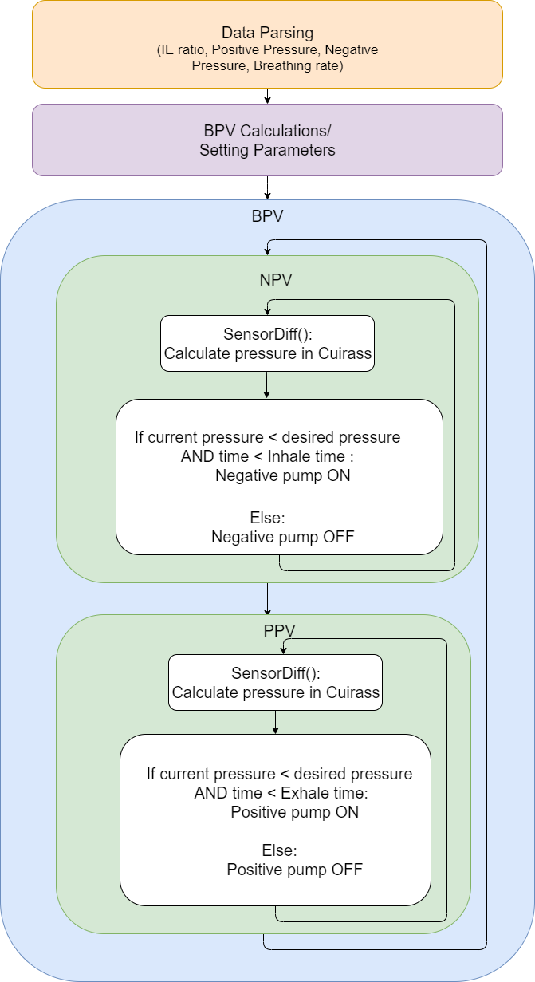

***Figure 7.17.*** *BPV Mode*

## 7.4 Prototyping Cost

This section provides a comprehensive cost breakdown of the expenses associated with manufacturing and testing of the prototype device. This determines the feasibility of manufacturing the device within certain budget limitations and how the actual price will compare to the current market price for a portable ventilator device. In *Table 7.3*, the Bill of Materials (BOM) consists of all the necessary materials used to build the final prototype that are essential for its functional use. However, it does not include any parts that were replaced during the manufacturing process, taxes or shipping charges for the components. The overall cost estimate is determined on a per-item unit cost basis, which means that any extra materials not used are not included in the cost calculation. However, this is not applicable for the tapes and tubes.

**Table 7.3:** Bill of materials for the prototype

| **Component** | **Specifications** | **Qty** | **Unit Cost** | **Total Cost** |
| --- | --- | --- | --- | --- |
| **Wearable Jacket & Cuirass** | | | | |
| Enclosure | 3D Print | 1 |  |  |
| Cuirass (simulated) | Plastic container 2130 mL | 1 | 3.00 | 3.00 |
| **Pressure Circuit** | | | | |
| Diaphragm Pump | DC12V 42W -85KPa, Flow 40L/min | 2 | 42.50 | 85.00 |
| Solenoid Valve | 12V DC ¼” 2-Way Normally Closed, 6.5W | 2 | 19.99 | 39.98 |
| Mechanical Valve | Ball Type Drain Valve, ¼” NPT | 1 | 28.99 | 28.99 |
| Male Connector | 10mm OD, ¼” NPT | 5 | 1.93 | 9.65 |
| Pipes | PU, 10mm OD, 5 Meters ⅛PT | 1 | 35.49 | 35.49 |
| **Controls System** | | | | |
| Pressure Sensor | BMP180 Barometric pressure and temp.  Resolution: up to 0.03hPa / 0.25m | 1 | 13.50 | 13.50 |
| Controller | Arduino Mega 2560 | 1 | 14.08 | 14.08 |
| 12V Battery | Rechargeable LiFePO4 12V, 8Ah | 1 | 71.99 | 71.99 |
| 9.6V Battery | Rechargeable Ni-Cd 9.6V, 1000mAh | 1 | 22.99 | 22.99 |
| Motor Driver | BTS7960 43A High Motor Driver Module | 2 | 13.39 | 26.79 |
| Relay Module | 5V 2-Channel Relay Module | 1 | 9.50 | 9.50 |
| **Hardware** | | | | |
| Screws, bolts, nuts | M3 (assorted length) | 14 | 0.20 | 2.80 |
| Electrical Tape |  | 1 | 1.20 | 1.20 |
| Teflon Tape |  | 1 | 2.22 | 2.22 |
| **Electronics** | | | | |
| USB Cable | USB A to USB B Cable | 1 | 1.78 | 1.78 |
| Breadboard | Small 54x82mm | 1 | 0.86 | 0.86 |
| Battery Connector | Tamiya connector | 1 | 1.69 | 1.69 |
| Jumper Cables | M-M, F-M, F-F | 50 | 0.06 | 3.00 |
| LEDs | Green, yellow, red | 3 | 0.02 | 0.06 |
| Piezo Buzzer | Single tone 12V, 4000 Hz, 85dBA, max 20mA | 1 | 0.98 | 0.98 |
| Resistors | 220Ω ±5% (x3), 2kΩ ±5% (x1) | 4 | 0.01 | 0.04 |
| Buck Boost Converter | XL6009 DC-DC 3.0-30 V to 5-35 V  Max output current: 4A | 1 | 11.50 | 11.50 |
| Switch | SPDT slide switch | 1 | 0.69 | 0.69 |
|  |  | **GRAND TOTAL** | | 387.78 |

Overall, the design manages to achieve the cost objective of below C$500 for the prototyping costs. In addition to that, the final prototype also meets all functional requirements specified in the project scope, demonstrating the successful integration of cost-effective and efficient design processes to produce a high-quality prototype device.

## 7.5 Adherence to Existing Risk and Mitigation Plan

Previously, we have conducted the Preliminary Hazard Analysis (PHA) and a brief Hazard & Operability Study (HAZOP) for the proposed design. Progressing on to our next step in the prototype stage, the main focus shifts on focusing our effort to adhere with the current plan and constantly assessing our scope for the safety feature of the device itself. The table below indicates the current action that the team undertook for our risk and mitigation plan that fall within the risk plan scope, along with the important components that we have not considered for this prototype. These exceptions are considered to be out of scope to reduce the prototype’s overall complexity of design integration between each main working components.

For the three systems in our safety plan scope, the standards that mainly referenced for prototype design specifications, was from IEC60601 (Medical Electrical Equipment: General requirements for basic safety and essential performance) [56]. All of the design specifications of the safety systems are detailed in the following subsections.

**Table 7.4:** System components and risk plan scope

| **System components** | **In Risk Plan Scope (YES/NO)** | **Current State/Application in prototype stage** |
| --- | --- | --- |
| Alarm system | YES | Efforts made to adhere to risk plan |
| Safety valve system | YES | Efforts made to adhere to risk plan |
| Safety pressure system | YES | Efforts made to adhere to risk plan |
| Heat management system | NO | *Not considered* |
| Cuirass safety precautions | NO | *Not considered* |

### 7.5.1 Alarm System Design

Part 1-8 of the IEC60601 outlines the guidance for designing a visual and auditory alarm signal for medical electrical equipment [56]. The current prototype implements the standards through use of a buzzer and three LED lights within the control system. The alarm system consists of two main modules: LED Indicator Lights and Buzzer Auditory Signal.

**LED Indicator Lights**

The prototype has three modes: High, Medium and Low Priority modes, summed up in the Table 7.5 below. The system is programmed to constantly monitor and transmit mainly pressure readings from the pressure sensor system. Different level of priorities for High, Medium and Low are identical to the three risk levels of Unacceptable, Medium, Low respectively. Current prototype incorporated the indicator lights into the design at the side of the backpack enclosure for simplicity and proof-of-concept, but for more user visibility in future prototype iterations, the visual alarm signal should be placed near the cuirass, within user’s peripheral view where it is easier for the user to monitor the device’s status. *Figure 7.18* below shows the three indicator lights at the side of the enclosure.

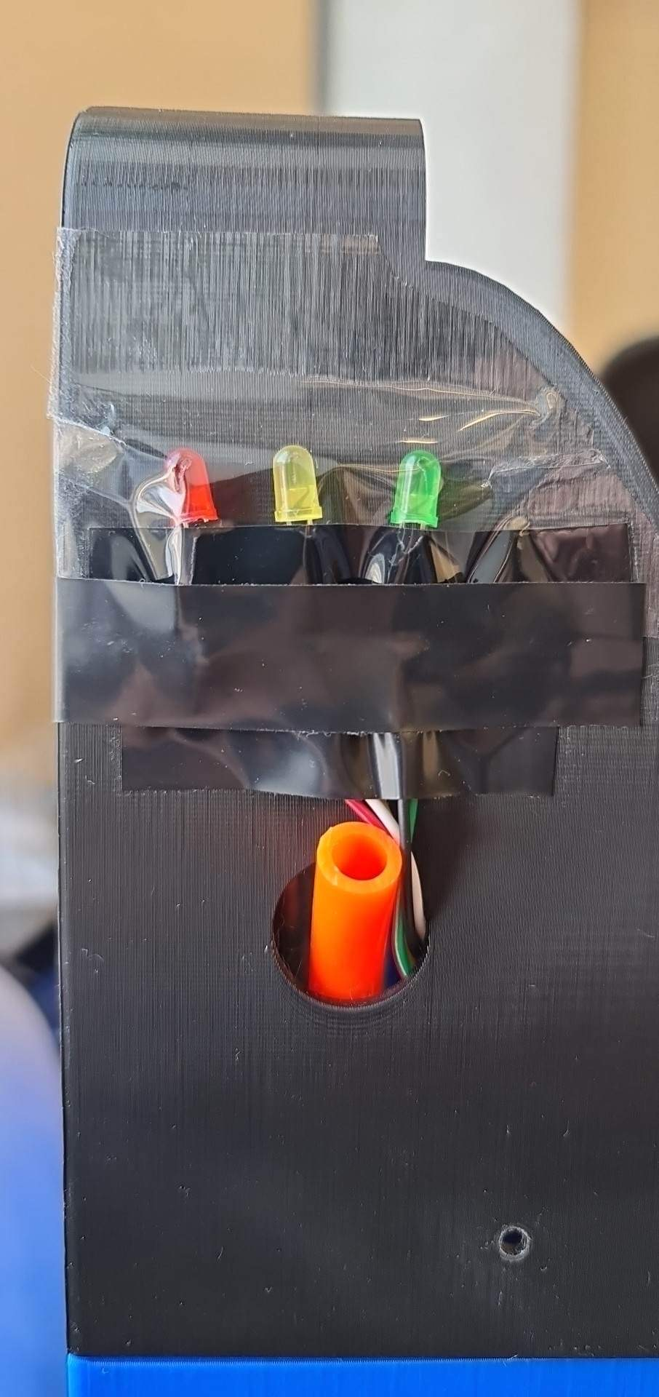

**Figure 7.18.** Indicator lights at the side of the backpack

**Table 7.5:** Characteristics of alarm indicator lights [56]

| **Alarm Category** | **Indicator Color** | **Flashing Frequency** | **Duty cycle** |
| --- | --- | --- | --- |
| High Priority | Red | 2.1 Hz | 40% on |
| Medium Priority | Yellow | 0.6 Hz | 40% on |
| Low Priority | Cyan | Constant (on) | 100% on |

**Buzzer Auditory Signal**

Burst auditory alarm signals accompanied with the LED indicator lights are implemented based on user-oriented design for the device in order to provide redundancy in case of obstructed view of the visual alarm signal during emergency situations and also to increase user response time through combination of both alarm signals. The following table details how the prototype was programmed to use existing information for integration with the existing visual alarm signal during emergency/hazardous situations.

**Table 7.6:** Characteristics of the burst auditory alarm signals [56]

| **Alarm Category** | **Number of beeps** | **Time between beeps** | **Sound Level/Volume** |
| --- | --- | --- | --- |
| High Priority | 10 | 125 ms | 35 dB from 1m distance |
| Medium Priority | 3 | 250 ms | 35 dB from 1m distance |
| Low Priority | 1 or 2 | 250 ms | 35 dB from 1m distance |

### 7.5.2 Safety Valve System Design

Our design of the safety valve system closely abides under section 9.77 (Pressure-relief devices) from IEC 60601-1 [56]. The prototype’s adherence to the requirements are detailed in the table below.

**Table 7.7:** Pressure-relief requirements for ME equipments

| **No.** | **Pressure-relief device requirements** | **Comply** |
| --- | --- | --- |
| 1 | Connected as close as reasonably practical to the pressure vessel or parts of the system that it is intended to protect. | *YES* |
| 2 | Installation that it is readily accessible for inspection, maintenance and repair. | *YES* |
| 3 | Not be capable of being adjusted or rendered inoperative without the use of a tool. | *YES* |
| 4 | Have its discharge opening so located and directed that the released material is not directed towards any person. | *YES* |
| 5 | Have its discharge opening so located and directed that operation of the device will not deposit material on parts that could result in an Unacceptable Risk. | *YES* |
| 6 | Adequate discharge capacity to ensure that the pressure will not exceed the maximum equipment pressure of the system to which it is connected by more than 10 % in the event of a failure in the control of the supply pressure. | *NO* |
| 7 | No shut-off valve between a pressure-relief device and the parts that it is intended to protect. | *YES* |
| 8 | The minimum number of cycles of operation shall be 100,000 except for one-time use devices. | *NO* |

The two requirements that cannot be met by the prototype are both due to a need for further testing, which can be achieved in future iterations of the device itself. Initially, the design consisted of three solenoid (automatic) valves and one manual valve within the safety design. However, upon conducting a more thorough investigation during the design of our prototype, the team discovered that the solenoid valves are normally closed which needs a constant supply of power for it to be open during operation, which easily heats up the wires in circumstances where a long open valve setting is required during emergencies. Hence, the final safety design will reduce redundancy in consideration for the prototype’s efficiency.

### 7.5.3 Safety Pressure System Design

Bidirectional pressure sensor was installed inside of the cuirass for pressure monitoring between pressure input by the pumps and the measured pressure within the cuirass. This safety feature provides redundancy alongside the mechanical valve in the pressure circuit, acting as one of the failsafe mechanisms if one or the other pressure relief mechanisms fail to work. In order to properly analyze the risks associated with the system design, where the safety-critical role of the design heavily depends on the use of programmable medical electrical systems, our team refers to clause 14: Programmable Electrical Medical Systems (PEMS) for the general requirements [56].

**Table 7.8:** PEMS requirements for ME equipments

| **No.** | **PEMS device requirements** | **Comply** |
| --- | --- | --- |
| 1 | The safety features are designed to detect and respond to any errors in the hardware or software of the pressure sensor module. | *YES* |
| 2 | The safety features are fail-safe, meaning that the device will continue to operate safely even in the event of a fault. | *YES* |
| 3 | The safety features are validated and verified to ensure that they function as intended. | *YES* |
| 4 | The safety features are documented in the risk management plan, including any risk assessments performed and the measures taken to mitigate identified risks. | *YES* |
| 5 | The safety features are monitored and controlled throughout the life cycle of the prototype, including during manufacturing, use, and maintenance. | *NO* |

The safety system of the device's PEMS is not to be considered as a standalone means to ensure safe device operation. In addition to the PEMS, the system also incorporates mechanically actuated safety valves and visual and auditory alarms to provide a comprehensive safety mechanism for the user. While the prototype satisfies four of the general guidelines, life cycle and maintenance use safety are not currently within the scope of risk management at this early design stage.

### 7.5.4 Brief Risk Reassessment

From the previously conducted HAZOP analysis, the identified Unacceptable Risks using the Risk Matrix, along with its control measure were focused and reassessed for in the prototype stage (Refer to *Section 4.3*). *Table 7.9* below shows the reassessment of the HAZOP plan for Risks 1, 5 and 7. Although currently two of the risks which are related to battery overcharging and curirass are out of our project’s scope, one of the risks regarding pressure limits are considered and a system was implemented for control and prevention through the pressure sensor system warning component in the prototype.

**Table 7.9:** Risk reassessment in prototype stage for Unacceptable Risks

| **Hazardous Scenario / Unacceptable Risks** | **Proposed Risk Control Measure** | **Actual Risk Control Measure Implemented in the Prototype** |
| --- | --- | --- |
| **R1:** Negative pressure supplied to the cuirass exceeds the set limit | Include a circuit breaker system for the controls to immediately disconnect the power module to the pumps once the pressure sensors detects an operating pressure nearing the pressure limits | The device’s circuit board is programmed to immediately shut down the pumps and provide an incremental, slow pressure release once pressure sensor detects a 15% difference between input pressure and measure/reading values. |
| **R5:** Defective battery causing explosion hazard | Install a battery overcharge protection circuit with automatic cut off system to avoid swollen battery due to overcharging and preserve the ability for the battery to recharge over time | *NOT WITHIN SCOPE* |
| **R7:** Cuirass breaks during the breathing phase | Use cuirass material with high tensile strength to avoid sudden fracture due to pressure changes, and employ paddings around the cuirass to minimize chance of fracture caused by sudden impact from falling etc., | *NOT WITHIN SCOPE* |

The prototype development was guided by a comprehensive risk management plan that prioritizes user safety and complies with the general safety requirements for medical equipment. Throughout the design process, the team made careful considerations to ensure that the device is equipped with the necessary safety features, and while the current scope of the risk management plan is limited to the early prototype stage, future design iterations will expand the project's scope and enhance the safety of the device.

# 8.0 Measure of Success

## 8.1 Preliminary Testing for Functionality and Objectives

Preliminary testing was conducted to ensure the design meets our objectives. The success of the design is primarily measured through its portability and effectiveness and only metrics relevant to the subsystem prototyped are considered. Portability is broken down into weight and size of the design. Effectiveness is measured for both modes: constant NPV mode and BPV mode. In NPV mode, the design is expected to maintain a constant negative pressure set by the user. To test the effectiveness of NPV mode a desired negative pressure was inputted and the actual pressure in the cuirass was monitored to test whether the actual pressure remained at the inputted value with +/-10% tolerance.

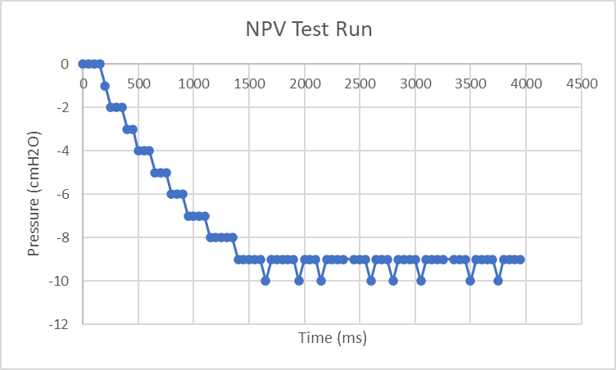

***Figure 8.1:*** *Test results for NPV mode (target pressure -10 cmH2O)*

In BPV mode, the user inputs the positive and negative pressure, the I:E ratio and the breathing rate. To test the effectiveness of BPV mode, I:E ratios and breathing rates and the actual pressure in the cuirass was measured to see if the desired pressure was achieved at the expected times. Sample input values used to BPV mode are 6 breaths/min (10 sec/breath), I:E ratio of 1:2 and a pressure range of +/-5cmH2O [39][155]. Using these values the expected pressure plot and testing results are shown in *Figure 8.2 and 8.3*.

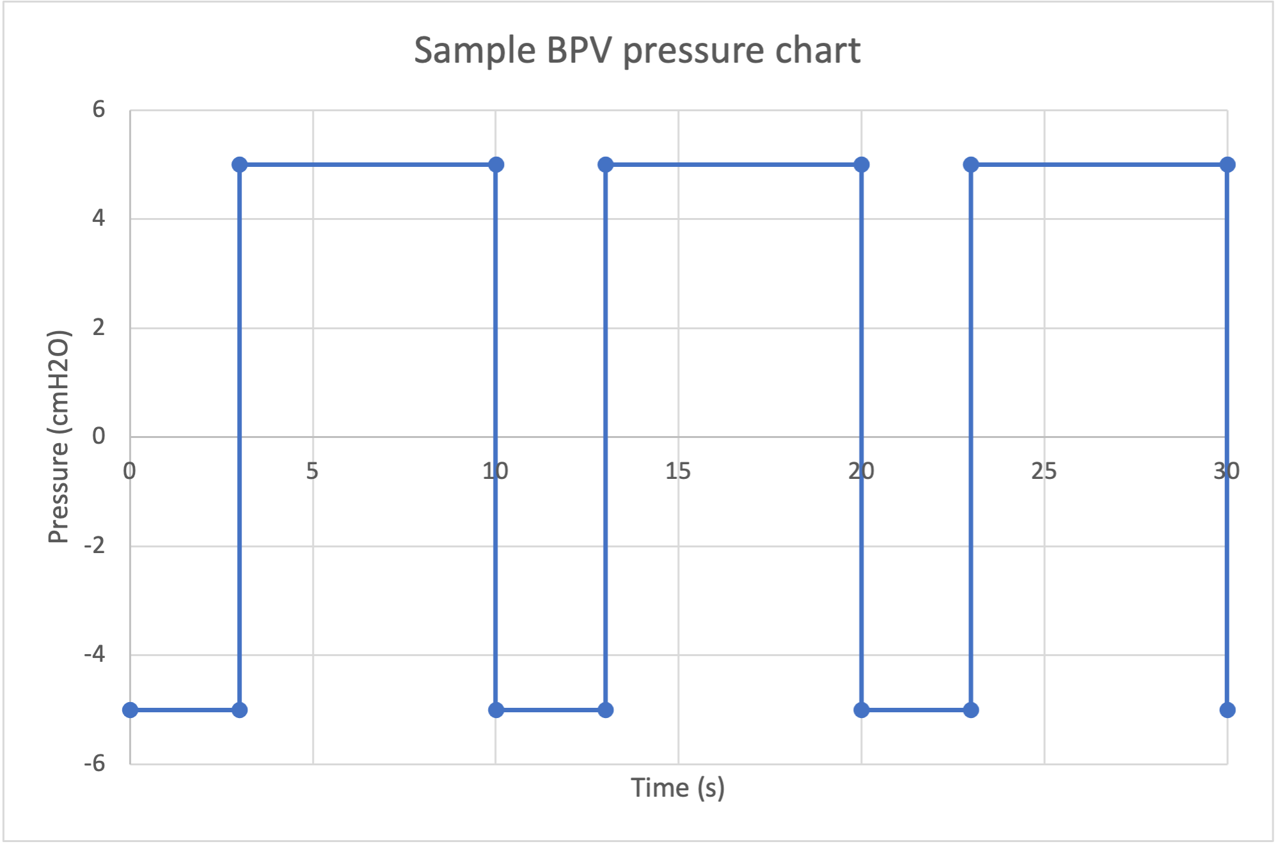

***Figure 8.2:*** *Expected BPV pressure chart*

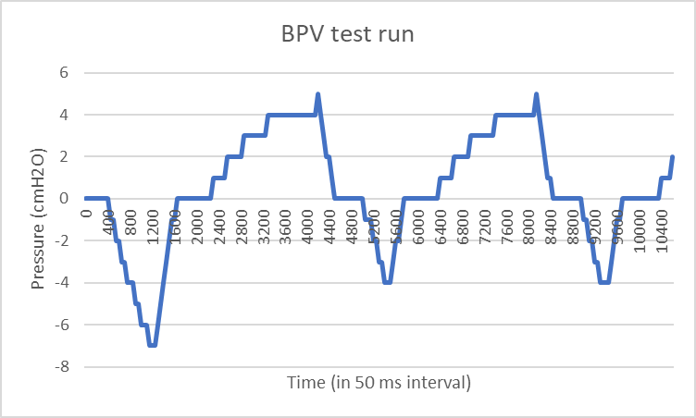

***Figure 8.3:*** *Results of BPV testing (I:E ratio of 2:1)*

*Table 8.1* contains a summary of preliminary testing methods and results. Overall, the prototype fully meets both objectives for portability and one of three objectives set for effectiveness. The two objectives not met are min/max pressure range and operable I:E ratio and breathing rate. The results of testing these objectives show that the operating pressure range is +10/-15cmH2O, and although the design is able to follow an inputted breathing rate and I:E ratio, it cannot reach the negative pressure fast enough and thus was stopping short of the desired pressure each cycle (only reaching -4 cmH2O instead of -5 cmH2O). Although the shape of the pressure plot from BPV testing is as expected, the timing does not match the expected value. In *Figure 8.3*, it appears as though the breathing rate is approximately 15 breaths/min (4 sec/breath) when it should be 6 breaths/min (10 sec/breath). This could be due to the internal clock rate, the pressure sampling rate, or the section of the BPV algorithm that calculates the time to control the pumps. Further debugging is required to identify the source of this error and fix the discrepancy. The small operable pressure range and the inability to reach negative pressure within desired time can be improved by using a stronger air pump.

***Table 8.1:*** *Preliminary testing methods and results*

| **Component** | **Method of testing** | **Goal** | **Measured result** | **Meets Obj?** |
| --- | --- | --- | --- | --- |
| **Objective A: Portability** | | | | |
| Weight | Weighing device | Less than 5 kg | 3.49 kg | YES |
| Size | Measuring dimensions | Less than 55.9 × 35.6 × 22.9 cm | 28 x 20 x12 cm | YES |
| **Objective B: Effectiveness** | | | | |
| Min/max pressure range | Measuring pressure achieved inside the cuirass using a pressure sensor and comparing to desired/programed pressure | Achieve a pressure range of +/- 35 cmH20 | Min pressure: -15cmH2O  Max pressure: +5cmH2O | NO |
| Operable I:E ratio and breathing rate | Measure whether desired positive and negative pressure is achieved within the time defined by inputted I:E ratio and breathing rate | Able to support I:E ratio range of 1:6 ~ 6:1 | Tested sample BPV values in Figure 8.3. Design was unable to reach negative pressure within the time set by the I:E ratio and breathing rate. | NO |
| Holding constant pressure in NPV mode | Input desired constant negative pressure, measure actual cuirass pressure every 5 seconds to test whether pressure is maintained. If the pressure read from the cuirass exceeds +/-10% a warning is flagged and the yellow led and buzzer will be activated. | Maintain constant negative pressure +/-10%. | Pressure was successfully maintained within +/-10% of the target pressure (Figure 8.1). | YES |

The following sections describe tests that should be conducted to ensure progress toward meeting the client's needs as the current prototype is expanded to include not only the subsystem described thus far, but the full jacket and cuirass design. Some tests will not be feasible at the prototype stage, such as extensive durability testing and measure of performance and effectiveness in supporting Fontan circulation, but must be considered for the final product.

## 8.2 Future Verification Testing

Throughout the design process, intermediate parts and steps are evaluated against the objective goals of the medical electrical device. Verification testing proves that the design meets the specified objectives at a particular stage of its development or for a particular part of the design.

**Table 8.2:** Verification Test Plan of Prototype and Final Product

| **Objective C: User Experience** |
| --- |
| **Ease of Use & Operation** |
| The System Usability Scale (SUS) is an industry-standard tool for measuring the usability of a product (See ***Appendix J***). For this purpose, ten users will be surveyed on their experience setting up and using the Fontan jacket. It is important to note that different stakeholders may participate in the test, including patients with Fontan failure (the intended users), physicians and healthcare workers, and their family members or caretakers. The goal of the survey is to achieve a score of 68, which is considered as above average on the usability scale [139]. |
| **Comfortability** |
| The comfortability of the Fontan jacket will be assessed through a survey of ten patients according to the 5-point Likert Psychometric Scale or Customer Satisfaction Score (CSAT) (See ***Appendix B***). Patients will be asked to use the design through their daily activities, which will range from lying down at rest to light daily activities (walking). The goal of this objective is to achieve at least 80% of positive user feedback. |
| **Objective D: Durability** |
| **Physical Durability** |
| The NIEV device will undergo positive and negative pressures and needs to be able to withstand various forces to maintain effective function. Durability testing may include pulsatile, flat plate, low- and high-cycle longitudinal, bending, axial, torsional, and custom-designed loading modes, depending on the movement, strain, and force that are present when the device is positioned on the human body [140]. Tests will be conducted in accordance with ISO 17025:2017 (General requirements for the competence of testing and calibration laboratories) [141] and ISO 80601-2-84-2020 (Medical electrical equipment — Part 2-84: Particular requirements for the basic safety and essential performance of ventilators for the emergency medical services environment) [142].  For the purpose of prototype testing, durability verification will be done through Finite Element Analysis (FEA) and stress analysis. |
| **Sealing** |
| Other durability considerations include the sealing of the device. This should comply with the ingress protection (IP) rating criteria, humidity, and particulate resistance so as to protect internal electrical and mechanical components of the device. The seal against user body will be measured by % leakage of air or error in pressure measurement within the cuirass versus desired pressure level. |
| **Objective E: Minimize Cost** |
| **Prototype Cost** |
| The total cost of all materials (BOM) and basic machining or manufacturing processes, such as 3D printing, should not exceed the course-provided budget of **C$500**. |
| **Final Product Cost** |
| The estimated total cost of all materials (BOM) should not exceed the objective goal of **C$20,000**. |

## 8.3 Future Validation Testing

Validation of the end product must be performed to ensure that it meets the client needs. As defined by Objectives A and B, the Fontan Jacket needs to be portable and effective. *Table 8.3* outlines the proposed test procedures and parameters to validate the design.

**Table 8.3:** Validation Test Plan of Prototype and Final Product

| **Objective A: Portability of the Device** |
| --- |
| **Compact and Lightweight** |
| Using a scale, the measured total weight of the device **should not exceed 5kg**. The total size of the device should not exceed **55.9 × 35.6 × 22.9 cm**, as determined in the design requirements.  Note that for prototype testing, the total weight of the device will be different from actual due to different material densities of PLA (3D printed, infill-dependent) and PC (final product). |
| **User Mobility** |
| The device should be able to support the patient in accomplishing daily tasks, so it **should not hinder basic positions**, such as lying down, sitting, and standing. For this scope, the patient is not expected to do vigorous activities like competitive sports. A simple evaluation will be to ask ten users to wear the Fontan jacket in the basic positions: lying down on back, side, and front; sitting, crouching; standing and walking. |
| **Battery Life** |
| Average battery life can be taken from the lowest and highest setting (least power consumption to most, respectively). The device will continuously run at each extreme mode of operation until intervention is needed (replacement or charging). It should be noted that battery cycles will affect subsequent performance, so a “fresh” unit should be used for each test cycle. The objective goal is **at least 8 hours of continuous use** on a “single charge”, defined as full battery. |
| **Objective B: Effectiveness** |
| **Level of CVP** |
| CVP can be measured through ultrasound imaging [143]. The measurements will be taken after 10 minutes of unassisted breathing and after 10 minutes of Fontan jacket assisted breathing. The CVP of assisted breathing should be **2mmHg** lower than that of unassisted breathing. |
| **Level of CO** |
| Cardiac index (CI), the parameter of CO based on the patient size, can be directly measured by cardiovascular magnetic resonance (CMR) imaging in aorta [10]. CMR measurement will be made after 10 minutes of unassisted breathing and after 10 minutes of Fontan jacket assisted breathing. The CO index of assisted breathing should be **0.4L/min/m2** higher than that of unassisted breathing. |
| **Inspiratory to Expiratory (I:E) Ratio** |
| I:E ratio can be simply measured by taking the proportion of the inspiratory and expiratory phases in one breath cycle (time to inhale:time to exhale).  Since I:E ratio will be a driving parameter or setting of the device, its validation measurement will be based on the accuracy of the desired output and total range of setting of **1:6 ~ 6:1**. |

# 9.0 Future Development

Future iterations of the device need to further expand on the project scope that the team has not covered yet. General improvements for the design to be more efficient and ergonomic should always be considered while creating and updated iteration of the device, but the design scope that the team have yet to cover includes:

1. Support for different activity levels: assist-control mode
2. GUI design for the device
3. Wearable design
4. Cuirass design

This section further details some of the important aspects of the project that the team has not managed to cover yet, but was deemed vital for future development.

## 9.1 Improvements on Safety Features, Extension on Risk & Mitigation Plan

The two main safety features that were lacking in the current prototype is the heat management of the components and cuirass safety design. Some guidelines and requirements to follow on designing the two modules are outlined in the table below according to IEC 60601 [56].

**Table 9.1:** Relevant guidelines to follow in designing the modules

| **Module** | **Section** | **Description** |
| --- | --- | --- |
| Heat Management | Clause 11.1 | General requirements for temperature-rise testing of the equipment. |
| Clause 8.8.4 | Requirements for thermal insulation, cooling, and heating of equipment |
| Cuirass Safety | Clause 9.3 | Requirements for the protection against mechanical hazards, including requirements for stability, strength, and protection against sharp edges and points. |
| Annex B | Guidance on the application of risk management to medical devices. |

So far, the team has done a comprehensive risk management plan:

1. Identified the potential hazards associated with the ME equipment device
2. Assessed Risks regarding identified hazards and severity levels
3. Identified the risk mitigation strategies
4. Implemented risk controls

The rest of the risk mitigation plan that we have yet to execute includes Testing Risk Controls - to ensure they are effective and reliable; Monitor and Review - where new hazards or potential risks are identified through continuous monitoring of the device performance; and lastly, Documentation and Communicate - in which all risk management results documented to be communicated to stakeholders and users.

## 9.2 System Simulation

The initial design included only the control system and pressure circuit, due to the reduced scope of the design effectiveness based on level of CVP and level of CO achieved (*See Section 2.2*) were excluded. To begin testing the effectiveness of the design based on CVP and CO levels the system should be simulated using a model for the lungs and the connection between external pressure and pleural pressure outlined in *Section 1.1*. A model of the system can be built using MatLab and Simulink and existing models of the lungs can be integrated to test the effectiveness. This procedure is also used to simulate positive pressure ventilators (See *Appendix L*).

Additionally, in order to build a more rigorous control system transfer functions for the pumps, solenoid, and pressure sensor need to be tested for. Once these values have been determined the system can be modeled using standard control systems procedure. For both NPV and BPV mode, the desired output is to track the pressure values inputted by the user. Using negative feedback and a PID controller more accurate real-time control can be achieved. After creating a full model to simulate the system the PID can be tuned to ensure that it meets our specifications, specifically that it can track the inputted pressure value with less than 5% error and that it can reach the desired value vast enough to follow the inputted I:E ratio and breathing rate. These specifications correspond to the error, rise time, and percent overshoot tuned via the PID controller. By implementing this controller pressure can be maintained even when there are unknown disturbances, for example small leakages from the cuirass [154].

Finally, simulations involving computational flow dynamics (CFD) should be completed to have more accurate data on how air and pressure flow impact the design. As mentioned previously our team was unable to conduct CFD analysis of the system due to limited time and expertise, however we recommend that it is revisited for future work on the design.

## 9.3 Integration between Backpack and Cuirass

The cuirass plays a critical role in the device's operation, regulating pressure and ventilation for the user. Integrating it with the backpack is essential to maintain the required pressure and ensure proper ventilation. Any issues with connections between the cuirass and backpack, such as leaks or design malfunctions, could cause a loss of pressure or inadequate ventilation. These issues could seriously affect the safety and effectiveness of the device. Some important design considerations include:

1. The attachment between the cuirass and the backpack should be secure and leak-proof, to ensure proper pressure regulation for the user.
2. The materials that are used in constructing the cuirass should be compatible with the operating gas used in the system along with being able to withstand the stresses and strains of regular use.
3. The cuirass is designed to be easily adjustable, to accommodate different body sizes and shapes, while maintaining a comfortable and secure fit for the user.
4. The design considers any potential interference with other system components, such as tubing or electrical wiring, ensuring that these do not interfere with the user's movement.

The integration should be designed with the overall ergonomics of the device in mind, to ensure that it is comfortable and easy to use for extended periods of time, which is one of the device’s primary objectives.

## 9.4 Medical Grade Prototype

Due to limited time and budget, the prototype was not built using medical grade parts, thus after the jacket and cuirass have been integrated and thoroughly tested the next step is to build a medical grade prototype to further test the design. The medical grade prototype must follow all standards and regulations so that it can be used and tested. All parts must be tested using ISO 60601-1 the standard for medical electrical equipment. *Table 9.2* summarizes which parts do not meet the relevant standards and components that should be used instead to meet those standards. After building a prototype using components meeting the standard the system as a whole must be tested in accordance with ISO 60601-1 [56].

**Table 9.2:** Component standards qualifications

| **Component** | **Relevant ISO/IEC standard** | **Does the current prototype components meet the ME standards?** | **Actual components that meet the ME standards** |
| --- | --- | --- | --- |
| Air pump | ISO 60601-1 | NO | BTX Diaphragm Pump [156] |
| Solenoid valve | ISO 407/ISO 5599 | YES  (CE compliant) | Pressure relief Valve, 0-55cmH2O [157] |
| Safety valve | ISO 4126-1 | *Not Applicable* | Compatible with above parts: X-Valve [158] |
| Air filter | ISO 16890 | *Not Applicable* | Compatible with above parts: Pump Filter Muffler [159] |
| Main battery | IEC 60086-4 (Lithium) | YES  (CE compliant) | *Not Applicable* |
| Secondary battery | IEC 62133-1 (Nickel) | NO | *Not Applicable* |
| Sensor | ISO 60601-2 | YES | *Not Applicable* |
| Encasing | ISO 60601-1 | NO | Redesign |

# 10.0 Conclusion

This document summarizes all work done up to the design critique stage of the project, and details the entire prototyping process based on the initial proposed design and feedback received during the design critique. Based on this feedback the scope of the design was refined to only include the pressure circuit and controls. A detailed prototyping plan was created and implemented for each subsystem of the refined proposed design. The prototyping process was documented including the assembly process, any problems that arose and modifications that were made to address them. After the prototype was assembled and modifications made, various tests for functionality were conducted. Overall, the design is successfully able to manipulate the pressure within the provisional cuirass. The design fully meets the objectives set for portability and partially meets the objectives set for effectiveness. Furthermore, future steps to improve the design are expanding the safety and risk management features, building a detailed simulation of the full system for CFD analysis, integrating the jacket and cuirass into the pressure circuit and control system, and finally, building a medical grade prototype.

# 11.0 Appendices

## Appendix A: Ranking Objectives Matrix

**Table X.1:** Decision matrix

|  | **Effectiveness** | **Portability** | **User Experience** | **Cost** | **Durability** |
| --- | --- | --- | --- | --- | --- |
| **Effectiveness** |  | O | X | X | X |
| **Portability** | X |  | X | X | X |
| **User Experience** | O | O |  | X | X |
| **Cost** | O | O | O |  | O |
| **Durability** | O | O | O | X |  |
| **Total Score** | **3** | **4** | **2** | **0** | **1** |

According to the decision matrix, the ranking of objectives by importance is as follows:

1. Portability
2. Effectiveness
3. User experience
4. Durability
5. Cost of device

## 

## Appendix B: CSAT/Likert Comfortability Scale

| *How would you describe your overall experience for comfortability on wearing the device?*   | | ① | ② | ③ | ④ | ⑤ | | --- | --- | --- | --- | --- | | Extremely Uncomfortable | Somewhat Uncomfortable | Average Comfortability | Somewhat Comfortable | Extremely Comfortable | | | --- | --- | --- | --- | --- | --- | --- | --- | --- | --- | --- | |
| --- | --- | --- | --- | --- | --- | --- | --- | --- | --- | --- | --- |

## 

## Appendix C: Design for Human Factors

*Device-User interface for medical devices* [84]

| **Design Element** | **Actions** |
| --- | --- |
| User actions | 1. Receive information from the device 2. Interpret the information 3. Manipulate the device, its components and its controls |
| Device actions | 1. Receive input from the user 2. Respond to and provide feedback to the user on their actions |
| User interface | All components users interact with while setting up the device, actively using the device, or maintaining device (e.g. replacing battery) |

## 

## Appendix D: List of Stakeholders and Their Interests

| **Stakeholders** | **Interests** |
| --- | --- |
| Patients/Users | * Social: Impacts user’s daily lives and increases the user’s quality of life (feeling a sense of normalcy). * Social: Impacts user’s social image through wearing device * Social: Positively impacts user’s outlook in life as device aims to reduce harm on organ that leads to mortality and morbidity * Economic: Increase in treatment cost (purchase costs, maintenance costs, check-up costs) |
| Patient’s circle: family, friends | * Social: Positively impacts family’s quality of life and physical interaction with user * Social: Positively influence family’s outlook on patient’s condition |
| Caretaker | * Economic: Decreases the amount of jobs aimed for in-home caretaker as less supervision is needed with device |
| Researchers/Academias | * Economic: Increase number of researchers and academics needed to study, report, analyze the new device * Social: Increases relevant/up-to-date information with regards to ventilation device and its effect on Fontan failure * Social: Extending information and usage on other use cases |
| Hospital | * Economic: Increase use of these devices and related services * Economic: Job opportunity for nurses, doctors * Economic: Increase in number of clinics specifically for new device |
| Regulatory agencies at the provincial or federal level | * Legal: Meeting the provincial and federal laws and regulations on intellectual property |
| Public community | * Social: Raise public awareness to services for people with heart conditions and respiratory challenges (reduce stigma) * Social: Raise awareness of device existence and the impacts it has on potential users. |
| Manufacturer and distributor of existing solutions | * Economic: Impact their existing sales, increases competition, and increases opportunity to expand their market * Economic: Increase in employment for maintenance of new device * Legal: Patent of intellectual property |
| Design team | * Legal: Responsible for the design meeting all laws and regulations * Economic: Will benefit from the success of the design |

## 

## Appendix E: Benchmarking

### E.1 Negative Pressure Ventilators (Iron Lung)

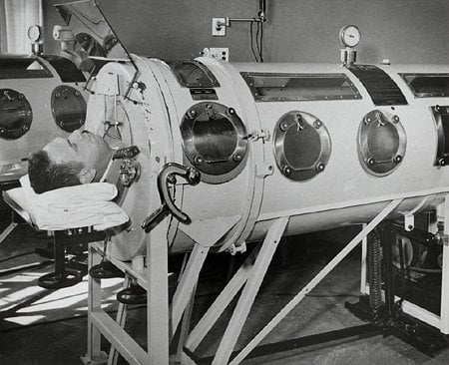

**Figure E.1**. The iron lung encloses the body except for the head [79]

There are several variations of the iron lung, which was the main form of external ventilation during the poliomyelitis epidemic in the 1950s. The most common ones are summarized in *Table E.1*.

***Table E.1:*** *Design Features of Different Iron Lung Models* [80] [81] [82]

| **Type/Model** | **Description** | **Mechanism (Unique)** |
| --- | --- | --- |
| Drinker & Shaw | First successful iron lung using salvaged materials, built with US$500 in 1927 (equivalent to US$8530 in 2022)  Mass produced for US$2K (equivalent to US$34K/CA$46K in 2022) | Large metal cylinder with a tight rubber seal around neck  Whole body except head enclosed  Piston pump at foot-end through to generate pressure changes |
| Emerson | Goal to simplify, modify, improve Drinker model at half cost  W33”xL92”xH56”, 640-800lbs (290-337kg)  Require only greasing of motor and new fan belt once a year to maintain reliable function for many years. | Several glass side ports and large rectangular metal doors for easier access and care  Thick leather diaphragm to move air powered by vacuum cleaner pump with cyclic feature (can add 2 for more pressure)  Can be manually operated in case of power failure |
| Porta-Lung | Made of plastic (fiberglass)  More portable at 100lbs; 45.5kg  Cost £5K in 1991 (equivalent £10.4K/CA$16.3K in 2022)  Problem to replace worn out negative pressure pumps currently as they are no longer manufactured. | Can accommodate different vacuum pumps with pressure adjustment ranging -60 to +20 cmH2O; respiratory rate 4-60/min; and variable I:E ratios |

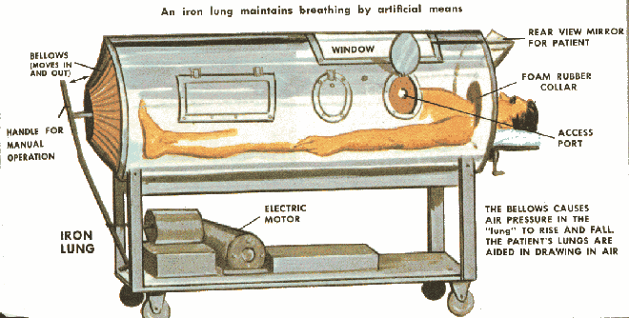

**Figure E.2.** Emerson Iron Lung [83]

**1901: Eisenmenger Bimotor**

Eisenmenger (Hungary) patented the first portable biphasic (negative/positive) cuirass ventilator which enclosed only the chest and abdomen. Initially, the bellows were operated by the patient’s foot, but later replaced with motors.

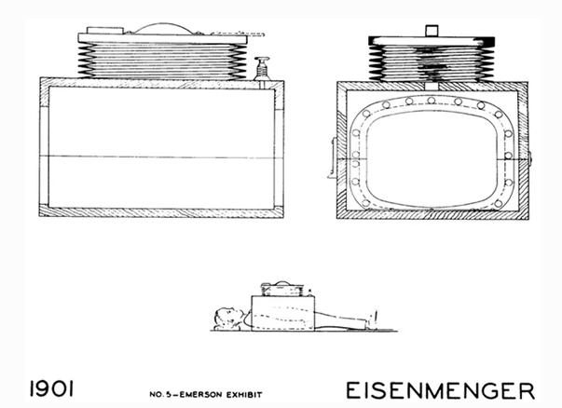

**1926: Schwake**

Schwake (Germany) patented an impractical pneumatic chamber in which the patient had to stand and manually move a large bellows comprising an entire side of the box to generate negative pressure. The patient can see the pressure gauge placed near the face.

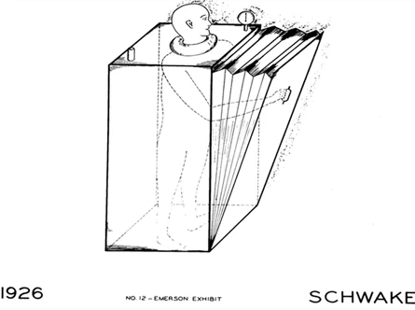

**1928: Drinker & Shaw Model**

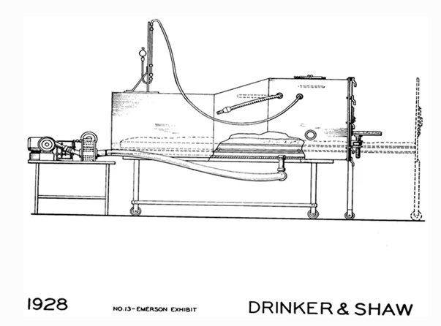

**1937: Both Portable Cabinet Respirator**  
The Both brothers (Australia) made a tank ventilator from plywood, making it lighter, easier to transport, and cheaper.

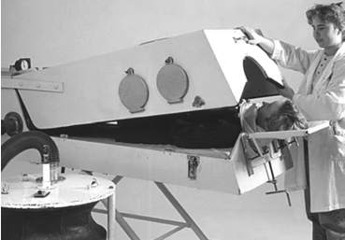

**1952: Cape Warwick**

Smith-Clark (UK) redesigned the Both model iron lung with an option to tilt the head down for pulmonary toilette (clearing music and secretions from the airways).

**1975: Porta-Lung**

Weingarten (USA) designed a lighter (100lbs; 45.5kg) and more portable tank made from fiberglass.

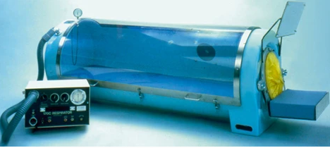

### E.2 Cuirass Ventilator

#### E.2.1 Hayek RTX and MRTX

The Hayek RTX and MRTX are the closest benchmark for the design due to their somewhat portable form factor and multiple control modes. A summary of the devices’ features are shown in *Table E.2* [86] and *Table E.3*.

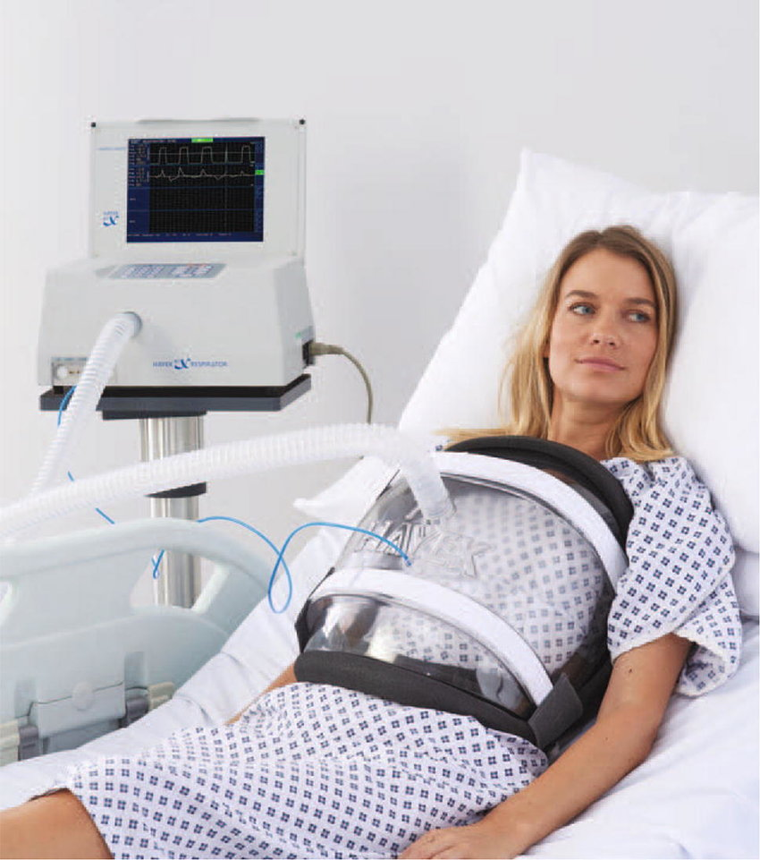

**Figure E.3.** Hayek RTX device worn by a patient

***Table E.2:*** *Design Features of Hayek RTX*

| **Technology** | Biphasic Cuirass Ventilation (BCV) allows for user control over the I:E ratio. |
| --- | --- |
| **Seal Material** | Soft foam seal. |
| **Size Availability** | 11 different sizes, ranging from babies to adults. |
| **Modes of Operation** | 1. Continuous Negative (CNEP) 2. Secretion Clearance Mode 3. Control Mode 4. Trigger Mode 5. Synchronized Mode |

***Table E.3:*** *Key Design Features of Hayek MRTX*

| **Technology** | Biphasic Cuirass Ventilation (BCV) allows for user control over the I:E ratio. |
| --- | --- |
| **Size** | 14×14×18 cm |
| **Weight** | 3.5 kg |
| **Rechargeable Battery** | Yes, up to 4 hours of full ventilation [87]. |
| **Min/Max Pressure Range** | −50 to 50cmH2O [74]. |

## 

The Hayek RTX Cuirass shell is available in 11 sizes, as shown in the table below. []

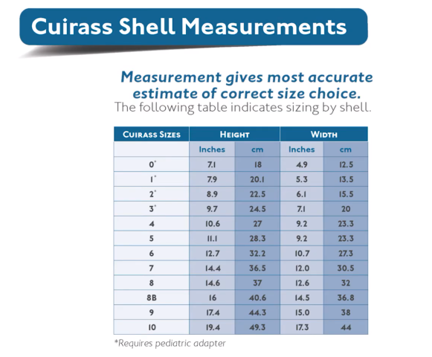

**Figure E.4.** Hayek RTX Size Chart

#### E.2.2 Breathe Global Venti

Venti is a wearable and lightweight ventilator jacket based on the NPCV technology, developed by Breathe Global. *Table 3.6* shows some design features regarding this recently developed jacket.

***Table 3.6:*** *Design Features of Breathe Global Venti*

| **Technology** | Negative Pressure Cuirass Ventilation (NPCV) |
| --- | --- |
| **Level of Training** | No training is needed due to the simplicity of the design. |
| **Remote Information Monitoring** | Real-time monitoring allows any information with regard to its use to be monitored by the user's physicians, respirologist, caregiver, or whoever prescribed the technology to the user. |

### E.3 Intermittent Abdominal Pressure Ventilation (IAPV)

IAPV is another non-invasive ventilation technique that uses positive pressure ventilation that works with abdominal compressions. Some of the early prototypes for this ventilation technology consist of a distensible rubber bag applied around the patient’s chest in the form of a belt. This belt is rhythmically filled and emptied with air, with a rate of compression that is modified according to the user's respiratory rate [88]. When the belt is filled with air, it forces the abdominal contents and subsequently, the diaphragm of the patient to move upwards, causing breathing out. During the patient's inspiratory phase of respiration, the belt deflates and the diaphragm descends back down because of gravity, facilitating inhalation [89].

**Lunabelt Dima Italia**

Lunabelt is an IAPV belt/corset to be used alongside its portable ventilator, LUNA DS. Design features of the Lunabelt and LUNA DS are discussed in *Table E.4* alongside an assessment of the device according to the objective of our design requirements under *Table E.5* [90] [91].

***Table E.4:*** *Design Features of Lunabelt*

| **Technology** | Intermittent Abdominal Pressure Ventilation (IAPV) |
| --- | --- |
| **Internal Battery** | Uses Li-Po battery, and can be used during sleep. |
| **Allows User to set Parameters** | Users can set parameters of the device such as   * Pressure inside the belt * Inspiratory time * Respiratory rate * Time to inflate the bladder |

***Table E.5:*** *Lunabelt Objective Analysis*

| **Objective** | **Description** | **Meets Obj?** |
| --- | --- | --- |
| **A: Portability** | Lunabelt's total weight is 4.4 kg, with an internal battery that allows for up to 10 hours of use. The design is very ergonomic which allows for a large range of movement and mobility for the user [91]. | *YES* |
| **B: Effectiveness** | IAPV only works efficiently if the patient is sitting at a position with an angle of 30° or greater, with the most optimal and efficient at 75° [91]. | *NO* |
| **C: User Experience** | Lunabelt is designed for home care and is relatively easy to use. However, the ventilation may be uncomfortable for users due to its method of physically pushing the abdominal area [92]. | *NO* |
| **D: Durability** | Flexible inflatable bladder is less prone to fatigue from cyclic pressures compared to a rigid body or shell. | *YES* |
| **E: Cost of the Device** | Device cost is less than C$20,000, which achieves the objective goal for device cost. | *YES* |

The brief analysis in *Table E.5* shows how Lunabelt is unable to achieve the objective goals for Effectiveness and User Experience in the design requirements. Lunabelt is considered to be an ideal design compared to other existing devices that were previously discussed due to the absence of bulky and protruding wear such as a chest shell that limits user movement with a tradeoff of its effectiveness. However, IAPV use will be optimized when it is employed in combination with other existing NIV support [88].

### E.4 High-Frequency Chest Wall Oscillation (HFCWO)

AffloVest is a fully mobile, mechanical High-Frequency Chest Wall Oscillation (HFCWO) jacket. This device focuses on airway clearance therapy where it breaks up mucus and brings it to the upper airways, where it can be coughed out [94]. While modern ventilators such as Hayek RTX also include HFCWO for its Secretion Clearance Mode. The mobile design of AffloVest makes it easier for the user to do their daily tasks while using the device in contrast to having to sit or lay down constantly while using the device.

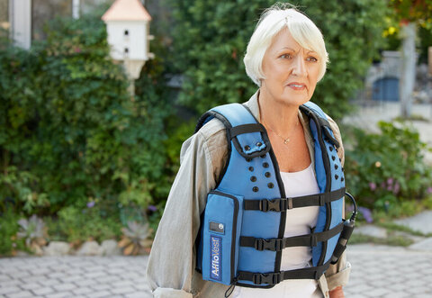

**Figure E.5.** A mobile design for HFCWO by AffloVest

An objective analysis will not be done for this device as AffloVest’s functionality and HFCWO therapy are not relevant to improve Fontan circulation. However, its mobile and ergonomic design will be considered in the assessment and analysis of the proposed design to improve portability and comfort.

## Appendix F: Evidence of brainstorming

This is an archive of preliminary sketches and concept drawings during the brainstorming and idea generations stages.

**Idea generation sketches**

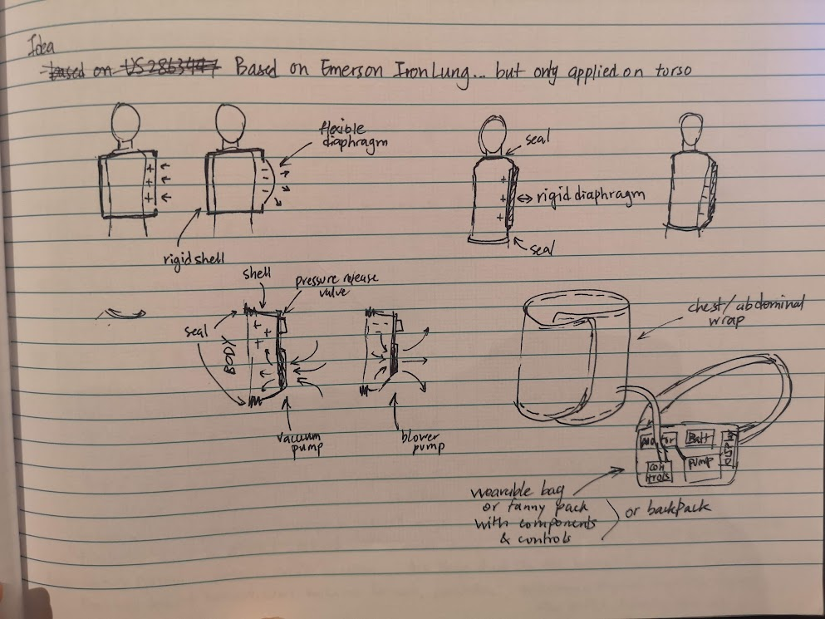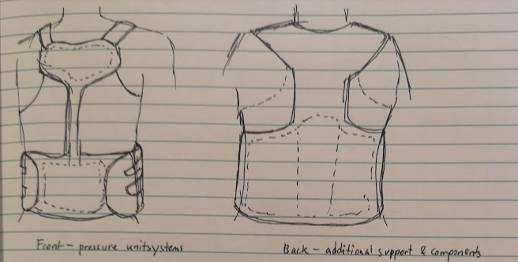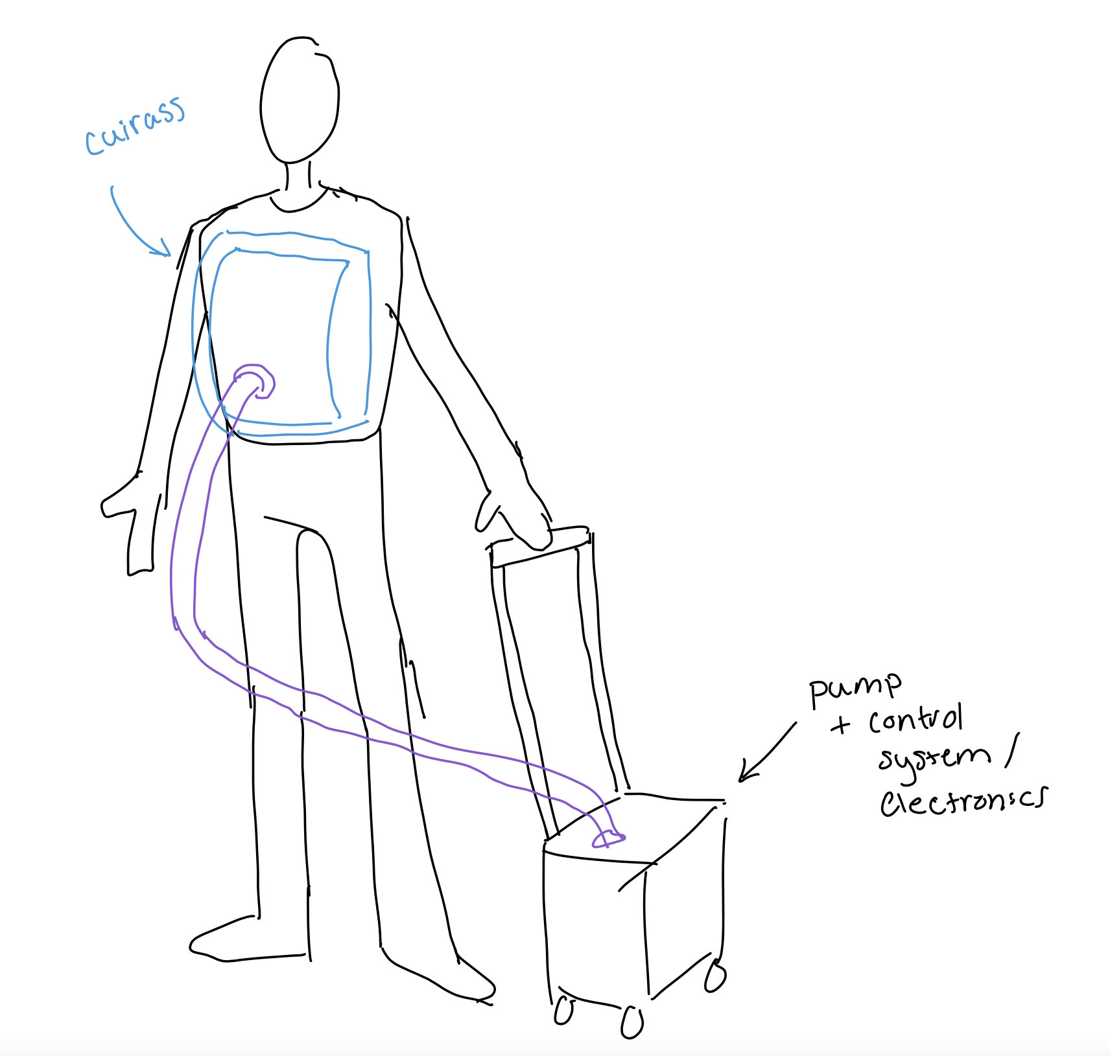

**Preliminary drawings for Candidate 2**

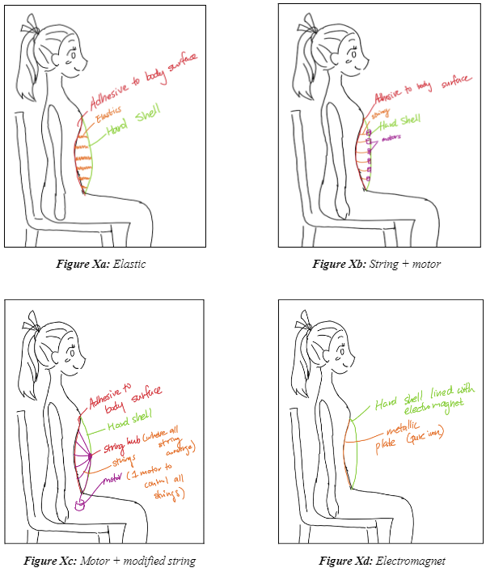

**Preliminary drawings for Candidate 3**

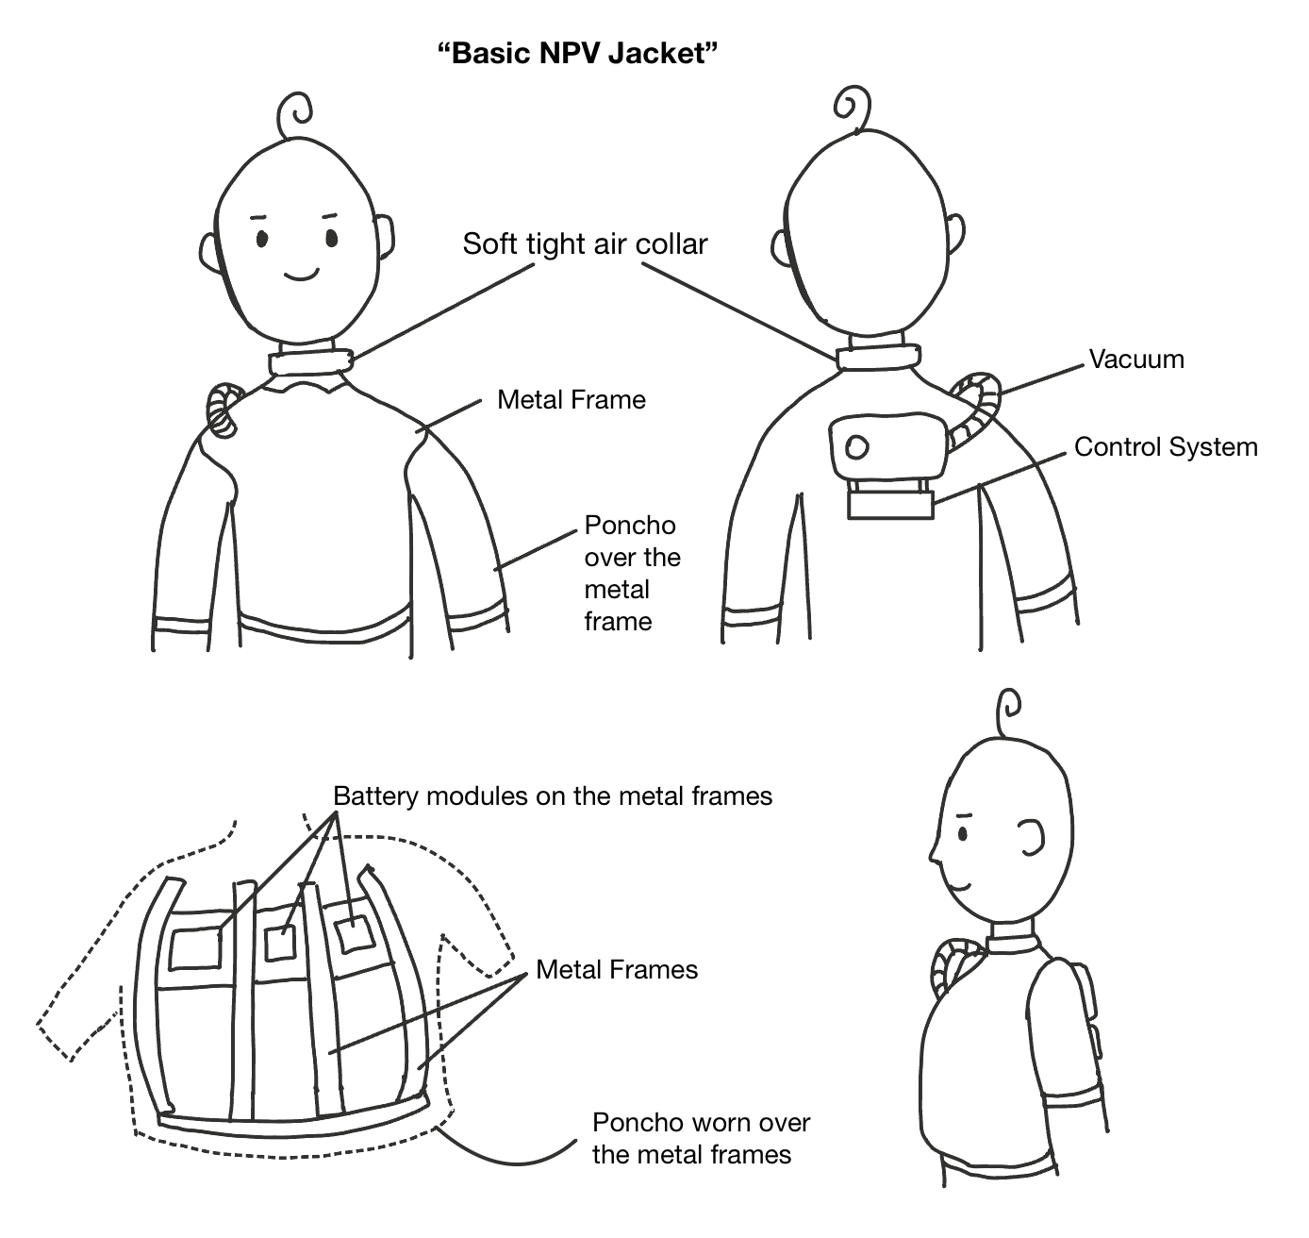

**Initial cuirass drawings of the proposed design**

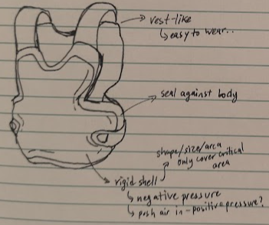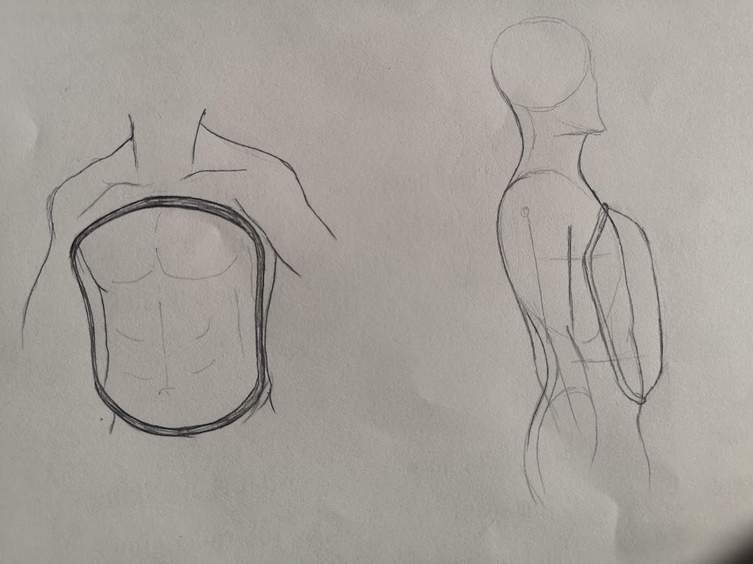

## Appendix G: Detailed mechanisms of Alternative Designs.

### G.1 Artificial Ribs

There are largely two ways in manipulating the volume within the artificial ribs without involving pressures: 1) moving the ribs, 2) moving the sternum. The first option would reduce the design by removing the unnecessary sternum but it would result in much more disadvantages: having to control each rib separately greatly complicates the design increasing its weight, size, and cost. The second option although may require a complicated sternum, it reduces the number of parts to control and allows better mimicking of body motion taking advantage of the similar structure.

The sternum motion involves horizontally spacing between the rib and sternum, and vertically spacing between ribs. Any motion involving the sternum moving away from or near the chest wall affects the horizontal spacing. Moving away extends the horizontal elastic connection between the sternum and ribs, mimicking rib motion during inhalation, resulting in an increase in the control volume. The reverse motion would mimic the exhalation paired with decreased control volume. Similarly, an extension and contraction of the sternum would extend/contract the vertical elastic connection between the ribs to induce an increase/decrease in the control volume.

#### G.1.1 Servo Motor Mechanism

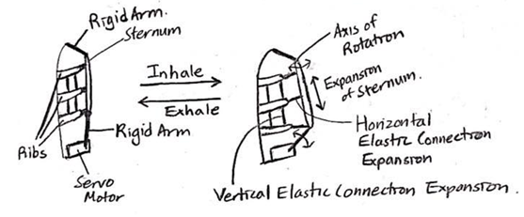

**Figure G.1a.** Servo motor mechanism

The bottom end of the sternum is connected to a rigid arm, which is controlled by a servo motor. Rotation of the rigid arm would move the sternum out and in. This requires the sternum to be composed of smaller plates connected by an elastic material to allow for extension (Figure G.1b). This mechanism involves both vertical expansion/contraction of the sternum and increase/decrease in horizontal spacing between the sternum and ribs when manipulating volume.

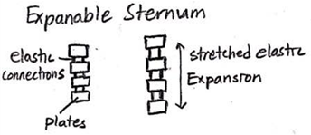

**Figure G.1b.** Expandable Sternum.

***Table G.1:*** *Pros and Cons of Servo Motor Mechanism.*

| **Pros** | **Cons** |
| --- | --- |
| * Allows outward motion and expansion, and can better manipulate volume thus the pressure with little motion (minimal power consumption). * Economically servo motors are easy to acquire and control. | * Possible lack of torque, which can result in the collapse of the system. * Expandable sternum composed of multiple smaller parts requires much more difficult assembly. |

### 

#### G.1.2 Umbrella mechanism

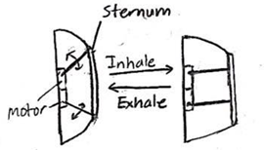

**Figure G.2.** Umbrella mechanism

Sternum is connected to arms that can rotate where its rotation opens and folds the sternum, similar to an umbrella. Expanding would push the sternum away from the chest wall, and folding pulls the sternum near the chest wall. This affects horizontal spacing between the sternum and ribs.

***Table G.2:*** *Pros and Cons of Umbrella Mechanism.*

| **Pros** | **Cons** |
| --- | --- |
| * It is a simple mechanism without any need for elastic components. The simplicity suggests simpler assembly and better durability. | * Requires additional legs within the rib cage backed by a surface (chest wall), this will induce positive pressure on the patient's body. |

## 

#### G.1.3 Leadscrew Mechanism

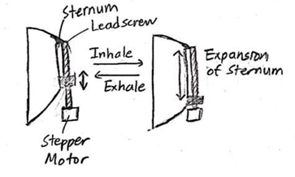

**Figure G.3.** Leadscrew mechanism

One end of the sternum is controlled by a leadscrew, where its vertical linear motion vertically expands and contracts the sternum, affecting the vertical spacing between the ribs.

***Table G.3:*** *Pros and Cons of Leadscrew Mechanism.*

| **Pros** | **Cons** |
| --- | --- |
| * High durability is expected from a metallic material. * High precision in controlling volume, since stepper motors are often utilized in cases where high precision is required. | * Fixed screw length may pose safety issues from its protrusion. * Stepper motors and precise lead screws are expensive and heavy. |

## 

#### G.1.4 Winding wire mechanism

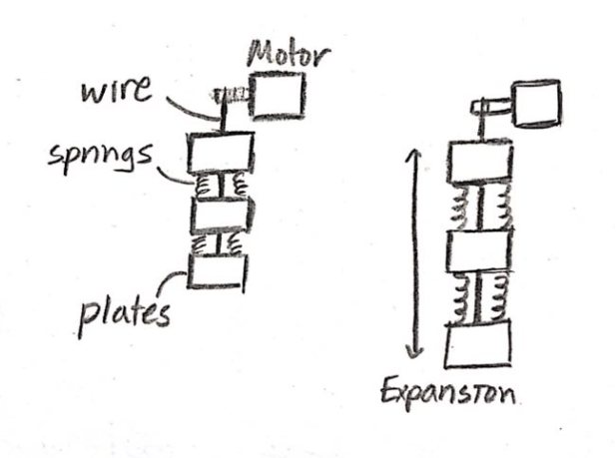

**Figure G.4.** Winding wire mechanism

A motor winding and unwinding wire will relax and pull the sternum, which is composed of smaller plates connected by springs. This affects the vertical spacing between the ribs.

***Table 4.4:*** *Pros and Cons of Winding Wire Mechanism.*

| **Pros** | **Cons** |
| --- | --- |
| * High flexibility of the sternum possibly allows better mobility for the user. | * Limited durability from high stress applied to wires and springs. * Complex in assembling sternum composed of multiple springs and wire passing through. |

#### G.1.5 Mechanism selection

The critical disadvantages are first examined in accordance with meeting the main function and constraints. The umbrella mechanism is eliminated since it applies positive pressure on expansion when it is supposed to induce negative pressure, failing to meet the function. Then the advantages and disadvantages related to the predetermined objectives are investigated, which identifies the servo motors as the mechanism that best meets the objectives.

### G.2 Electromagnetic Chest Jacket

The following section will describe the iterative design process of the Electromagnetic Chest Jacket. It will begin with the initial design which aims to use only elastic force. The second design aims to use string and motors to control the chest wall movement. Lastly, the 3rd design is a modified version of the 2nd design, by combining all strings to the pulley system. *Figures 4.5a-d* shows the design sketches for each of the aforementioned designs. Each design process, its pros and cons, are discussed in each of the subsequent sections.

## 

***Figure G.5a.*** *Elastics Mechanism* ***Figure G.5b.*** *String + Motor Mechanism*

## 

***Figure G.5c.*** *Modified String + Motor* ***Figure G.5d.*** *Electromagnet Mechanism*

#### G.2.1 Elastic Mechanism

Hard shell is attached to the chest and abdominal wall. When exhaling, as the chest wall contracts, the elastic is pulled towards the chest wall. When breathing in, the elastic will want to snap back into place, and will generate a force to expand the chest wall.

#### G.2.2 String + Motor Mechanism

Strings are attached from the body surface to the rigid shell. Each string has its individual motor, which will be attached to the rigid shell, to manipulate the string length (which manipulates chest wall movements). During inhalation, the string is wound up by the motor and during exhalation, the string is retracted, much like the mechanism used in retractable cable reel.

***Table G.5:*** *Pros and Cons for Elastic Mechanism and String + Motor Mechanism*

| **Pros** | **Cons** |
| --- | --- |
| * No moving parts * No control system - very easy to design, implement, and test | * Difficult to exhale, chest wall movement is being counteracted with an elastic force. * NPV only * No control - can’t control the amount of pressure |

#### G.2.3 Motor + Modified String Mechanism

Working methodology is similar to design 2, however the mechanism manipulates string much like a pulley system. The pulley is manipulated by the motor, using the same principle of winding up and unwinding the string for inspiration and expiration respectively.

***Table G.6:*** *Pros and Cons for Motor + Modified String Mechanism*

| **Pros** | **Cons** |
| --- | --- |
| * Has control over the chest movement, and the amount of force exerted on the chest. * User can exhale freely (no pressure exerted). * Less moving parts. Need to control only 1 motor. | * Need to have great string/pulley management with risk of tangling and only works for NPV. |

#### G.2.4 Electromagnet Mechanism

A flexible, but non-breathable metallic fabric such as a high purity iron sheet as shown in figure G.5d, will be used to adhere to the body’s surface. Then using a rigid shell, and attaching electromagnets, the magnetic attraction force will assist with chest wall expansion for inspiration.

For exhalation, there is an option for NPV and BPV. NPV means that the electromagnet’s power is cut, to allow for passive exhalation. To induce positive pressure, one can reverse the current flow to flip the polarity of the magnet. The magnetic plate will repel the soft fabric, and thus applying pressure on the chest wall to assist with expiration.

***Table G.7:*** *Pros and Cons for Electromagnet Mechanism*

| **Pros** | **Cons** |
| --- | --- |
| * Can be both NPV and BPV * Has control over the chest movement by controlling the amount of force exerted on the chest. * Electromagnets are cheap, commercially available. Easier to prototype and test. * Electromagnets come in various sizes with various strengths, each easily accessible. | * High purity iron sheets tend to rust, thus making it harder to maintain. The lifespan of device decreases significantly. * Adverse effects of electromagnets. * The device is unsuitable to be used in hospital settings - as many machines are electromagnetically sensitive. |

Regarding the adverse effects of electromagnets to users, such effects also include heating of body tissues. Short-term exposure of high levels of electromagnetic fields can be harmful and since there isn’t a clear way to contain the electromagnetic fields inside the jacket (albeit the electromagnets used are relatively weak). According to the World Health Organization, states that short-term exposure at the levels present in the environment doesn't have any apparent detrimental effects. There is still an ongoing debate about whether long-term low-level exposure can evoke biological responses and influence people's well-being. Thus due to the lack of clarity of safety confirmation via electromagnetic exposure, the constraint of health and safety measures are not met for this design.

#### G.2.5 Feasibility of Electromagnet Mechanism

After multiple design iterations, design candidate 2 concludes that the electromagnetic mechanism to be a feasible method to achieve the function of the design. This section covers the basic concept of the design in detail and how each component functions to achieve the design objectives.

$Pressure=Force/ Area$**(Eq.7)**

The average male corresponds to a Grade 8 and Grade 9 Cuirass (See ***Appendix E.2***). Using MRTX as a benchmark for the amount of force generated, the minimum pressure for inspiration is -10cmH2O [96] (-980.665 N/m2), and the maximum pressure for expiration is +8cmH2O (784.532 N/m2). From *Eq.7* , the former yields a minimum pressure force of -116.1 1N and a maximum pressure force of 92.89 N. The latter yields -165.06 N and 132.07 N, respectively. *Table G.8* summarizes these findings.

***Table G.8:*** *Force needed to apply for different cuirass sizes*

| **Cuirass Size** | **Dimensions (cm)** | **Weight (kg)** | **Force produced (negative) in Newtons** | **Force produced (positive) in Newtons** |
| --- | --- | --- | --- | --- |
| Grade 8 | 37 x 32 | 50 - 75 | -116.1 1 | 92.89 |
| Grade 9 | 44.3 x 38 | 75 - 90 | -165.06 | 132.07 |

The specifications of commercially available electromagnet, more specifically Round Electromagnets (Flat-Faced), is listed in *Table G.9* [97].

***Table G.9:*** *Specifications of commercially available electromagnets*

| **Holding Force** | **Force Produced (F=ma, a=9.8m/s2)** | **Diameter** | **Height** | **Cost** | **Weight** |
| --- | --- | --- | --- | --- | --- |
| 18.18kg (40lbs) | 178N | 3.175cm (1.25”) | 3.175cm (1.25”) | $32.10 | 0.119kg (0.263lbs) |
| 4.55kg (10lbs) | 44.59 N | 1.905cm (0.75”) | 3.175cm (1.25”) | $28.89 | 0.048kg (0.106lbs) |

## 

### G.3 Electromagnetic Chest Jacket

#### G.3.1 Alternating NPV Cuirass and IAPV

The NPCV was found to be portable as a stand-alone wearable device, but was limited in functionality due to only being able to administer negative pressure. In order to supplement its function, the “Alternating NPV and IAPV” jacket combines the NPCV, which induces cyclic negative pressure to the chest area during inspiration, with an IAPV belt, which applies pressure to the abdominal area during expiration. The cuirass can be simplified as it only needs to pump air out to reduce pressure, and the IAPV works by inflating a rubber bladder inside the corset and pushing the diaphragm upwards to eject air from the residual volume [99].

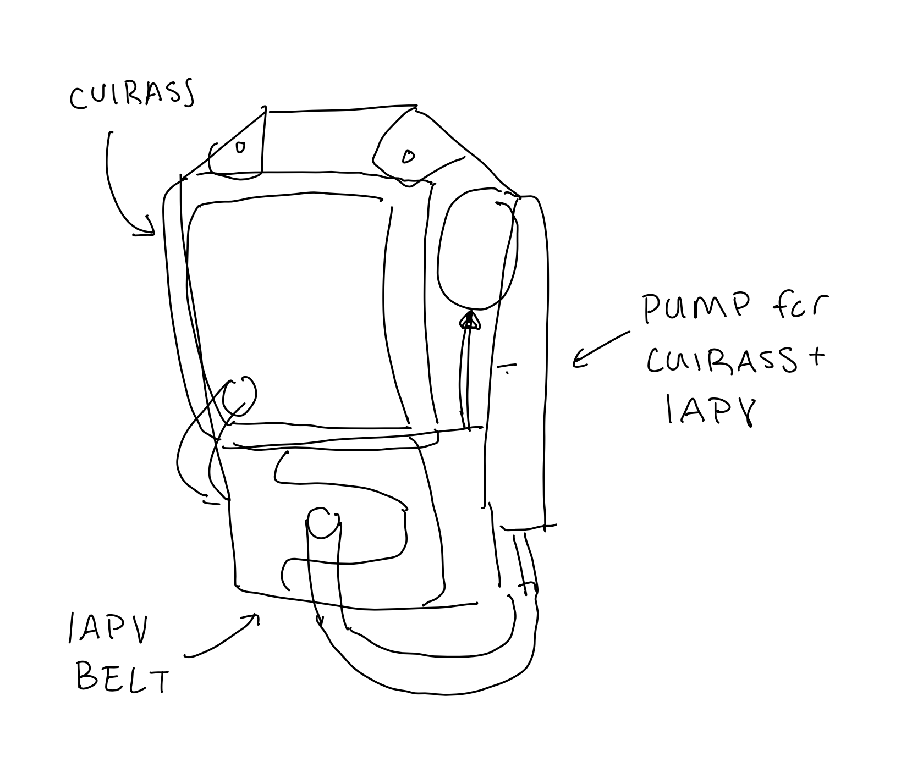

**Figure G.6.** Early concept sketch of Alternating NPV Cuirass and IAPV

***Table G.10:*** *Pros and Cons for Alternating NPV Cuirass and IAPV*

| **Pros** | **Cons** |
| --- | --- |
| * Supports BPV. * Based on existing solutions which have been proven to work. | * Combining the cuirass and IAPV belt make a more complex system and both systems will need to be synchronized by the controller. * Uses more parts than only a cuirass ventilator (needs two pumps one for cuirass and one for IAPV belt). This adds weight and is less portable. |

#### G.3.2 Constant NPV Cuirass and IAPV

Rather than having cyclic negative pressure as in the “Alternative NPV Cuirass and IAPV” design, a constant negative pressure can be applied during both inspiration and expiration, with the IAPV belt supporting expiration.

***Table G.11:*** *Pros and Cons for Constant NPV Cuirass and IAPV*

| **Pros** | **Cons** |
| --- | --- |
| * Simpler control system because the pressure in the cuirass is constant and not cyclic. | * Constant NPV could impede with the users natural breathing * Constant NPV is less effective [dr. honjo’s paper] than BPV, so it may be that even with the added IAPV, constant NPV is less effective than alternating NPV |

#### G.3.3 NPV Poncho with IAPV

The NPV Poncho with IAPV uses a rigid shell with a fabric “poncho” to generate negative pressure ventilation combined with an IAPV belt. Like an Iron lung (Section 3.2) the poncho wraps around the entire torso.

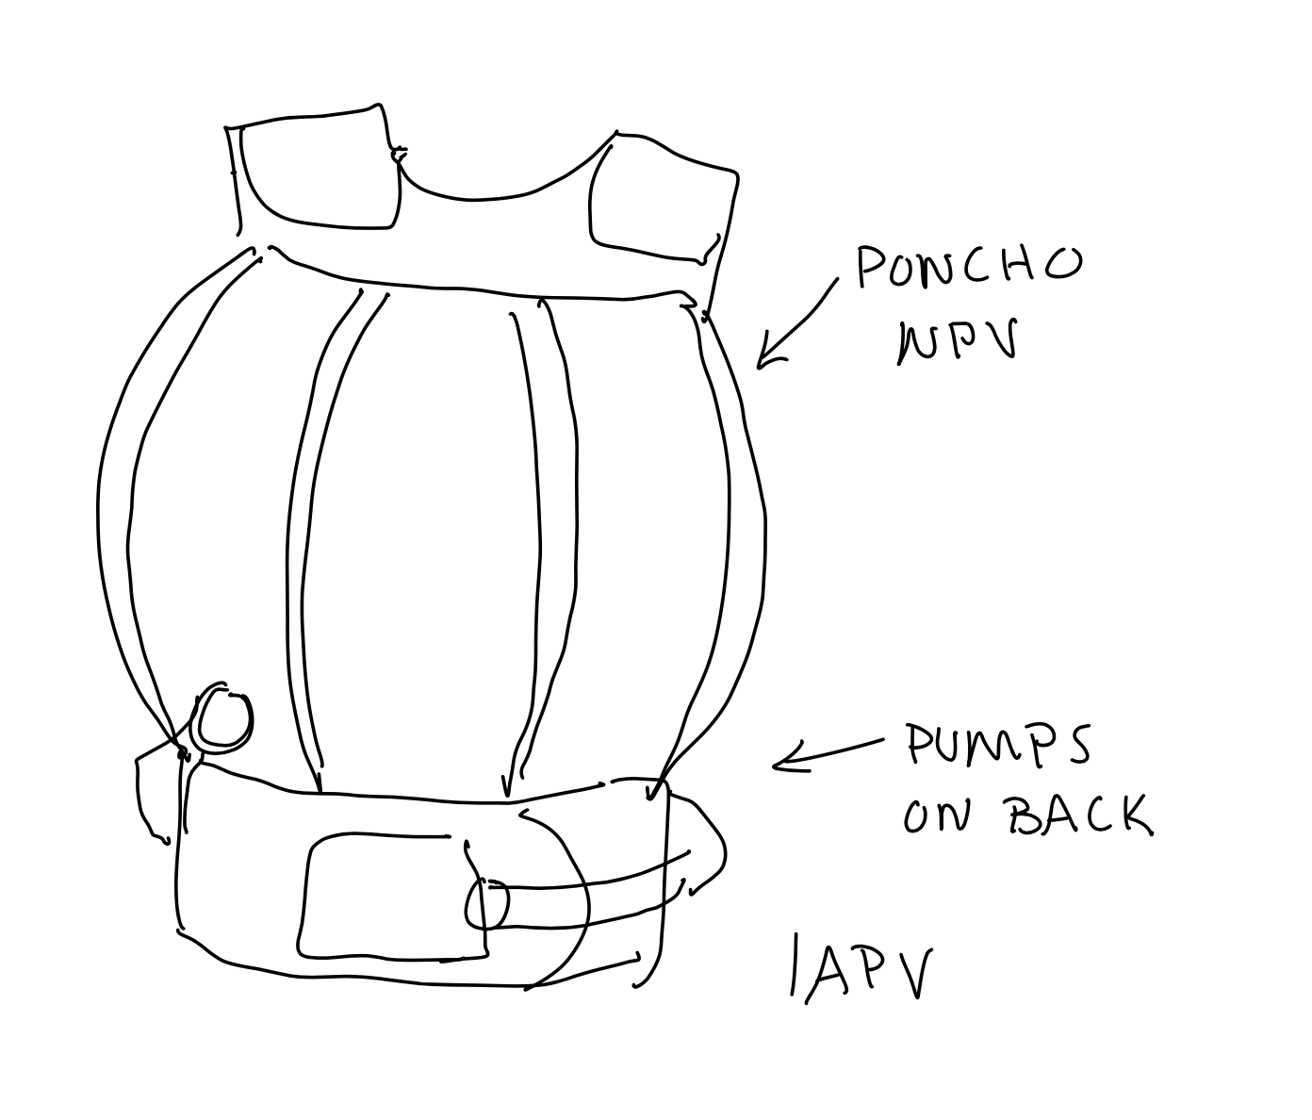

**Figure G.7.** Early concept sketch of NPV Poncho with IAPV

***Table G.12:*** *Pros and Cons for NPV Poncho and IAPV*

| **Pros** | **Cons** |
| --- | --- |
| * Like cuirass + IAPV, the NPV poncho +IAPV creates BPV | * Based on existing designs the NPV poncho is bulkier and heavier than using a cuirass * Rounded shape will reduce the user’s range of motion * Fabric is less airtight, reducing its ability to generate negative pressure around the chest wall. * Adding IAPV component also add complexity + weight to the design (a separate pump is required) |

## 

## Appendix H: Preliminary Hazard Analysis for the MD

| **Component** | **Potential Hazards** | **Possible Risk Control Measures** |
| --- | --- | --- |
| **Monitoring & Control Systems** | **R1:** Electromagnetic interference causes error in ventilator to function properly [145] | Electromagnetic protection with compliance to IEC 60601-1-2:2014 Medical electrical equipment, Requirements and tests [146] |
| **R2:** Power failure during use of device | Adhere to standards for power supply, circuit protection and troubleshooting [147] |
| **R3:** Software or control system failure which causes excessive pressure in patient’s airway | Leak-before-break, manual pressure release valve, breakaway or emergency removal of device, indicator lights/sound during undesirable events |
| **Human Factors** | **R4:** Accidents due to user failing to identify dangerous zones on the device | Required regulatory labeling on hazard-prone zones as per ISO 15223 [148] |
| **R5:** User design interface on the device causes use error | Control, indicators, symbol used, ergonomic features, physical design and layout, visibility of warnings must be present in the device [149] |
| **R6:** Inadequate skill level operating the device causing improper device calibration | Include instructions for use by qualified operators and general users, including how-to-use, alerts, labeling/symbols, recommendations for troubleshooting |
| **Mechanical Environment** | **R7:** Moving parts, electrical components, and other critical features cause harm when in contact with user | All should be enclosed or guarded where it is possible to avoid accidents |
| **R8:** Fire hazard from electrical systems due to sudden impact/mechanical force on the device | Protection of electrical systems when exposed to mechanical disturbances |
| **R9:** Failure of the device components due to aging, wear, battery depletion and repeated use | Availability of spare parts and clear communication to the user on the lifetime cycle of the MD |
| **R10:** Skin irritation or abrasions caused by the device that is in close proximity with user’s skin [150] | Availability of proper sizing and fit for different users with propper medical seals and medical grade elastomers according to ISO 10933 test standards [151] |

### 

## Appendix I: Common Terms for Risk Matrix

| **Common Terms (Severity Levels)** | **Description** |
| --- | --- |
| Fatal | Results in death |
| Critical | Results in permanent impairment or irreversible injury |
| Serious | Results in injury or impairment requiring medical surgery or surgical intervention |
| Minor | Results in temporary injury or impairment not requiring medical surgery or surgical intervention |
| Negligible | Results in inconvenience or temporary discomfort |

| **Common Terms (Probability Levels)** | **Description** |
| --- | --- |
| Frequent | Likely to happen, often, frequently, always |
| Probable | Likely to happen several times during the lifetime of medical device |
| Occasional | Can happen, but not frequently |
| Remote | Unlikely to happen, rare |
| Improbable | Not likely to occur during the lifetime of medical device |

# 

## 

## Appendix J: System Usability Scale (SUS)

The System Usability Scale (SUS) is a tool used for measuring the usability of products, services, devices, and software applications [139]. The questionnaire can be easily scaled and used on a variety of sample sizes with results that easily differentiate between “usable” and “unusable” systems. Participants are asked to score the following statements on a scale from Strongly Disagree (1) to Strongly Agree (5):

|  | **1** | **2** | **3** | **4** | **5** |
| --- | --- | --- | --- | --- | --- |
| 1. I think that I would like to use this system frequently. |  |  |  |  |  |
| 2. I found the system unnecessarily complex. |  |  |  |  |  |
| 3. I thought the system was easy to use. |  |  |  |  |  |
| 4. I think that I would need the support of a technical person to be able to use this system. |  |  |  |  |  |
| 5. I found the various functions in this system were well integrated. |  |  |  |  |  |
| 6. I thought there was too much inconsistency in this system. |  |  |  |  |  |
| 7. I would imagine that most people would learn to use this system very quickly. |  |  |  |  |  |
| 8. I found the system very cumbersome to use. |  |  |  |  |  |
| 9. I felt very confident using the system. |  |  |  |  |  |
| 10. I needed to learn a lot of things before I could get going with this system. |  |  |  |  |  |

The SUS scores for each question can be converted into a new number for interpretation. For each odd-numbered statement, the new score is $SCORE-1$, while for even-numbered statements, the new score is $5-SCORE$. Then, the scores are summed and multiplied by 2.5. This converts the score from a range of 0 to 40 to a range of 0 to 100. It is important to note that the final score, though out of 100, is not a percentage, but rather a clear indication for the usability score.

In general, a score above 68 is considered as above average on the SUS scale. Below 68 means that the system is not very usable and needs improvement.

## Appendix K: Acronyms and Equations

| **Acronyms** | **Expanded abbreviation** | **Equations and explanations** |
| --- | --- | --- |
| Ptotal | Total pressure generated by the muscle | Ptotal = Pel + Pres  = (V · 1/C) + (V · R) |
| Pel | Sum of elastic components | Pel = V/C |
| Pres | Sum of non-elastic components | Pres = VR |
| V | Lung volume |  |
| C | Compliance - elastic characteristic of system | C 𝛼 1/R  C = ᇫV/ᇫP (not inst. changes, slope) |
| CL | Compliance of lung - depend both on intrinsic elastic prop + size/volume | Specific compliance→ convert relative to specific by C/FRC  FRC = Functional residual Capacity |
| R | Resistance - resistive characteristic of system |  |
| V | flow | When V = 0 (static)  Ptotal = Pel = V · 1/C  When V != 0 (dynamic) |
| Rrs | total resistance of the respiratory system |  |
| Vr | Resting volume of respiratory system |  |
| Crs | Compliance of respiratory system | Crs = CL + Ccw  Crs ↓ as V ↑ (b/c Prs ↑>> V)  Crs ↓ as V < Vr |
| Pm | Mouth pressure | Pm = Patm = 0, exception: PPV patient |
| Prs | Trans-respiratory system aka pressure across resp. sys | Prs = Palv - Patm = 0 since Palv = Patm |
| PL | Transpulmonary pressure | PL = Palv - Ppl |
| Pcw | Trans chest wall pressure aka. transthoracic pressure | Pcw = Ppl - Pbs |
| Pbs | Pressure at the body surface | Pbs = Patm = 0, exception: NPV patients |
| Ppl | Pleural pressure | Force acting to inflate the lung within the thorax, is generated by the opposing elastic recoils of the lung and chest wall and the forces generated by respiratory muscles. |
| Pmus | Sum of resistive (breathing apparatus and physiologic) and elastic pressures generated by the respiratory muscles during spontaneous ventilation | Active: Ptotal = Pmus (spont. breathing)  Passive: Pmus = 0 (artif. vent.) |
| Passive mode | Pmus = 0 | Face mask on baby on passive mode → increases lung volume → trigger Hering-Breüer reflex |
| Hering-Breüer reflex | inhibits the activity of the respiratory muscles | Sees affect of compliance |

# 

## Appendix L: Simulation of Pressure Controlled Ventilation

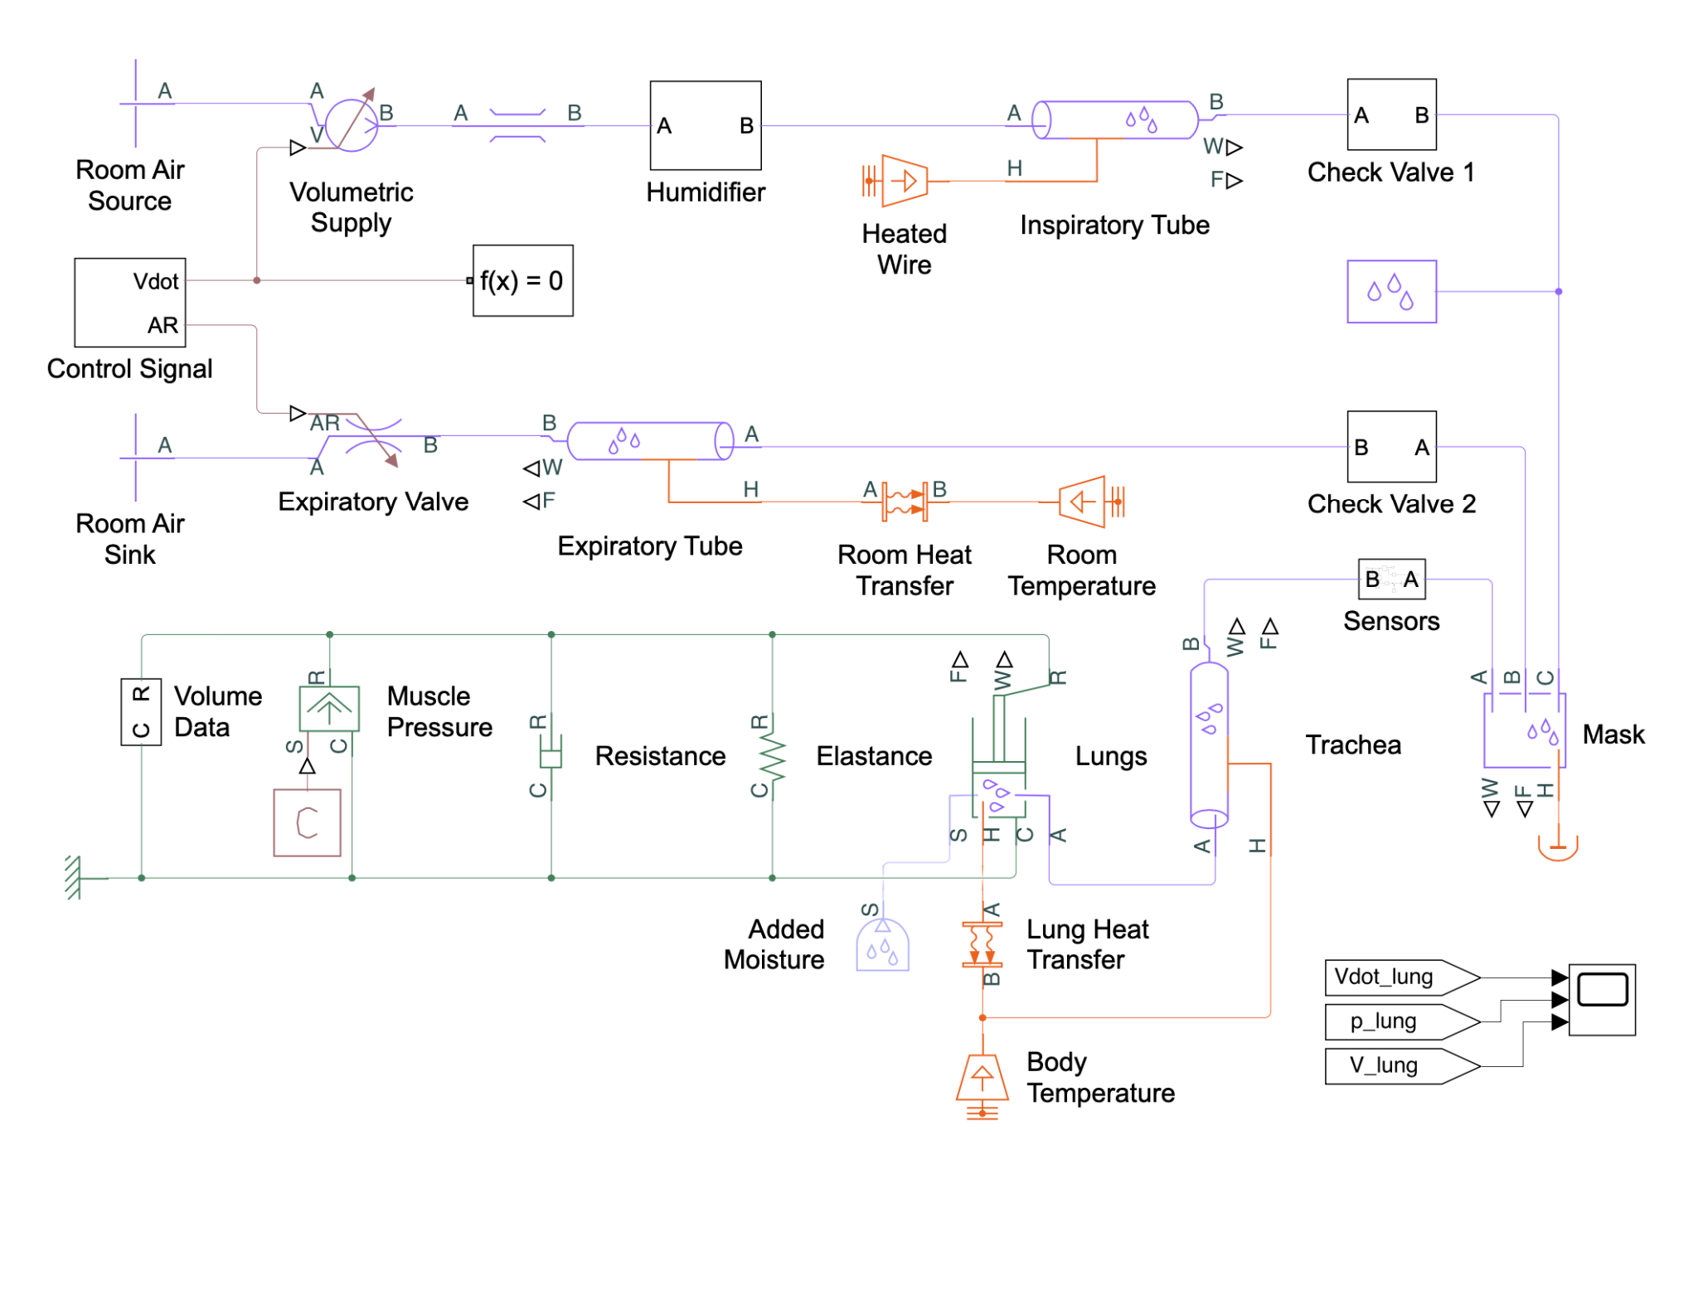

***Figure L1:*** *Medical ventilator with lung model [153]*

## 

## 

## 

***Figure L2:*** *Results of simulating positive pressure control ventilation*

# 12.0 References

[1] “Anatomy and Physiology of the Heart - Normal Function of the Heart - Cardiology Teaching Package - Practice Learning - Division of Nursing - The University of Nottingham”, *Nottingham.ac.uk*. [Online]. Available: https://www.nottingham.ac.uk/nursing/practice/resources/cardiology/function/anatomy.php. [Accessed: 11 Oct 2022].

[2] “Single Ventricle - Encyclopedia of Disease”, *Amc.seoul.kr*. [Online]. Available: https://www.amc.seoul.kr/asan/healthinfo/disease/diseaseDetail.do?contentId=31648. [Accessed: 11 Oct 2022].

[3] “Fontan Procedure”, *AboutKidsHealth*, 2009. [Online]. Available: https://www.aboutkidshealth.ca/Article?contentid=1661&language=English. [Accessed: 7 Oct 2022].

[4] J. Rychik et al., “Evaluation and Management of the Child and Adult With Fontan Circulation: A Scientific Statement From the American Heart Association”, *Circulation*, vol. 140, no. 6, 2019. Available: https://doi.org/10.1161/CIR.0000000000000696. [Accessed: 7 Oct 2022].

[5] G. Mazza, E. Gribaudo and G. Agnoletti, “The pathophysiology and complications of Fontan circulation”, *Acta Biomedica*, vol. 92, no. 5, 2021. Available: https://www.ncbi.nlm.nih.gov/pmc/articles/PMC8689331/. [Accessed: 8 Oct 2022].

[6] D. Young, *Control of cardiac output*. San Rafael, CA: Morgan et Claypool Life Sciences, 2010. [Online]. Available: https://www.ncbi.nlm.nih.gov/books/NBK54476/. [Accessed: 8 Oct 2022].

[7] “Venous Return - Hemodynamics”, *CV Physiology*, 2017. [Online]. Available: https://www.cvphysiology.com/Cardiac%20Function/CF016. [Accessed: 11 Oct 2022].

[8] S. Nayak and P. Booker, “The Fontan circulation”, *Continuing Education in Anaesthesia Critical Care & Pain*, vol. 8, no. 1, pp. 26-30, 2008. Available: https://doi.org/10.1093/bjaceaccp/mkm047. [Accessed: 11 Oct 2022].

[9] Y. Kotani et al., “Fontan Failure and Death in Contemporary Fontan Circulation: Analysis From the Last Two Decades”, *The Annals of Thoracic Surgery*, vol. 105, no. 4, pp. 1240-1247, 2018. Available: https://www.sciencedirect.com/science/article/pii/S0003497517314662. [Accessed: 11 Oct 2022].

[10] P. Charla et al., “Augmentation of pulmonary blood flow and cardiac output by non-invasive external ventilation late after Fontan palliation”, *BMJ Journals*, 2021. [Online]. Available: https://heart.bmj.com/content/107/2/142.info. [Accessed: 10 Oct 2022].

[11] S. Deshpande, “Long term negative pressure ventilation: Rescue for the failing fontan?”, *World Journal of Cardiology*, vol. 6, no. 8, p. 861, 2014. Available: https://www.ncbi.nlm.nih.gov/pmc/articles/PMC4163715/. [Accessed: 11 Oct 2022].

[12] D. Hess and R. Kacmarek, “Physiologic Effects of Mechanical Ventilation”, *Essentials of mechanical ventilation*, 4th ed. McGraw Hill, 2019. [Online]. Available: https://accessanesthesiology.mhmedical.com/content.aspx?bookid=2493&sectionid=199646004. [Accessed: 8 Oct 2022].

[13] B. Morgan, “Information and Procedure: Intra-Abdominal Pressure Monitoring”, *London Health Sciences Centre*, 2022. [Online]. Available: https://www.lhsc.on.ca/critical-care-trauma-centre/information-and-procedure-intra-abdominal-pressure-monitoring. [Accessed: 11 Oct 2022].

[14] “Respiratory Pump”, *TheFreeDictionary.com*. [Online]. Available: https://medical-dictionary.thefreedictionary.com/respiratory+pump. [Accessed: 11 Oct 2022].

[15] M. Grebosky, "Optimizing Breath through Diaphragmatic Breathing: An Essential for Balance", *Move With Matt*, 2019. [Online]. Available: https://www.mattgrebosky.com/blog/optimizing-breath-through-diaphragmatic-breathing-an-essential-for-balance. [Accessed: 11 Oct 2022].

[16] E. N. Marieb and K. Hoehn, “The Respiratory System,” *Human Anatomy & Physiology*, 11th ed., Hoboken, NJ: Pearson Education., 2019, p. 835.

[17] “Pleural diseases,” *Michigan Medicine*. [Online]. Available: https://www.uofmhealth.org/conditions-treatments/pulmonary/pleural-diseases. [Accessed: 05 Nov 2022].

[18] K. Neupane and R. T. Jamil, “Physiology, Transpulmonary Pressure,” *National Library of Medicine*, 2022. [Online]. Available: https://www.ncbi.nlm.nih.gov/books/NBK559004/. [Accessed: 5 Nov 2022].

[19] A. Egbe et al., "Venous congestion and pulmonary vascular function in Fontan circulation: Implications for prognosis and treatment", *International Journal of Cardiology*, vol. 271, pp. 312-316, 2018. Available: https://www.ncbi.nlm.nih.gov/pmc/articles/PMC6146405/. [Accessed: 8 Oct 2022].

[20] A. Al-Eyadhy, “Mechanical ventilation strategy following Glenn and Fontan surgeries: On going challenge!”, *Journal of the Saudi Heart Association*, vol. 21, no. 3, pp. 153-157, 2009. Available: https://www.ncbi.nlm.nih.gov/pmc/articles/PMC3727352/. [Accessed: 10 Oct 2022].

[21] A. Tellechea Rotta and W. Brunow de Carvalho, “Mechanical Ventilation Following Cardiac Surgery in Children”, *Current Respiratory Medicine Reviews*, vol. 8, no. 1, pp. 44-52, 2012. Available: https://www.ingentaconnect.com/content/ben/crmr/2012/00000008/00000001/art00008?crawler=true. [Accessed: 10 Oct 2022].

[22] P. Drinker, “The Iron Lung”, *JAMA*, vol. 255, no. 11, p. 1476, 1986. Available: https://doi.org/10.1001/jama.1986.03370110098030. [Accessed: 8 Oct 2022].

[23] “Home - Hayek Medical”, *Hayek Medical*. [Online]. Available: https://hayekmedical.com/. [Accessed: 8 Oct 2022].

[24] D. Peng et al., “Acute Hemodynamic Effects of Negative Extrathoracic Pressure in Fontan Physiology”, *Pediatric Cardiology*, vol. 40, no. 8, pp. 1633-1637, 2019. Available: https://link.springer.com/article/10.1007/s00246-019-02197-x. [Accessed: 11 Oct 2022].

[25] R. Cordina et al., “Resistance training improves cardiac output, exercise capacity and tolerance to positive airway pressure in Fontan physiology”, *International Journal of Cardiology*, vol. 168, no. 2, pp. 780-788, 2013. Available: https://doi.org/10.1016/j.ijcard.2012.10.012. [Accessed: 11 Oct 2022].

[26] L. Baldini, K. Librandi, C. D’Eusebio and A. Lezo, “Nutritional Management of Patients with Fontan Circulation: A Potential for Improved Outcomes from Birth to Adulthood”, *Nutrients*, vol. 14, no. 19, p. 4055, 2022. Available: https://doi.org/10.3390/nu14194055. [Accessed: 11 Oct 2022].

[27] N. Oldenburger, A. Mank, J. Etnel, J. Takkenberg and W. Helbing, “Drug therapy in the prevention of failure of the Fontan circulation: a systematic review”, *Cardiology in the Young*, vol. 26, no. 5, pp. 842-850, 2016. Available: https://doi.org/10.1017/S1047951115002747. [Accessed: 11 Oct 2022].

[28] Honjo, O, “Project Description - SickKids”, *Client Meeting*, 2022.

[29] D. Robert, P. Leger and M. Elliott, “Noninvasive Ventilation to Treat Chronic Ventilatory Failure”, *Principles and Practice of Sleep Medicine*, pp. 1318-1330, 2011. Available: https://doi.org/10.1016/B978-1-4160-6645-3.00113-4. [Accessed: 11 Oct 2022].

[30] M. Moore, G. White and D. Moore, “Association of Relative Backpack Weight With Reported Pain, Pain Sites, Medical Utilization, and Lost School Time in Children and Adolescents”, *Journal of School Health*, vol. 77, no. 5, pp. 232-239, 2007. Available: https://doi.org/10.1111/j.1746-1561.2007.00198.x. [Accessed 11 October 2022].

[31] “General Physical Activities Defined by Level of Intensity”. [Online]. Available: https://www.cdc.gov/nccdphp/dnpa/physical/pdf/pa_intensity_table_2_1.pdf. [Accessed: 11 Oct 2022].

[32] L. Falaize et al., “Battery Life of Portable Home Ventilators: Effects of Ventilator Settings”, *Respiratory Care*, vol. 59, no. 7, pp. 1048-1052, 2013. Available: https://doi.org/10.4187/respcare.02711. [Accessed: 11 Oct 2022].

[33] E. Carr, “Respiratory Diseases of the Foal”, *Equine Respiratory Medicine and Surgery*, pp. 633-656, 1984. Available: https://doi.org/10.1016/B978-0-7020-2759-8.50050-7. [Accessed: 11 Oct 2022].

[34] S. Nayak and P. Booker, “The Fontan circulation”, *Continuing Education in Anaesthesia Critical Care & Pain*, vol. 8, no. 1, pp. 26-30, 2008. Available: https://doi.org/10.1093/bjaceaccp/mkm047. [Accessed: 11 Oct 2022].

[35] C. Toida, N. Shime, T. Itoi and M. Yamagishi, “Recovery from Fontan circulation failure by application of continuous negative extrathoracic pressure”, *Journal of Anesthesia*, vol. 21, no. 2, pp. 282-284, 2007. Available: https://doi.org/10.1007/s00540-007-0497-y. [Accessed: 11 Oct 2022].

[36] M. Yeong, W. Loughborough, M. Hamilton and N. Manghat, “Role of cardiac MRI and CT in Fontan circulation”, *Journal of Congenital Cardiology*, vol. 1, no. 1, 2017. Available: https://doi.org/10.1186/s40949-017-0010-x. [Accessed: 11 Oct 2022].

[37] J. King and D. Lowery, “Physiology, Cardiac Output”, *NCBI*, 2022. [Online]. Available: https://www.ncbi.nlm.nih.gov/books/NBK470455/. [Accessed: 11 Oct 2022].

[38] H. Ohuchi, “Where Is the “Optimal” Fontan Hemodynamics?”, *Korean Circulation Journal*, vol. 47, no. 6, p. 842, 2017. Available: https://www.ncbi.nlm.nih.gov/pmc/articles/PMC5711675/. [Accessed: 11 Oct 2022].

[39] “I:E Ratio”, *Ecampusontario*. [Online]. Available: https://ecampusontario.pressbooks.pub/mechanicalventilators/chapter/ie-ratio/. [Accessed: 11 Oct 2022].

[40] M. Barr, “The iron lung – a polio patient's story”, *Journal of the Royal Society of Medicine*, vol. 103, no. 6, pp. 256-259, 2010. Available: https://doi.org/10.1258/jrsm.2010.100003. [Accessed: 11 Oct 2022].

[41] “U.S. Overall Customer Satisfaction”, *The American Customer Satisfaction Index*. [Online]. Available: https://www.theacsi.org/the-acsi-difference/us-overall-customer-satisfaction/. [Accessed: 11 Oct 2022].

[42] J. Roland, “How Much Does the Average Man Weigh?”, *Healthline*, 2019. [Online]. Available: https://www.healthline.com/health/mens-health/average-weight-for-men. [Accessed: 11 Oct 2022].

[43] J. Jackson, “Discover the average chest size for men and learn how to measure your chest circumference”, *Critical body*, 2022. [Online]. Available: https://criticalbody.com/average-male-chest-size/. [Accessed: 11 Oct 2022].

[44] M. Hawryluk, “As ventilators become crucial, repair roadblocks remain”, *Fierce Biotech*, 2020. [Online]. Available: https://www.fiercebiotech.com/medtech/as-ventilators-become-crucial-repair-roadblocks-remain. [Accessed: 11 Oct 2022].

[45] “Lifespan of Biomedical Devices,” *Biomedical Engineering Advisory Group SA*, Australia, 2004.

[46] “Estimated Useful Lives of Depreciable Hospital Assets,” *American Hospital Association*, 1998.

[47] “Personal Property Manual,” *State of Nevada*, Department of Taxation, 2009.

[48] S. Loznen, “Expected Service Life of Medical Electrical Equipment”, *In Compliance Magazine*, 2021. [Online]. Available: https://incompliancemag.com/article/expected-service-life-of-medical-electrical-equipment/. [Accessed: 11 Oct 2022].

[49] M. Nonoyama et al., “Healthcare utilization and costs of home mechanical ventilation”, *Thorax BMJ*, 2018. [Online]. Available: https://thorax.bmj.com/content/73/7/644. [Accessed: 11 Oct 2022].

[50] H. Glass, “High-Acuity Ventilator Cost Guide”, *Medtronic*, 2019. [Online]. Available: https://hcpresources.medtronic.com/blog/high-acuity-ventilator-cost-guide. [Accessed: 11 Oct 2022].

[51] A. De Crescentis, “How Much Do Vents Cost in the Subacute Setting?”, *Medtronic*. [Online]. Available: https://hcpresources.medtronic.com/blog/how-much-do-vents-cost-in-the-sub-acute-setting. [Accessed: 11 Oct 2022].

[52] “Hayek RTX - ein neues Kapitel der Beatmung”, *Oxycare*. [Online]. Available: https://www.oxycare.eu/de/beatmung-absaugung/beatmung/niv-beatmung/hayek-rtx-ein-neues-kapitel-der-beatmung/. [Accessed: 11 Oct 2022].

[53] “Medical Devices Regulations”, *Justice Laws*, 2022. [Online]. Available: https://laws-lois.justice.gc.ca/eng/regulations/sor-98-282/. [Accessed: 11 Oct 2022].

[54] “ISO 14155:2020”, *ISO*. [Online]. Available: https://www.iso.org/standard/71690.html. [Accessed: 11 Oct 2022].

[55] “ISO 13485 — Medical devices”, *ISO*. [Online]. Available: https://www.iso.org/iso-13485-medical-devices.html. [Accessed: 11 Oct 2022].

[56] “IEC 60601-1-11:2015”, *ISO*. [Online]. Available: https://www.iso.org/standard/65529.html. [Accessed: 11 Oct 2022].

[57] “ISO 10651-2:2004”, *ISO*. [Online]. Available: https://www.iso.org/standard/35973.html. [Accessed: 11 Oct 2022].

[58] “Sea Level Pressure - Annual data for Toronto”, *Amateur Weather Statistics for Toronto*, Ontario. [Online]. Available: https://toronto.weatherstats.ca/charts/pressure_sea-yearly.html. [Accessed: 11 Oct 2022].

[59] “Relative Humidity - Monthly data for Toronto”, *Amateur Weather Statistics for Toronto*, Ontario. [Online]. Available: https://toronto.weatherstats.ca/charts/relative_humidity-monthly.html. [Accessed: 11 Oct 2022].

[60] “Average Humidity in Canadian Cities”, *Current Results*. [Online]. Available: https://www.currentresults.com/Weather/Canada/Cities/humidity-annual-average.php. [Accessed: 11 Oct 2022].

[61] “Climate and Average Weather Year Round in Toronto”, *WeatherSpark*. [Online]. Available: https://weatherspark.com/y/19863/Average-Weather-in-Toronto-Canada-Year-Round. [Accessed: 11 Oct 2022].

[62] A. Helmenstine, “What Is Room Temperature?”, *Science Notes and Projects*, 2020. [Online]. Available: https://sciencenotes.org/what-is-room-temperature/. [Accessed: 11 Oct 2022].

[63] W. Bierman, “The Temperature of the Skin Surface”, *Journal of the American Medical Association*, vol. 106, no. 14, p. 1158, 1936. Available: https://doi.org/10.1001/jama.1936.02770140020007. [Accessed: 11 Oct 2022].

[64] “Understanding human body temperature in infrared thermal readings”, *Med-Hot Medical Thermography*. [Online]. Available: https://med-hot.com/measuring-infrared-temperature/. [Accessed: 11 Oct 2022].

[65] A. Meadows, “What is a Normal Respiratory Rate for Sleep?”, *Sleep Foundation*, 2022. [Online]. Available: https://www.sleepfoundation.org/sleep-apnea/sleep-respiratory-rate. [Accessed: 11 Oct 2022].

[66] A. Rowden, “Normal respiration rate: For adults and all ages, and how to measure”, *Medical News Today*, 2021. [Online]. Available: https://www.medicalnewstoday.com/articles/324409. [Accessed: 11 Oct 2022].

[67] R. McMurray and S. Ahlborn, “Respiratory responses to running and walking at the same metabolic rate”, *Respiration Physiology*, vol. 47, no. 2, pp. 257-265, 1982. Available: https://doi.org/10.1016/0034-5687(82)90115-3. [Accessed: 11 Oct 2022].

[68] “Know Your Beats Per Minute to Win It”, *MU Health Care*. [Online]. Available: https://www.muhealth.org/our-stories/know-your-beats-minute-win-it. [Accessed: 11 Oct 2022].

[69] “Your lungs and exercise”, *Breathe*, vol. 12, no. 1, pp. 97-100, 2016. Available: https://doi.org/10.1183/20734735.ELF121. [Accessed: 11 Oct 2022].

[70] “Human Factors and Medical Devices”, *U.S. Food and Drug Administration*, 2022. [Online]. Available: https://www.fda.gov/medical-devices/device-advice-comprehensive-regulatory-assistance/human-factors-and-medical-devices. [Accessed: 11 Oct 2022].

[71] “Average Humidity in Canadian Cities”, *Current Results*. [Online]. Available: https://www.currentresults.com/Weather/Canada/Cities/humidity-annual-average.php. [Accessed: 11 Oct 2022].

[72] “Canadian Health Measures Survey: Cycle 2 Data Tables: Table 23 — Measured weight, by age and sex, household population,Canada, 2009 to 2011”, *Statistics Canada*, 2015. [Online]. Available: https://www150.statcan.gc.ca/n1/pub/82-626-x/2013001/t024-eng.htm. [Accessed: 11 Oct 2022].

[73] “Clothing Sizes”, *Dharma Trading Co.*. [Online]. Available: https://www.dharmatrading.com/home/clothing-sizes.html?lnav=home.html. [Accessed: 11 Oct 2022].

[74] N. Abughanam, S. Gaben, M. Chowdhury and A. Khandakar, “Investigating the effect of materials and structures for negative pressure ventilators suitable for pandemic situation”, *Emergent Materials*, vol. 4, no. 1, pp. 313-327, 2021. Available: https://doi.org/10.1007/s42247-021-00181-x. [Accessed: 11 Oct 2022].

[75] Resmed Digital Health Solutions PTE. LTD, “Non-invasive ventilation for COPD. can it help?,” *ResMed Thailand*. [Online]. Available: https://www.resmed.co.th/en-th/consumer/diagnosis-and-treatment/respiratory-care/copd/role-of-niv-in-copd. [Accessed: 07-Nov-2022].

[76] C. L. Alviar, et al., “Positive pressure ventilation in the Cardiac Intensive Care Unit,” *Journal of the American College of Cardiology*, vol. 72, no. 13, pp. 1532–1553, 2018.

[77] A. Corrado and M. Gorini, “Negative-pressure ventilation: Is there still a role?,” *European Respiratory Journal*, vol. 20, no. 1, pp. 187–197, 2002. Available: https://doi.org/10.1183/09031936.02.00302602

[78] L. Kilgore, “Lung physiology: Breathing,” *CrossFit*, 2020. [Online]. Available: https://www.crossfit.com/essentials/lung-physiology-breathing. [Accessed: 7 Nov 2022].

[79] D. Kindy, “Texas man lives 70 years in an iron lung: ‘I never gave up’,” *Smithsonian*, 2021. [Online]. Available: https://www.smithsonianmag.com/smart-news/texas-man-lives-70-years-in-an-iron-lung-i-never-gave-up-180979008/. [Accessed: 7 Nov 2022].

[80] “The iron lung,” *Science Museum*, 2018. [Online]. Available: https://www.sciencemuseum.org.uk/objects-and-stories/medicine/iron-lung. [Accessed: 07 Nov 2022].

[81] J. M. Shneerson, “Non-invasive and domiciliary ventilation: negative pressure techniques,” *Thorax BMJ*, 1991. [Online]. Available: https://thorax.bmj.com/content/thoraxjnl/46/2/131.full.pdf. [Accessed: 7 Nov 2022].

[82] N. M. T. Braun, “Negative pressure noninvasive ventilation (NPNIV): History, rationale, and application,” *Nocturnal Non-Invasive Ventilation*, pp. 27–71, 2015. Available: https://doi.org/10.1007/978-1-4899-7624-6_2.

[83] “LUNG1 - Hub History: Boston history podcast,” *HUB History*, 29-Oct-2018. [Online]. Available: http://www.hubhistory.com/episodes/the-iron-lung-episode-104/attachment/lung1-2/. [Accessed: 7 Nov 2022].

[84] E. Kelly and A. Escarce, “Decades after polio, Martha is among the last to still rely on an iron lung to breathe,” *NPR*, 2021. [Online]. Available: https://www.npr.org/2021/10/25/1047691984/decades-after-polio-martha-is-among-the-last-to-still-rely-on-an-iron-lung-to-br. [Accessed: 7 Nov 2022].

[85] C. Onweni, et al., “Cuirass ventilation: An alternative home-based modality for chronic respiratory failure,” *Home Health Care Management & Practice*, vol. 32, no. 1, pp. 40–44, 2019. Available: https://doi.org/10.1177/1084822319875111.

[86] “Hayek RTX a new chapter in ventilation,” *Hayek Medical*. [Online]. Available: https://hayekmedical.com/hayeksitetwo/wp-content/uploads/2022/05/Hayek-RTX-Brochure-Final-01.09.16-copy.pdf. [Accessed: 8 Nov 2022].

[87] “Emergency - Hayek Medical,” *Hayek Medical*, 2022. [Online]. Available: https://hayekmedical.com/emergency/. [Accessed: 8 Nov 2022].

[88] J. R. Bach and A. S. Alba, “Intermittent Abdominal Pressure Ventilator in a Regimen of Noninvasive Ventilatory Support,” *Chest*, vol. 99, no. 3, pp. 630–636, 1991. Available: https://doi.org/10.1378/chest.99.3.630.

[89] F. Simioli, A. Annunziata, A. Coppola, E. M. Borriello, S. Spinelli, and G. Fiorentino, “Versatility of Intermittent Abdominal Pressure Ventilation in a Case of Complicated Restrictive Respiratory Failure and Covid-19,” *Healthcare*, vol. 10, no. 6, p. 1012, 2022. Available: https://doi.org/10.3390/healthcare10061012.

[90] P. I. Banfi, E. Volpato, and J. R. Bach, “Efficacy of New Intermittent Abdominal Pressure Ventilator for Post-Ischemic Cervical Myelopathy Ventilatory Insufficiency,” *Multidisciplinary Respiratory Medicine*, vol. 14, no. 1, 2019. Available: https://doi.org/10.1186/s40248-019-0169-4.

[91] “Lunabelt: Respi USA,” *RespiUSA*. [Online]. Available: https://www.respiusa.com/lunabelt. [Accessed: 8 Nov 2022].

[92] E. De Mattia, M. Iatomasi, B. Garabelli, C. Lunetta, V. A. Sansone, and F. Rao, “Use of the intermittent abdominal pressure ventilation to guarantee speech in a tracheostomized amyotrophic lateral sclerosis patient,” *Revista Portuguesa de Pneumologia (English Edition)*, vol. 23, no. 4, pp. 236–239, 2017. Available: https://doi.org/10.1016/j.rppnen.2017.03.002.

[93] “Venti,” *Breathe Global Devices Ltd.*. [Online]. Available: https://www.breathe.global/. [Accessed: 8 Nov 2022].

[94] “What is high frequency chest wall oscillation (HFCWO)?,” *AffloVest*, 2020. [Online]. Available: https://afflovest.com/articles/hfcwo/. [Accessed: 8 Nov 2022].

[95] “Priority medical devices list for the COVID-19 response and associated technical specifications,” *World Health Organization*, 2020. [Online]. Available: https://www.who.int/publications/i/item/WHO-2019-nCoV-MedDev-TS-O2T.V2. [Accessed: 8 Nov 2022].

[96] I. Gur, A. Eisenkraft, and E. Bar-Yishay, “The Application of Biphasic Extrathoracic Cuirass-Assisted Ventilation in Normal Subjects Wearing Chemical-Biological-Radiological-Nuclear (CBRN) Gas Masks,” *Military Medicine*, vol. 182, no. 3, 2017. Available: https://doi.org/10.7205/MILMED-D-16-00275.

[97] “Small electromagnets, Round & Flat-Faced,” *BuyMagnets.com*, 2022. [Online]. Available: https://buymagnets.com/product/round-electromagnets-flat-faced/. [Accessed: 8 Nov 2022].

[98] “Chest expansion,” *meddean.luc.edu.* [Online]. Available: http://www.meddean.luc.edu/lumen/meded/medicine/pulmonar/pd/chest.htm. [Accessed: 8 Nov 2022].

[99] G. Fiorentino, et al., “Intermittent abdominal pressure ventilation: An alternative for respiratory support,” *Canadian Respiratory Journal*, vol. 2021, pp. 1–5, 2021. Available: https://doi.org/10.1155/2021/5554765.

[100] “Strong and stiff,” *Curbell Plastics*. [Online]. Available: https://www.curbellplastics.com/Research-Solutions/Applications/Strong-and-Stiff. [Accessed: 8 Nov 2022].

[101] “Overview of materials for Acrylic, Cast,” *MatWeb*. [Online]. Available: https://www.matweb.com/search/datasheet.aspx?bassnum=O1303. [Accessed: 8 Nov 2022].

[102] “Overview of materials for Polycarbonate, Molded,” *MatWeb*. [Online]. Available: https://www.matweb.com/search/DataSheet.aspx?MatGUID=84b257896b674f93a39596d00d999d77. [Accessed: 8 Nov 2022].

[103] “Overview of materials for Polylactic Acid (PLA) Biopolymer,” *MatWeb*. [Online]. Available: https://www.matweb.com/search/DataSheet.aspx?MatGUID=ab96a4c0655c4018a8785ac4031b9278&ckck=1. [Accessed: 8 Nov 2022].

[104] “Acrylic vs. polycarbonate,” *ACME Plastics, Inc.* [Online]. Available: https://www.acmeplastics.com/acrylic-vs-polycarbonate. [Accessed: 8 Nov 2022].

[105] “How much does a 3D printing filament cost?,” *Fusion3*. [Online]. Available: https://www.fusion3design.com/how-much-does-3d-printing-filament-cost/. [Accessed: 8 Nov 2022].

[106] “Neoprene rubber sheet, 12‘L x 6‘W X 3/8’ thick, 60A, black,” *Global Industrial*. [Online]. Available: https://www.globalindustrial.ca/p/neoprene-rubber-sheet-no-adhesive-60a-38-thick-x-6-wide-x-12-long?ref=. [Accessed: 8 Nov 2022].

[107] “Black closed cell neoprene sponge material Datasheet - The Rubber Company,” *The Rubber Company*. [Online]. Available: https://therubbercompany.com/wp-content/uploads/2019/10/RC02100-Closed-Cell-Neoprene-Sponge-Material-Datasheet.pdf. [Accessed: 8 Nov 2022].

[108] “BISCO MS-1600 Medical Grade Series,” *Rogers Corporation*. [Online]. Available: https://rogerscorp.com/elastomeric-material-solutions/bisco-silicones/bisco-ms1600-medical-grade-series. [Accessed: 8 Nov 2022].

[109] “Ultra-lightweight Pro-Tac Nij IIIA Bullet Resistant Vest,” *Body Armour Canada Bullet & Cut Resistant Products*. [Online]. Available: https://www.bodyarmourcanada.com/shop-bullet-resistant-or-stab-resistant/bulletproof-vests-pro-tac-concealment-male-bullet-resistant-vest. [Accessed: 8 Nov 2022].

[110] “Bassdash backpack straps replacement adjustable padded shoulder straps for backpack dry bag (black, adult),” *Amazon*. [Online]. Available: https://www.amazon.ca/Bassdash-Backpack-Replacement-Adjustable-Shoulder/dp/B08NYJGLD3. [Accessed: 8 Nov 2022].

[111] “Gregory A3 QUICKSWAP shoulder harness - women's,” *REI Co-op*. [Online]. Available: https://www.rei.com/product/881013/gregory-a3-quickswap-shoulder-harness-womens. [Accessed: 8 Nov 2022].

[112] “Ventilation I:E ratio,” *Scottish Intensive Care Society*. [Online]. Available: https://www.scottishintensivecare.org.uk/training-education/sics-induction-modules/ventilation-i-e-ratio/. [Accessed: 8 Nov 2022].

[113] I. C. Muñoz-Ortega, D. A. Urrego-Higuita, A. F. Vallejo-Aristizábal, and A. M. Hernández-Valdivieso, “Device for simulation of restrictive pathologies in healthy subjects with non-invasive mechanical ventilation,” *Revista Facultad de Ingeniería Universidad de Antioquia*, no. 86, pp. 19–26, 2018. Available: https://doi.org/10.17533/udea.redin.n86a03.

[114] “1PC air single electrical control solenoid valve DC 12V 24V AC 110V 220V 3way 2position 1/4’ PT thread (color : 24VDC),” *Amazon*. [Online]. Available: https://www.amazon.ca/Single-Electrical-Control-Solenoid-2Position/dp/B097KB1FJ4/. [Accessed: 8 Nov 2022].

[115] Comet, “3 big advantages of using diaphragm agricultural pumps,” *Agricultural Diaphragm Pumps*, 2019. [Online]. Available: https://blog.comet-spa.com/diaphragm-pumps/3-big-advantages-of-using-a-diaphragm-pump. [Accessed: 8 Nov 2022].

[116] “DC12V small mini mute brushless water pump submersible impeller centrifugal pump,” *eBay*. [Online]. Available: https://www.ebay.com/itm/284250295823. [Accessed: 8 Nov 2022].

[117] “DC12V 42w -85KPA vacuum pump, flow 40L/min mini oilless Vacuum Pump, Mini Air Pump Motor,” *Amazon.ca: Industrial & Scientific*. [Online]. Available: https://www.amazon.ca/DC12V-Vacuum-Small-Oilless-85KPa/dp/B07H4R7QNC/. [Accessed: 8 Nov 2022].

[118] A. Thorne, “Are polyurethane products toxic to humans?,” *Custom Moulded Polyurethane*, 2020. [Online]. Available: https://custompolyurethane.co.uk/are-polyurethane-products-toxic/. [Accessed: 8 Nov 2022].

[119] “Solenoid valve 12V DC 1/4’ 2 way normally closed pneumatic aluminum electric solenoid air valve,” *Amazon.* [Online]. Available: https://www.amazon.ca/dp/B07STZ7YWZ/. [Accessed: 8 Nov 2022].

[120] “Bostitch BTFP72327 ball type drain valve, 1/4-inch NPT male thread,” *Amazon*. [Online]. Available: https://www.amazon.ca/BOSTITCH-BTFP72327-Drain-4-Inch-Thread/dp/B00HXD2UZA/. [Accessed: 8 Nov 2022].

[121] “Hromee Air Line Tubing Kit, 1/4’ (6.35mm) Od×32.8 Feet Polyurethane Pu Tube And Push To Connect Fittings, 14 Pcs Compressed Pipe And Accessories Kit,” *Amazon.* [Online]. Available: https://www.amazon.ca/Hromee-Polyurethane-Fittings-Compressed-Accessories/dp/B08BLC8PZ2/. [Accessed: 8 Nov 2022].

[122] “Nedexu 1/4 Air Hose Fittings Tube Connector,Quick Connect Air Line Compression Fittings Male 1/4 Npt Thread 10 Pack, Fittings,” *Amazon*. [Online]. Available: https://www.amazon.ca/dp/B0B36HDHMS/. [Accessed: 8 Nov 2022].

[123] “Beduan 1/4’ PT thread quick connect air hose manifold block splitter 2 way 5 ports (pack of 1),” *Amazon*. [Online]. Available: https://www.amazon.ca/Beduan-Thread-Connect-Manifold-Splitter/dp/B07MG33V5L/. [Accessed: 8 Nov 2022].

[124] C. Coward, “Programmable air is an Arduino-based air pump for your soft robotics projects,” *Hackster.io*, 2018. [Online]. Available: https://www.hackster.io/news/programmable-air-is-an-arduino-based-air-pump-for-your-soft-robotics-projects-9945c6ed96aa. [Accessed: 8 Nov 2022].

[125] A. Industries, “6V air valve with 2-pin JST PH connector,” *Adafruit Industries*. [Online]. Available: https://www.adafruit.com/product/4663. [Accessed: 8 Nov 2022].

[126] “AMS 5915 - Board-Mount Pressure Sensor With I2c Output,” *Analog Microelectronics.* [Online]. Available: https://www.analog-micro.com/en/products/pressure-sensors/board-mount-pressure-sensors/ams5915/. [Accessed: 8 Nov 2022].

[127] “Eco-worthy Lithium Battery 12V 8Ah lifepo4 battery 3000+ deep cycle battery with BMS protection for Kids Ride-on car, alarm system, speaker, gate opener, used as UPS Backup Battery,” *Amazon*. [Online]. Available: https://www.amazon.ca/ECO-WORTHY-Rechargeable-Phosphate-Protection-Fishfinder/dp/B092PR8QFQ/. [Accessed: 8 Nov 2022].

[128] “Qsmily 6V battery pack, 1000mah ni-CD AA rechargeable battery pack with SM Connector and charge cable, suitable for Solar Outdoor Light Security Light Amphibious Stunt RC Car,” *Amazon*. [Online]. Available: https://www.amazon.ca/Qsmily-Rechargeable-Connector-Suitable-Amphibious/dp/B08M3PX5SZ/. [Accessed: 8 Nov 2022].

[129] “DSD Tech SH-D2004 20x4 2004 LCD display screen blue with IIC module interface adapter for Arduino Uno R3 mega2560 nano raspberry pi,” *Amazon*. [Online]. Available: https://www.amazon.ca/DSD-TECH-SH-D2004-Interface-Raspberry/dp/B07TBYFN3X. [Accessed: 8 Nov 2022].

[130] “Adafruit Membrane 3X4 matrix keypad + extras [ada419],” *Amazon*. [Online]. Available: https://www.amazon.ca/dp/B00NAY2XUS/. [Accessed: 8 Nov 2022].

[131] “Neoprene high quality foam sheets,” *Foam Factory, Inc.* [Online]. Available: https://canada.foambymail.com/product/neoprene-high-quality-foam-sheets.html. [Accessed: 8 Nov 2022].

[132] “Arduino Uno Rev3 [A000066],” Amazon. [Online]. Available: https://www.amazon.ca/ARDUINO-A000066-Uno-DIP-1-5/dp/B008GRTSV6. [Accessed: 8 Nov 2022].

[133] “AMS5915-0100-D amplified low pressure sensor 0-100 mbar 0 to 1.450 PSI I2C mini module,” *store.ncd.io*. [Online]. Available: https://store.ncd.io/product/ams5915-0100-d-amplified-low-pressure-sensor-0-100-mbar-0-to-1-450-psi-i2c-mini-module/. [Accessed: 8 Nov 2022].

[134] “ISO 14971:2019,” *ISO*, 2019. [Online]. Available: https://www.iso.org/standard/72704.html. [Accessed: 8 Nov 2022].

[135] “ISO/TR 24971:2020,” *ISO*, 2020. [Online]. Available: https://www.iso.org/standard/74437.html. [Accessed: 8 Nov 2022].

[136] B. D. Ehrhart, S. R. Harris, M. L. Blaylock, A. B. Muna, and S. Quong, “Risk assessment and ventilation modeling for hydrogen releases in vehicle repair garages,” *International Journal of Hydrogen Energy*, 2020. [Online]. Available: https://www.osti.gov/servlets/purl/1671818. [Accessed: 8 Nov 2022].

[137] H. Kondo, “Prusa i3 MK3S/Mk3s+ Build Volume: How big is it really?,” *All3DP*, 17-Feb-2022. [Online]. Available: https://all3dp.com/2/prusa-i3-mk3s-build-volume-how-big-is-it-actually/. [Accessed: 8 Nov 2022].

[138] M. Sarcevic, “Gluing 3D prints: The Best Glue for PLA, ABS & petg,” *All3DP*, 2022. [Online]. Available: https://all3dp.com/2/gluing-3d-printed-best-ways-bond-3d-prints/. [Accessed: 8 Nov 2022].

[139] “System Usability Scale (SUS)”, *Usability*. [Online]. Available: https://www.usability.gov/how-to-and-tools/methods/system-usability-scale.html. [Accessed: 11 Oct 2022].

[140] “Durability/Fatigue Testing”, *MED Institute*. [Online]. Available: https://medinstitute.com/services/medical-device-testing/durability-and-fatigue-testing/. [Accessed: 11 Oct 2022].

[141] “ISO/IEC 17025:2017”, *ISO*. [Online]. Available: https://www.iso.org/standard/66912.html. [Accessed: 11 Oct 2022].

[142] “ISO 80601-2-84:2020”, *ISO*. [Online]. Available: https://www.iso.org/standard/72441.html. [Accessed: 11 Oct 2022].

[143] C. Xing et al., “New Method for Noninvasive Quantification of Central Venous Pressure by Ultrasound”, *Circulation: Cardiovascular Imaging*, vol. 8, no. 5, 2015. Available: https://doi.org/10.1161/CIRCIMAGING.114.003085. [Accessed: 11 Oct 2022].

[144] “Muscles of the neck and torso - classic human anatomy in motion: The Artist's Guide to the dynamics of figure drawing,” *Doctorlib*. [Online]. Available: https://doctorlib.info/anatomy/classic-human-anatomy-motion/6.html. [Accessed: 8 Nov 2022].

[145] R. Jones and D. Conway, "The effect of electromagnetic interference from mobile communication on the performance of intensive care ventilators", *European Journal of Anaesthesiology*, vol. 22, no. 8, pp. 578-583, 2005. Available: https://doi.org/10.1017/s0265021505000979. [Accessed: 11 Oct 2022].

[146] "IEC 60601-1-2:2014", *IEC*. [Online]. Available: https://webstore.iec.ch/publication/2590. [Accessed: 11 Oct 2022].

[147] "ISO 80601-2-87:2021", *ISO*. [Online]. Available: https://www.iso.org/obp/ui/#iso:std:iso:80601:-2-87:ed-1:v1:en. [Accessed: 11 Oct 2022].

[148] "ISO 15223-1:2016", *ISO*. [Online]. Available: https://www.iso.org/standard/69081.html. [Accessed: 11 Oct 2022].

[149] "ISO/TR 24971:2020", *ISO*. [Online]. Available: https://www.iso.org/standard/74437.html. [Accessed: 11 Oct 2022].

[150] C. Onweni et al., "Cuirass Ventilation: An Alternative Home-Based Modality for Chronic Respiratory Failure", *Home Health Care Management & Practice*, vol. 32, no. 1, pp. 40-44, 2019. Available: https://doi.org/10.1177/1084822319875111. [Accessed: 11 Oct 2022].

[151] "ISO 10993-1:2018", *ISO*. [Online]. Available: https://www.iso.org/standard/68936.html. [Accessed: 11 Oct 2022].

[152] “L298n stepper driver,” *RobotDigg*. [Online]. Available: https://www.robotdigg.com/product/772/L298N-stepper-driver. [Accessed: 8 Nov 2022].

[153] “Medical ventilator with lung model,” *Medical Ventilator with Lung Model - MATLAB & Simulink*. [Online]. Available: https://www.mathworks.com/help/simscape/ug/medical-ventilator-with-lung-model.html. [Accessed: 25-Mar-2023].

[154] Mehedi IM, Shah HSM, Al-Saggaf UM, Mansouri R, Bettayeb M. “Fuzzy PID Control for

Respiratory Systems.” *J Healthc Eng*. 2021 Jun 24;2021:7118711. doi: 10.1155/2021/7118711. PMID:

34257855; PMCID: PMC8253636.

[155] Petros A, Fernando S, Shenoy V, Al-Saady. “The Hayek Oscillator Nomograms for tidal volume and minute ventilation using external high frequency oscillation.” *Anaesthesia,* Volume 50, p. 601, 1995. Available: https://associationofanaesthetists-publications.onlinelibrary.wiley.com/doi/pdf/10.1111/j.1365-2044.1995.tb15112.x. [Accessed: 24-Mar-2023].

[156] “BTX single and dual head miniature diaphragm pump (gas),” *Parker Hannifin Corp*. [Online]. Available: https://ph.parker.com/us/12051/en/btx-single-and-dual-head-miniature-diaphragm-pump-gas. [Accessed: 25-Mar-2023].

[157] “Valve, Pressure Relief, 0-55 cmH2O True APL, 1/2-20, Chrome Brass,” *AAA Wholesale Company*. [Online]. Available: https://www.aaawholesalecompany.com/ane-00-273-ea.html. [Accessed: 25-Mar-2023].

[158] “X-valve - miniature pneumatic solenoid valve | Parker Na,” *Parker Hannifin Corp*. [Online]. Available: https://ph.parker.com/us/12051/en/x-valve-miniature-pneumatic-solenoid-valve/912-000001-021. [Accessed: 25-Mar-2023].

[159] “Pump Filter Accessories,” *Parker Engineering Your Success Motion Control Technology* . [Online]. Available: https://ph.parker.com/us/12051/en/pump-filter-accessories. [Accessed: 25-Mar-2023].